Name_______________________________________________________Date________________Period_____________
What’s in a Shape?
Directions: Read the following explanations about the different shapes of countries, and then complete the mapping and questions that follow. You may need to refer to a world map for reference. Article from www.Thoughtco.Com/Geographyandhumanities (annotations/Highlight Plus are worth 20 points)
A country's boundaries, as well as the shape of the land it encompasses, can present problems or help to unify the nation. The morphology (shape) of most countries can be divided into five main categories: compact, fragmented, elongated, perforated, and protruded. A countries shape defines much more than just its borders; it has the potential to determine economic, political, and social consequences as well. Take a closer look at the 5 main categories of shapes.

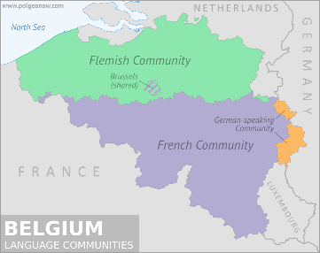
1. Compact- Compact countries are those that are round (circular or oval-ish in shape) where edges are roughly the same distance from the center point (often the capital). A compact state with a circular shape is the easiest to manage. Belgium is an example of a compact nation in Europe. Although it is small, or compact as the name suggest, it is also internally divided between two cultural groups: the Flemings in the North and the Wallonia in the South. The government long ago divided the country into these two regions, giving each control over its cultural, linguistic, and educational matters. Yet, despite this division, Belgium's compact form has helped to keep the country together despite numerous European wars and attacks by neighboring countries. Since the country as a whole is relatively small and centered, Belgium has been able to keep out intruders. One potential downside of a compact nation is that it may not have a large variation of resources or cropland.

2. Fragmented
Nations such as Indonesia, which is composed of more than 13,000 islands, are known as fragmented or archipelagic states because they are composed of archipelagos (multiple islands). Fragmented states often span hundreds of miles, and often have sections of the nation so far from capital that the population may develop cultural divides. A fragmented nation may also have to deal with multiple governing neighbors, all that bring different their own situations. It could also be difficult to govern such a country. Denmark and the Philippines are also archipelagic countries separated by water. As you might expect, the Philippines has been attacked, invaded, and occupied numerous times over the centuries due to its fragmented shape, starting in 1521 when Ferdinand Magellan claimed the islands for Spain. Due to many different borders, invaders often see fragmented nations as easy targets. However, fragmentation also has positives. Different cultural groups can subdivide and since these nations are usually larger, they provide more opportunities for shipping, trade, and resources.

Elongated
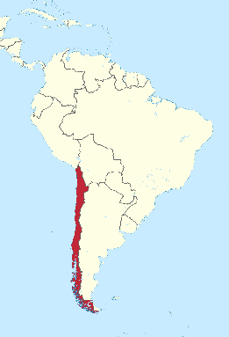
An elongated nation is one that stretches north and south or east and west, and is a long thin shape. The elongated nation may or may not have a centered capital or focal point. The Elongated nation, such as Chile, makes for difficult governance of peripheral areas in the north and south, which are far from the central capital of Santiago. Elongated nations are often too long to fully protect all of their perimeters at the same time, so invasions or splitting has been a common occurrence. Vietnam is also an elongated state, which has battled numerous attempts by other countries to divide it, such as the 20-year Vietnam War, where first French and then U.S. forces tried unsuccessfully to keep the southern part of the nation separated from the north.

Perforated
South Africa is the classic example of a perforated state, which completely surrounds Lesotho. The landlocked nation of Lesotho can only be reached by going through South Africa. If there is hostility between the two nations, access to the surrounded nation can be difficult. Italy is also a perforated state. Vatican City and San Marino—both independent countries—are completely landlocked by Italy. Being perforated could be a benefit, as perforated nations are usually larger and often more powerful than the countries they surround. Also, a perforated country would most likely establish communication and trade routes that landlocked nations would have no choice but to follow. Think major road systems; Lesotho has to connect their interstate systems to South Africa’s if it wants it people to be able to travel out of the country or to bring goods in. The downside of a perforated state is that you completely encompass another nation, so you must always be aware of political tensions, policies, and relations, so as to not be ‘attacked from the inside’.

Protruded
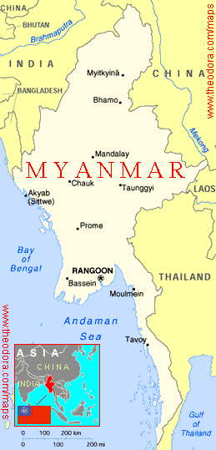
A protruded or panhandle country such as Myanmar or Thailand has an extended arm of territory. Like an elongated state, the panhandle complicates management of the country. Myanmar has existed in one form or another for thousands of years, but the country's shape has made it an easy target for many other nations and people. Protruded states usually form due to the need to have a specific resource that is not located in the larger region, often access to water. Protruded nations have also formed to encase a group of people who are divided geographically but similar in culture. Picture the state of Oklahoma: You can get an idea of how hard it would be to defend a protruded country if it has a prominent panhandle. Protruded nations usually gain a valuable resource, but also have to defend a narrow section of territory often from many other nations.

Mapping Directions: (40 points)
1. Color and label three compact nations, other than Belgium, red.
2. Color and label three fragmented nations, other than Indonesia, purple.
3. Color and label three elongated nations, other than Chile, green.
4. Color and label two perforated nations in orange.
5. Color and label three protruded nations, other than Myanmar, in blue.

Free Response Questions- Answer in complete sentences.
6. What potential disadvantages does a country have if it is landlocked? (10 points)

7. If you are a more powerful country, what specific advantages would you have as a perforated nation? (10 points)

8. Historically, how have elongated and protruded nations faced problems/disadvantages? (10 points)

9. Politically, what advantage does a compact nation have in comparison to a fragmented nation? (10 points)

10. If you were to start a new country in the United States today, what shape would you choose and where would you put it? Draw it on your map! (10 points)

