Name________________________________________________Date___________________ Period______________

Inside Earth

Written in partnership with NASA and Iris Consortium

It's a common refrain that the ocean depths are the last great frontier of the Earth. Yet there's a place that's even more inhospitable to humans than the crushing depths of the sea: our planet's interior. It's made of iron. In some places, it's 10,000 degrees F, and plenty of scientists devote their life's work to understanding it. But how exactly do you conduct research on an impenetrable, hostile environment like the Earth's core?
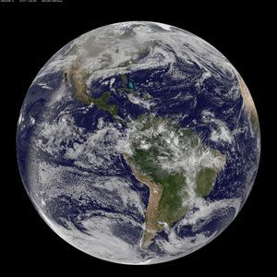
Back in the day, scientists and creative types alike used to believe that a whole different world lived below us. Jules Verne imagined a place ripe for adventure with dinosaurs and giant birds, while Edmond Halley thought the Earth was hollow with a couple concentric rings floating around in the middle. As cool as those ideas were, they didn't last. Both were thrown out by the latter part of the 18th century.
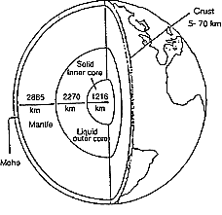
Today, by using seismological and magnetic field data as well as other theoretical calculations, it's possible to get a sense of the actual size and composition of our planet's nether regions. Because there's no way to get a sample of the Earth's core, Miaki Ishii, a professor in Harvard University's seismology group, says, "We basically use methods that are similar to medical imaging."
Instead of using CAT-scans and X-rays to see the center of the Earth, researchers use waves emitted by earthquakes to get a sense of the planet's innards. Just like an X-ray, seismic waves bounce around, changing direction and speed based on the material they pass through. If researchers can gauge how quickly a wave moves from one tracking station to another, they can get a pretty good sense of what the ground that wave is traveling through looks like, or how deep and dense the materials are.
These tests are what allowed scientists to see that the core of the Earth is broken into three layers all with slightly different structures. The core's heat is mostly due to the slow decay of radioactive elements left over from when the planet first formed. The molten iron outer core lies about 3000 kilometers below our feet, while the solid iron inner core is another 2000 kilometers further down. A few other elements, including oxygen and silicon, are thrown in for good measure. But for the most part, iron rules the Earth's underbelly.
To learn more about Earth's innards, scientists have looked outward. Researchers like Maria Zuber, a geophysics professor at MIT, and Ishii have used evidence from space to support their conclusions about Earth. Iron meteorites collected after their fall to Earth are pretty solid clues that the iron element is plentiful in the Universe. Zuber says iron seems to be favored planetary building block. It's the heaviest element made during stellar fusion, so planets form with high concentrations of it.
Zuber and colleagues also have studied the insides of other planets to learn about Earth's core. Published in the journal Science this year, Zuber and her colleagues at MIT examined Mercury's core by using the planet's magnetic field to their advantage.
"The fact that it [Mercury] has a magnetic field tells us that it's iron and that part of it is molten," Zuber says. Without at least a partially liquid core, convection wouldn't occur, making it impossible for a planet to form a magnetic field. These same processes happen inside the Earth, too. The energy released by the swirling liquid within our own planet's outer core allows Earth to create a self-sustaining, solar-wind-blocking shield. Without it, life on this planet wouldn't exist.
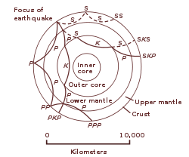
So the basics of Earth's core are well established. But that doesn't mean the book is closed; geologists are still turning up surprises. In new research published in the journal Nature, Dario Alfé and his colleagues at University College London used first principle calculations—quantum mechanical equations that show how the electrons of certain elements behave in various states—to study the radioactivity of the Earth's inner core. Their findings didn't match up with what scientists had believed about the core. If Alfé is right, the Earth's inner core is either half as old, or twice as radioactive, as previously believed.
"Earthquakes and seismic waves tell you a lot about the density [of the core] because you're looking at the size of the waves," Alfé says. "But it doesn't tell you anything about the temperature." By using theoretical models, the researchers saw that conduction—another form of heat transfer—is happening in the core at a higher rate than initially expected, leaving less heat for convection to do away with. In other words, the inner core appears to be cooling two times faster than anyone thought.
This means that there could be another source of heat that spurs on convection in the outer core. Researchers thought that the inner core's radioactivity clocked in at around 400 parts per million—think of it as a little over 30 drops of radioactivity per gallon of material. But now, it's looking like that number could be more like 800 parts per million. On the other hand, it might mean that the inner core is simply younger than earlier estimates predicted—in other words, that the molten outer core has been solidified into the inner core more recently than previously believed. This doesn't mean that the Earth itself is any younger—it's still 4.5 billion years old. Rather, it would mean that the solid inner core got to its current, relatively cooler state in about half the time anyone expected it to.
Alfé and his team drew their conclusions by using their knowledge of the melting point of iron to understand the pressure and the temperature at the center of the Earth. It's a roundabout, but efficient way of understanding something right beneath our feet. "It's very indirect," Zuber says, "but it's the only game in town."

Directions: Answer the questions in complete, thought out sentences.
1. Why did people before the 1800’s believe that inner earth was filled with dinosaurs or concentric rings (think rings like Saturn)? Answer need to be historically accurate. (15 points)
______________________________________________________________________________________________________________________________________________________________________________________________________________________________________________________________________________________________________
2. What type of limitations-Geographic or Technologic- would pose more of a problem about why we can’t explore inner earth? (15 points)
______________________________________________________________________________________________________________________________________________________________________________________________________________________________________________________________________________________________________
3. Explain how seismic activity has helped scientists understand what is inside the Earth? (20 points)
______________________________________________________________________________________________________________________________________________________________________________________________________________________________________________________________________________________________________
4. If researcher, Dario Alfie is correct in his findings, what new theories about earth’s inner core are being suggested? (15 points)
______________________________________________________________________________________________________________________________________________________________________________________________________________________________________________________________________________________________________
5. If scientists can’t go into the earth, why are they turning to space for more answers? (15 points)
______________________________________________________________________________________________________________________________________________________________________________________________________________________________________________________________________________________________________
6. Why is it important for geographers and scientists to study what the earth is made of? (20 points)
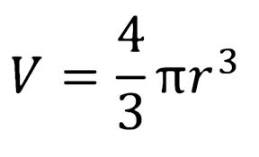
______________________________________________________________________________________________________________________________________________________________________________________________________________________________________________________________________________________________________
Bonus: Find the volume of Earth by using the following equation and the information from the images above (if you google the answer, it will be WRONG since google doesn’t have my numbers on this page!) . Round to the nearest Kilometer in exponential form. (10 points and your name in the hall of fame on my board for a full week)

