jName__________________________________________________Date_________________Period_______________
West, Central, and Southern Africa Pre European Colonization
Directions: Read the following information and then complete all questions and mapping activities.
Ancient Beginnings
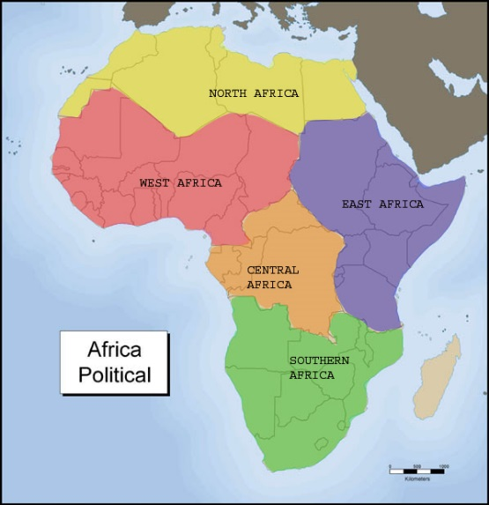
1. As the Sahara dried up around 6,000 BC people moved south into West Africa around the Niger River, just as they had moved eastward into the Nile Valley from the Middle East. West, Central, and Southern Africa included savannahs, areas with flat grassy plains and rainforests. The rainforests of west and central Africa did not support much farming, so these people’s lives were vastly different than those that settled in the Nile River Valley, where agriculture was a lifeline. Due to this difference in vegetation, people often made their homes in the savannahs, which were mostly covered in short grasses and small shrubs. Over time, these savannahs became more populated and families units began creating new homes and cultural groups.
2. Once people created lasting settlements, they brought in herding animals, like cows and goats, to use as a food source. Desertification usually spreads due to long term climate changes, however, since this area was not a natural home to these animals, the soil and grasses thinned out quickly. As a result, people had to constantly keep their animals moving; herding them from one area to another prompting more desertification. In other areas people practiced slash and burn farming, a very early technique to clear out fields for crops or animals. Again because the native plants were removed, the soil was thinned and desertification occurred. These types of farming methods have been in use in Africa since 4000B.C.
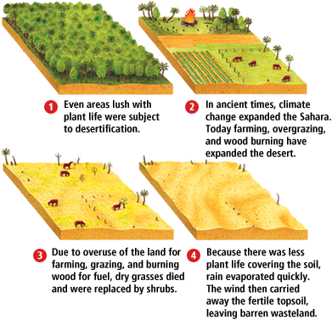
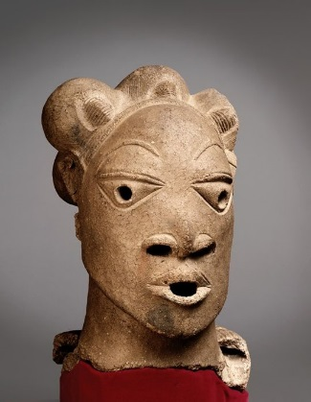
3. Like other ancient peoples, most Africans believed in more than one god, though they usually believed in one creator god (greater than the others). Most Africans also used nature to explain different aspects of daily life. Western, Central, and Southern Africans believe that spirits were presented in and through animals, plants, or natural forces. This belief system, where everything can possess a soul is known as Animism. Each community or group of people have different gods, spirits, and beliefs due to different events in their own lives. Most of these early societies did not have written languages, but preserved their history by telling stories to younger generations. Griots (gree-OHZ) keep the stories alive while maintaining heritage and cultures. Now that written languages are found in almost all societies around the world, story tellers still maintain a role in the societies by ensuring that their traditional ways are not forgotten or lost.
The Nok Culture
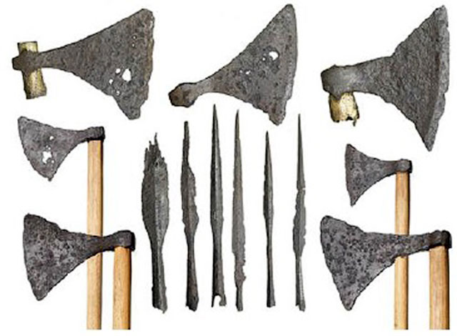
4. The early history of African societies is not always clear, as most societies used materials that decayed like plant fibers. Due to this, few artifacts have survived. Much of central African and southern African information has been pieced together due to the lack of findings. However, in recent years archeologists have found evidence of at least one cultural group that used iron and clay. In the area between the Benue and Niger Rivers- an area about 300 miles- scientists have found small clay statues and waste products from ironmaking, charcoal, and iron smelting furnaces. Archeologists were surprised to find that iron had been produced in this area before 500BC. Due to previous evidence, it was originally thought that iron making was done only in the eastern parts of Africa due to trade with the orient and later Middle East. One early West African people who produced iron were called the Nok. They lived in modern day Nigeria, but did not follow the same traditional mays of iron making in other parts of the world. Thus meaning, they invented their own means and methods and did not borrow or learn from other societies. These people were the first in western Africa to make and use iron. To produce iron the Nok mined iron ore and then smelted it. Ironsmiths worked in iron into tools and weapons. Some of these items made their way into trade routes across West Africa.
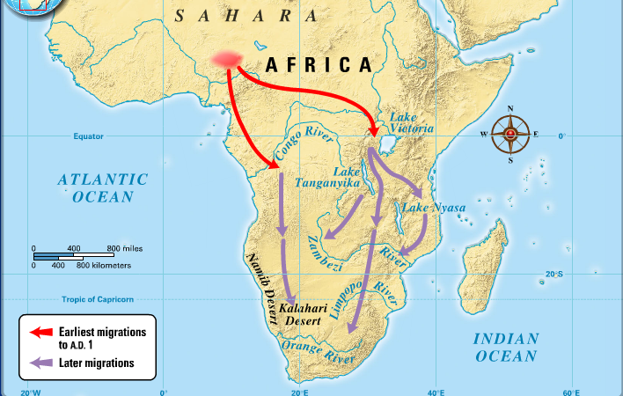
Bantu Migration
5. The Bantu people lived in the same areas as the Nok. The Bantu spread across Africa in what was one of the greatest movements in history. They slowly moved south and east along a frontier, opening up new lands to farming and herding. They also brought iron making into new areas south of Nigeria. The Bantus were not one people, but many groups of people who spoke a parent language of Bantu. ‘Bantu’ means ‘the people’ and they had similar cultures. The Bantu migration was a slow process that took thousands of years (nearly 3,000 thousand). During this time the Bantus settled in various areas, including the Congo Rainforest, along major river systems, and on the west coast and into interior farmlands. These people adapted new ways of life with new farming trade systems. In addition, they kept their ironmaking systems, which set them apart from other groups of peoples in the same areas. Iron would help ensure that the Bantus maintained a strong presence. Due to their strength, the Bantu often misplaced other peoples, pushing them out as they moved in, especially hunter gathering communities of Central Africa. As they moved they took on new cultural traits while sharing some of theirs with others. The Bantus are responsible for much of the cultural convergence within in the continent.
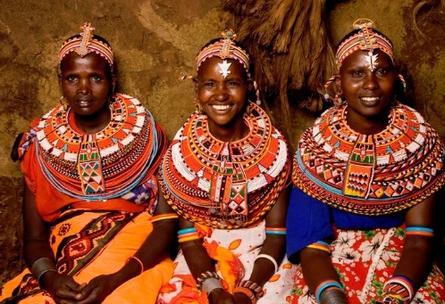
6. Africa’s history is rich in native culture. Today, Africa has cultural influences from nearly all parts of the world. Africa has shared culture from being part of early Middle Eastern trade routes, the Atlantic Slave Trade, and European colonization to name a few. Today Africa is a diverse continent, with over 1,500 spoken languages and 54 countries. As Africa modernizes we will see how the culture will continue to be influenced by various peoples.
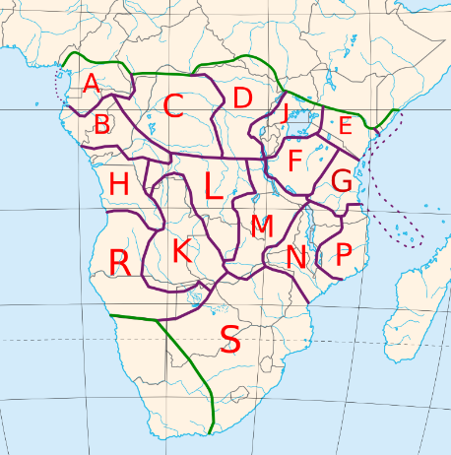

Name__________________________________________________Date_________________Period_______________
West, Central, and Southern Africa Pre European Colonization
Directions: Using the reading over Africa pre colonization, answer the following questions in complete sentences. ½ credit reduction due to incomplete sentences.
1. How were the environments of early African settlements different from those of the Nile River Valley?

2. Explain what desertification is and how it affected the continent of Africa.

3. Create a title for paragraph 3 and summarize it below.

4. Why did early civilizations use animism in their daily life?

5. How was it possible to have lasting artifacts from the Nile River Valley but not from various areas that the Nok settled?

6. Why were archeologists surprised to find that the Nok worked with iron in ancient times?

7. Why was the Bantu migration a slow process?

8. How are the Bantu responsible for cultural convergence across the African continent?

9. During more modern times (1800’s) Africa is colonized by European empires. Why is it culturally important to understand what Africa was like before white Europeans arrived to the continent?

10. Predict how the African continent would change with the arrival of European settlements both through human and physical geography.

