Name: ________________________________Date_________Period__________IS# 6.3

Chechnya and Crimea; Russian Territorial Claims

Background: Following the dissolution (break up) of the Soviet Union in 1991, Armenia, Azerbaijan, and Georgia became independent nations. The Caucasus region has become the setting for various territorial disputes since the collapse of the Soviet Union, especially since groups like Chechnya did not become independent nations.
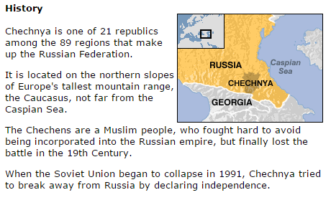
Where is Chechnya?

What country is Chechnya a part of?

Does it seem like they want to be? Why?

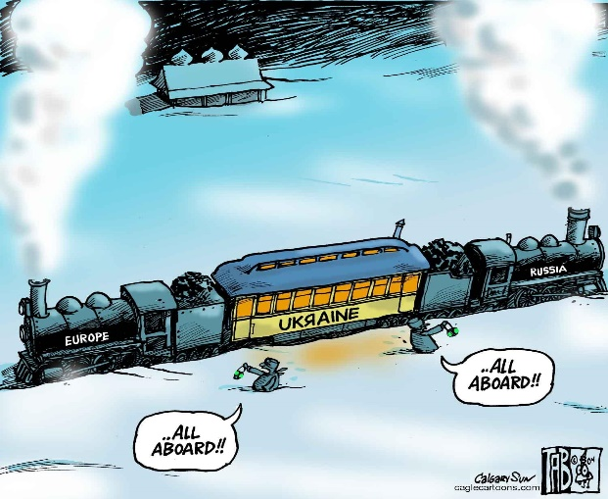

Look at the political cartoon to the left for 1 minute. Then, predict what current issues Ukraine may be dealing with today and why.
Discussion:

- Should regions that have internal support and similar cultural and ethnic characteristics as well as a desire to self-govern have the right to create their own internationally recognized territory?

- What arguments could you pose to claim that places like Chechnya should not be given their independence?

Political Geography –
Crimea | Chechnya
- Highly strategic location on the Black Sea -__________________________  - Major _____________reserves and pipelines  - Allows Russia to further develop naval ________and _____________from Eastern Europe or Turkey, via Black Se | - Strategic location on _______side ____ ________________mountains.  - Region is critical (historically) to _______ ___________by any West Asian power.  - North Caucasus is also a __________ ______________ countries in South Caucasus such as Georgia and Armenia.
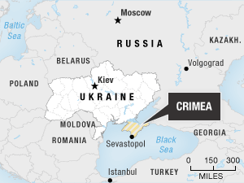
Crimea Video Questions
1. Why were people protesting in Ukraine?

2. What happened in the Crimean government? How?

3. What did Russia claim they wouldn’t do?

4. What referendum (vote) took place? What was the international opinion?

5. What does the Crimean Parliament vote to do? What is the USA response?

6. What is the outcome of this situation?

Human Geography
Crimea | Chechnya
- Eastern Ukraine has a heavy percentage of ___________________ and Ethnic Russians  - This has allowed Russia to _____________________ disputed ___________over secession in areas like Crimea (March 16th, 2014)  - ____________voted to _____________the region 2 days later, against the will of many people. | - Chechnya has attempted to gain __________________twice since the fall of the____________________.  - The region is majority _________________- unlike Russia.  - The people have a different ___________ and speak ___________________as well.  - ____________________have fought the Russian military and also carried out terror attacks against civilians in an attempt to ________________________  __________________.

Chechnya Video Questions
1. How has physical geography affected regions like Chechnya?

2. How did people group themselves within the Caucus Regions?

3. What does a nationalist or Separatist want within Chechnya?

