Name: | Examples
Types of Maps:  Physical | Title:  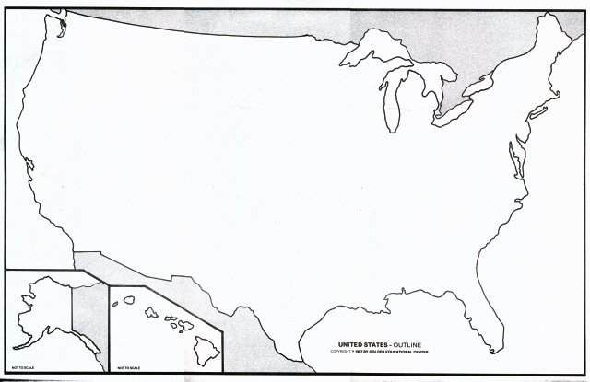
Political | Title:  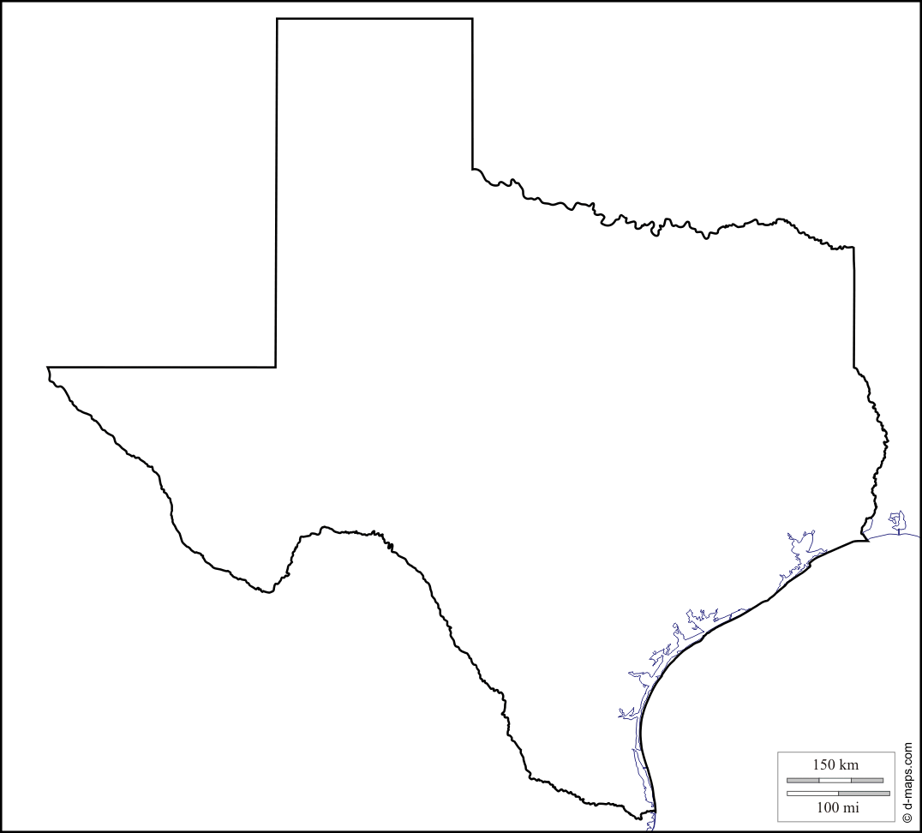
Thematic | Title:
Below answer the following questions by finding the correct information and describing the type of map.
1. What is the name of the highest point in North America?
Type of Map:___________________________________ Answer:____________________________________________________
2. What major bodies of water divide Canada and the United States?
Type of Map:___________________________________ Answer:____________________________________________________
3. What are the National Capitals of both Canada and the United States?
Type of Map:___________________________________ Answer:________________________,____________________________
4. Name the Capital for each state that begins with the letter ‘A’.
Type of Map: ____________________________
A.
B.
C.
D.
5. Which area of North America has the highest population density?
Type of Map:___________________________________ Answer:____________________________________________________
6. What vegetation is most common in Canada and the United States?
Type of Map:___________________________________ Answer:____________________________________________________

