Name_________________________________________________________Date_______________________Period_____________________Due____________________
Governments of Europe

Directions: Each of the boxes below represent one type of government. Color the boxes in accordance with the Key below, until all boxes are colored. There may not be an even number of boxes per government.

Monarchy- Purple Democracy- Green Dictatorship-Yellow
Theocracy- Red Communism-Blue Totalitarianism-Orange
Power is gained by taking over or seizing control | Only Parties that are supported by government are legal | John F. Kennedy | Oldest form of government in the world | Queen Elizabeth
Vatican City | People have no say in economic activities. | Voting power can elect or remove officials from office | United Kingdom | Kim Jung Un  North Korea
Leadership is passed down by Birth Right | Power was given by a Divine Right. | Adolf Hitler From Nazi Germany | Josef Stalin  Soviet Union | Only certain religions, may participate in government
Citizens have very little rights and freedoms. | Government controls all aspects of life with no room for negotiation | Home to the Pope, and the Roman Catholic Church | Church beliefs and morals rule government. | Citizens are guaranteed certain unalienable rights
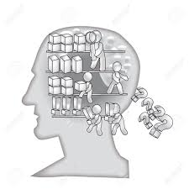 |  | 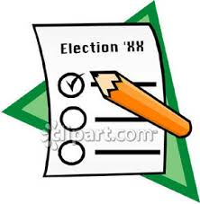 | 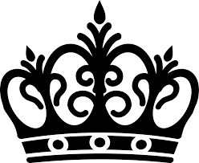 | 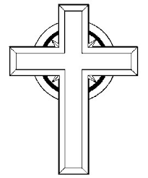

Name_________________________________________________________Date_______________________Period_____________________Due____________________
Governments of Europe

Directions: Each of the boxes below represent one type of government. Color the boxes in accordance with the Key below, until all boxes are colored. There may not be an even number of boxes per government. Don’t forget to color code the images below!

Monarchy- Purple Democracy- Green Dictatorship-Yellow

Theocracy- Red Communism- Blue Totalitarianism- Orange
Power is gained by taking over or seizing control | Only Parties that are supported by government are legal | John F. Kennedy | Oldest form of government in the world | Queen Elizabeth
Vatican City | People have no say in economic activities. | Voting power can elect or remove officials from office | United Kingdom | Kim Jung Un  North Korea
Leadership is passed down by Birth Right | Power was given by a Divine Right. | Adolf Hitler From Nazi Germany | Josef Stalin  Soviet Union | Only certain religions, may participate in government
Citizens have very little rights and freedoms. | Government controls all aspects of life with no room for negotiation | Home to the Pope, and the Roman Catholic Church | Church beliefs and morals rule government. | Citizens are guaranteed certain unalienable rights

