Name: _________________________Date: _______________Period: _________ISN#8.3
Safari Tour
Directions: Hold on to your hats and watch for hippos and crocs. We will be touring Africa today to see the sights and geography of the continent. Make sure you take notes, as your Tour Guide is only going to tell you once! Bring your Binoculars, hiking boots, and don’t be scared of a little rain. Make sure you eat before we leave, as you need your energy, and PLEASE DON’T FEED THE ANIMALS.
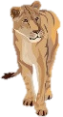
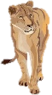
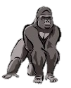
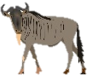
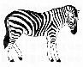
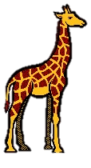
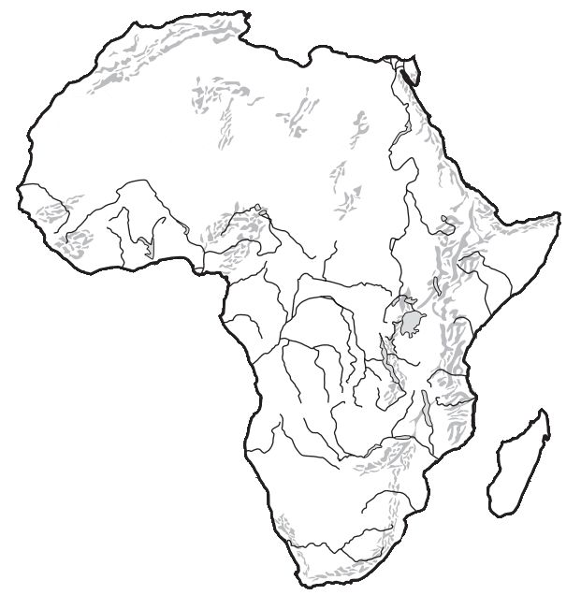

- Sahel/Sahara (use Dots for the Sahel)
  - Sahel: ______________________________________________________________
  - Great Green Wall was created to stop ______________________________________
  - Description: __________________________________________________________
- Savanna (use lines for the savanna)
  - Description: __________________________________________________________
  - Name some animals that are native to the grasslands: _____________________________
___________________________________________________________________
- Rivers/Rainforest (use stars for the Rainforest)
  - Description: __________________________________________________________
  - Would these rivers be good for transporting goods or people? ________ Why? _________
___________________________________________________________________
- Eastern Highlands (use dashes for the Eastern Highlands)
  - Plateau: _____________________________________________________________
  - Description: __________________________________________________________
- Great Rift Valley (use x’s for the Great Rift Valley)
  - Rift valley: ___________________________________________________________
  - Description: __________________________________________________________
Which area of Africa would you most like to visit? Why?
______________________________________________________________________________________________________________________________________________________________________________________________________________________________________________________________________________________________________________________________________________________________________________________________________
Please feel free to tip your Safari Tour Guide….

