The Nile River Valley

Egypt is probably the best known of all the ancient River Valley civilizations. The Egypt of ancient times probably looked very much like the Egypt of today. Egypt is a large country but most of it is a sandy desert. Here and there is an oasis- a place in the desert where there is irrigation or an underground spring. But in this vast country, crops can be grown only in one long, narrow strip of land; the valley of the Nile river. The Nile flows from the mountains of East and Central Africa to the Mediterranean Sea.
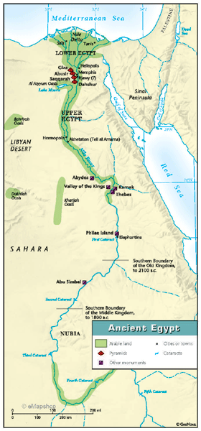
The Nile River is such a crucial feature of Egypt that is been said by historians that all of Egypt is the ‘gift of the Nile’. Each year, from June to October, rain and melting snow from the mountains at the source of the Nile cause the river to overflow and spread out over the flatlands of the southern Nile Valley. The flood reaches its highest level at the beginning of September. As the flood recedes, the gentle slope of the land allows the water to drain off gradually. A layer of silt, or fertile soil, which the river has carried along in it's flood is left behind.
Today dams, or cataracts, control the rivers flooding but in ancient times Egyptian farmers plan their work according to the flood. They knew when it would come every year. They harvested their crops before it began, then waited for the water to soak the hard dry ground before it drained off and left it's new fertile soil. There is little or no rainfall in Egypt, so the flood moisture is sufficient for only one planting. Early in their history however, the Egyptians learned to irrigate the land by using water from the Nile and caring it to the fields in short canals. They could plant and harvest two or even three crops each year. Each year the valley receives a fresh layer of soil. Because of this, the land of the Nile Valley has been farmed continuously for more than 6,000 years.
The Nile Valley has other natural resources besides the amazingly fertile soil. For example, it has a sunny climate that is free of frost all year and well suited to farming. The Nile Valley also has deposits of clay, granite, sandstone, and limestone. These minerals are used for building. The ancient Egyptians needed these materials, for there were few forests to furnish lumber.
Moreover, the Egyptians were able to build a great civilization along the Nile River because of the valleys location. Deserts and seas surround the Nile valley. These deserts and seas provided a natural barrier that defended Egypt from invasion for thousands of years. Because their land was well protected, the Egyptians did not need large armies. Instead, they used their wealth, their resources, and their skills to build a great civilization that lasted more than 3000 years.

1. Into what Sea does the Nile River empty?
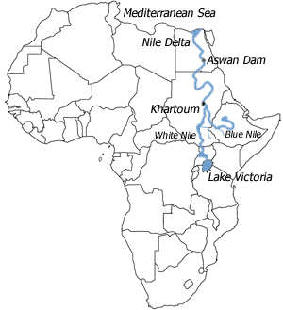
2. Does the Nile River flow northwards or southwards? How can you tell?

3. Which two headwaters join to form the Nile in Nubia?

4. Could Egypt have been an agricultural society without the Nile River? Why or why not?

5. What other natural advantage of the Nile Valley has that allowed Egypt to Flourish as a civilization?

1. Into what Sea does the Nile River empty?
2. Does the Nile River flow northwards or southwards? How can you tell?

3. Which two headwaters join to form the Nile in Nubia?

4. Could Egypt have been an agricultural society without the Nile River? Why or why not?

5. What other natural advantage of the Nile Valley has that allowed Egypt to Flourish as a civilization?

