*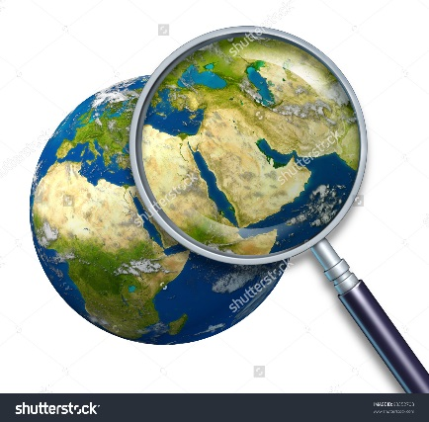*

*A nation is a group of people who share a common language, religion, culture, and common institutions. When a national group has a state or country of its own, its called a nation-state. Albania, Iceland, and Japan are examples of nation-states. Other nations, such as the Kurds of the Northeast, do not have their own country. They are considered a state-less nation.*

A Stateless Nation: The Kurds