Name___________________________________________________________Date_________________Period_______________
The Fertile Crescent: A Fertile Land

Mesopotamia, or “The Land between Two Rivers”, was part of a larger region called the Fertile Crescent. The Sumerians, the world's first civilization, settled and farmed the land between the Tigris and the Euphrates rivers. Although Mesopotamia had fertile soil, farming was not easy. The flooding of the rivers destroyed crops annually, and in the dry season plants wasted away due to long droughts. The farmers eventually developed methods that helped them store or reroute water to increase the amount of food they could grow all year long. In time, other societies and civilizations developed along the Tigris and Euphrates, becoming the first areas with permanent civilizations lasting to present day.
Although climates were not always ideal for living, the Fertile Cresent stretched from between the Tigris and Euphrates Rivers, to the Mediterranean Sea, and as far to the Sinai Peninsula, connection Asia to Africa. The Fertile Crescent holds importance for here were the first permanent civilizations and cultures created. Also, throughout much of the Middle East, dry hot climates are found, but the Fertile Crescent provides an oasis for farming and agriculture that is still important today for the people of this region.

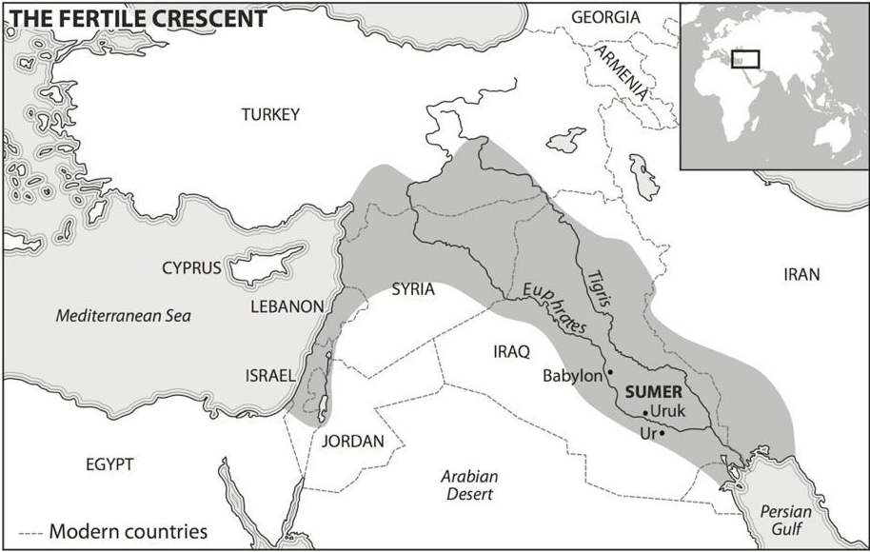
1. Between what three continents does the Fertile Crescent meet and join?
2. What are the names of the two rivers that make the area of Mesopotamia?
3. What large body of water is west of the Fertile Crescent?
4. Identify what the most important natural resource is and explain why it is so important.

5. Location-Name three early civilizations that were formed on the Euphrates River.
6. Human Environment Interaction- Why do you think civilizations had not lasted before advanced farming techniques?

7. Movement-As it states, the earliest and permanent civilizations were in the Fertile Crescent. In time, where do you think civilizations would also be created? Support your answer with the map above.

8. Critical Thinking-The earliest civilizations are found here. What other concepts or ideas do you also think were created or started in this part of the world?

