Name______________________________________________________________________________Date___________________Period______________
US Territories and Land Claims
Did You Know?__________________________________________________________________________________________ ______________________________________________________________________________________________________________________________________________________________________________________________________________
1. Puerto Rico  - _____________________________to the US (keeps a US presence in the__________________  - Helps Protect the __________________________  - They ___________their own ____________________  - _________Representative in ________________- but they don’t vote.  - ____________________for President  - Do ______________and _________Federal ________ | 2. Guam  - _________________________to the US (keeps a US presence in the __________________  - Needed Naval and Air force Base in the Pacific after ______________  - Today its our closest base to __________________  - Over ___________Active Military Personnel on the island with a population of only ______________people.  - They __________their own _______________________  - They _________________participate in US government  - They are ____________________(travel freely from US to Guam)
Puerto Rican Flag and Map  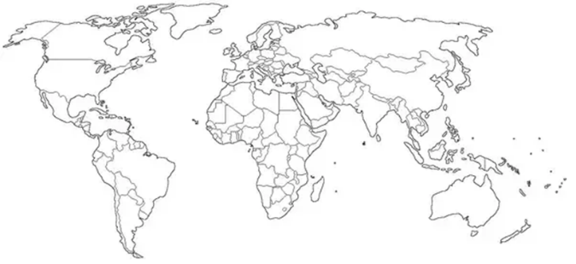 | Guam’s Flag and Map
3. American Samoa  - _____________________ to the US (keeps a US presence in the __________________--  - Highest percentage of _____________-people in any American land.  - Was ceded (________) by America in the early 1900’s.  - They ____________their own ________________  - They have representation in Congress, but ________ _____________on current issues.  - They are_______________________, but you can enlist in the Military and ___________________ | 4. US Virgin Islands  - Was strategically Importance during______________, and the 1960’s during the _______________________  - Today it’s a large _____________________, brining in Money!  - USA and England use the Virgin Islands to share control of the___________________________.  - Home to the __________Caribbean_______________.  - They have their own government and_____________.  - They are_____citizens, who can travel freely to the US.  - Can vote in primary elections, but _____for president.
American Samoa Flag and Map | US Virgin Island Flag and Map
5. Northern Mariana Islands  - Was strategically important to watch the growing _______________________ from the mid _________  - Today it is used as a military ___________________base for both _____________and_____________.  - Used in conjunction with __________ _____________ _____________________Forces.  - They are _______________who elect their own governor.  - They __________in US elections, but do have representation.  - US only granted citizenship in _____________to the people. | Northern Mariana Islands Flag and Map

