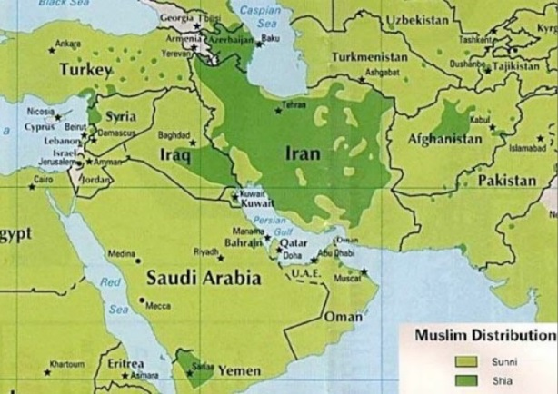

**Charges of Sunni Terrorism in Iran**

Jundallah (a pro-Sunni group)was designated as a Foreign Terrorist Organization on November 4, 2010. Since its inception in 2003, **Jundallah,** a violent extremist organization has engaged in numerous attacks resulting in the death and maiming of scores of Iranian civilians and government officials. Jundallah’s stated goals are to secure recognition of cultural, economic, and political rights from the government of Iran through non-violent and violent means. In October 2007, Amnesty International reported that Jundallah by its own admission, carried out gross abuses such as hostage-taking, the killing of hostages, and attacks against non-military targets.

**Charges of Sunni Mistreatment in Iran**

“Iran’s Sunni Muslims face widespread discrimination by Iranian authorities. Sunni leaders have reported abuses and restrictions on their religious practice, including detentions and abuse of Sunni clerics and bans on Sunni teachings and religious literature. Sunnis are not allowed to build mosques in large cities and have been banned from conducting separate prayers.

Attacks in Sunni-populated areas are not unusual. In May, one person was killed and two injured after police forces opened fire on protestors. They were protesting the recent arrests of local Sunni clerics. Last year, at least 12 people believed to be protestors were killed and several Sunni mosques have been destroyed or turned into parks.

**Sunnis in Iran**

Iran is a country dominated by **Shia Muslims.** With this dominance has come some conflict—and not all of it having to do purely with matters of deeply held religious faith. In many places, Sunnis and Shias have vied for political power and sought to advance their people’s interests at the expense of others.

After the Iranian Revolution, Islamic Law was reintroduced. Although the new government was a republic with elements of a parliamentary democracy, it was also a theocracy. Shia clerics have final approval of legislation, with the intention of ensuring compliance with Islamic law. Iran does permit and have religious minorities, which include a small population of **Sunni Muslims**. However, relations between the government and its Sunni minority have been complicated, and religious minorities are treated as **second-class citizens**.

*Within Islam there are two main branches—Sunni and Shia. The death of Muhammad led to the dispute over the succession of the leadership in Islam. The Shia insisted that the Muslim leader be a descendant of Muhammad. The Sunni believed the leader should be selected by the Islamic community on the basis of personal qualities and abilities. It is estimated that between 85 and 90 percent of all Muslims worldwide are Sunni.*

Sunni and Shia Conflict