Name______________________________________________________Date________________Period______________
Introduction to Human Geography Warm-Ups
Human Geography is how people interact with the earth. Human Geography can be based on economics (money), governments, environments, or culture to just name a few.
Image 1 Image 2
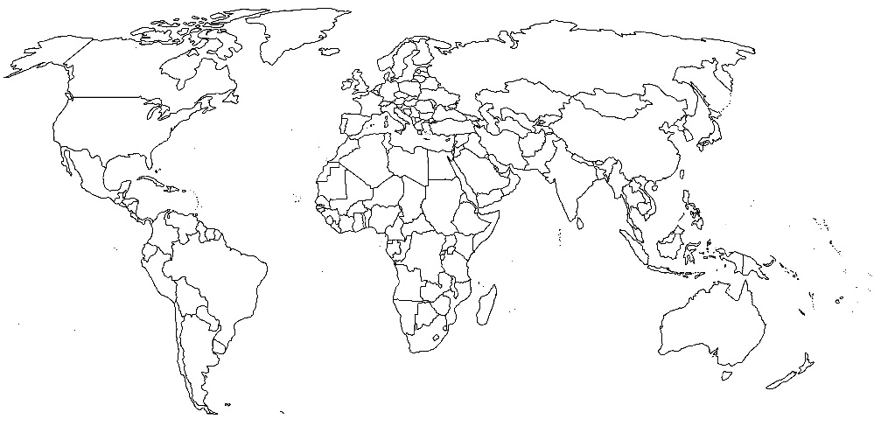

1. What is Image 1:__________________________________________________________________________________
2. What is Image 2:__________________________________________________________________________________
Spatial Reorganization (or spatial perspective) focuses on how individual places, people, or objects are related to one another across the surface of the earth from local to global scale.
3. After watching the video how are image 1 and 2 connected? Provide a minimum of 4 examples.
A.
B.
C.
D.
4. Color in all of the countries of the world involved in getting your coffee to you.
----------------------------------------------------------------------------------------------------------------------------------------------------------------
Closure
1. In your own words describe friction of distance and provide a real example from Texas or the United States.

2. How has spatial association been modified due to advancements in communication, trade, and technology?

3. How can birth and mortality rates shape spatial reorganization? Be specific in your response.

