Name_______________________________________Date_____________Period___________
TRTW: Settlement Patterns in the United States
Guiding Question: What is the most important factor when studying settlement patterns in the United States, both historically and in modern day?
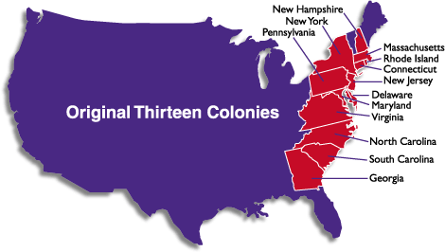
1. Early Colonies (1607-1763)
The settlement of the early colonies in the New World was just as much planned as it was unplanned. English settlers were looking for a new opportunity in life due to religious persecutions they were facing in Great Britain. The first set of colonists boarded their ships and set sail for the New World, hoping for plentiful land to farm and freedom of religion. These were some of the first Europeans to call American their permanent home. The first permanent group settled in Jamestown, Virginia. They desired a location south of the 40* line of latitude so that they could take advantage of farming for three seasons throughout the year. The exact location, Jamestown, was decided on due to its protection from the Chesapeake Bay and was built at the mouth of the James River. Early colonists knew that they would have to rely on navigable river systems to move crops, timber, and raw materials back to their mother country. Jamestown was also an ideal location due to its proximity to the Atlantic Ocean. Returning home to England, whether for resupplying the colony or in a state of emergency was possible for the colonists due to their access to the ocean. Virginia, although cold and snowy in the winter, provided a long summer for planting, plenty of fresh water for crops and animals, and water access for trade and safety. Little did these early colonists know that they would be the start of something much bigger…

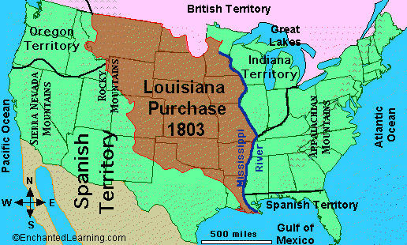
2. Louisiana Purchase (1802-1865)
The Louisiana Purchase was one of the greatest purchases that the United States has ever made and it wasn’t just the cost that was great. The Louisiana Purchase came at a time when the United States wanted to expand west, but it also knew that it was not in a place to fight for territorial acquisition. However, at the same time in history, the French leader Napoleon, was trying to unify his country and regain power to the newly established French Democracy. To help do this he decided to sell the territory so he wouldn’t have to worry about controlling and protecting it. Thomas Jefferson was sent to then congress to persuade its members to pay the 15 million dollar price tag, equating to roughly 4 cents an acre for the land. He did this by explaining that the United States needed a North South navigable river to resupply the west, and the Mississippi was the only option. He also used the talking point of having the French port of New Orleans, as this was a key location if any other empire ever wanted to invade. He also explained that the territory held millions of acres ideal for farming, crops and agriculture. Jefferson also highlighted the fact that Lewis and Clark were already exploring the territory and there were reports of other navigable rivers, maybe even to the Pacific Ocean. Although in the end the Missouri River did not connect to the Pacific, it was a navigable river that did not freeze over and would later become a lifeline to those moving west to the modern states of Oregon and Washington. The Louisiana Purchase also geographically opened American minds and eyes to the idea of connecting the country from the Atlantic Ocean to the Pacific Ocean, in an era known as Manifest Destiny.

3. Gold Rush/Oregon Trail (1850-1910)
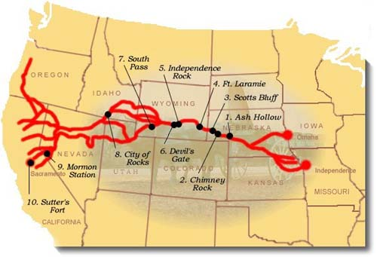
After the establishment of our nation, many Americans began to look west towards California and Oregon. These adventurous American’s were hoping for religious freedom and cheap land. Once gold was discovered in 1849, a mass migration of people to the west was in motion. Both the Gold Rush and the Oregon Trail became synonymous in history with danger, death, and lost hopes. These two trails are considered to be the hardest two American transportation routes due to the fact that the climates and terrain were so harsh. Once technology advanced and caravans of wagons were used on trails, trails cut through land and did not always follow water routes. Although this opened up many new places, it created a new set of problems. Traveling became much more dangerous and took almost three times as long. Settlers came into contact with more natives and faced setbacks, causing them to travel during the cold snowy months. Even with these new dangers, the Oregon Trail and the Gold Rush migration were still done by nearly a million people in the first year alone. These people started out in St. Louis, the Gateway City, and traveled West through the Great Plains, and over the Rocky Mountains. From the Rocky Mountains they either continued to the Pacific North West for Oregon, or turned south and crossed the Sierra Nevada Mountains for Gold in California. The rocky terrain and freezing winters caused the Oxen to travel at 2 miles per hour. Most of the people who made the journey on the Oregon Trail ended up walking next to their wagons, and often died due to infections from their feet. If you were lucky enough to survive The Oregon Trail and the Gold Rush Migration, you may have been able to settle new land or find gold, but most met their fate on the long hard journey.

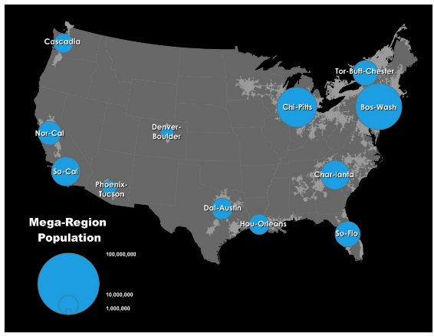
4. Megalopolis and Urbanization (Modern Day)
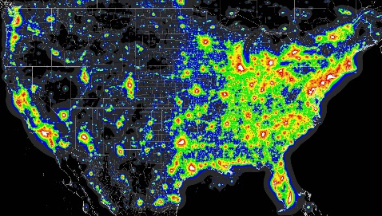
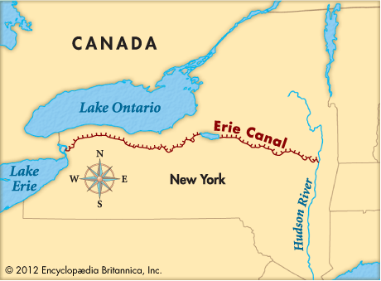
A megalopolis is a large urban area comprised of a continuous cities or urban centers. In the United States, one megalopolis encompasses the District of Columbia and parts of 11 other states. This area has become known as BoWash: Meaning Boston to Washington. To be defined as a megalopolis you must be able to travel through different cities and/or states, without ever leaving a large urban and populated area. Meaning if you travel from Washington D.C. to New York City, the names of the roads and signs may change to reflect new states, but you would never feel that you left the city. This type of urbanization develops due to the fact that many large cities are near popular resources, whether they be jobs or the availability of work, natural resources like water or steel, or have geographic importance. For the megalopolises in the United States, we see a combination of all of these items. Another megalopolis is the area around the Great Lakes. This area extends from Chicago, Illinois, to Detroit, Michigan, to Cleveland, Ohio. This area became heavily industrialized during the second American Industrial Revolution in the earth 1900’s. This area would not have developed into what it is today had the Erie Canal not be created. The Erie Canal allows for water transportation from the Great Lakes all the way to the Atlantic Ocean. The Erie Canal is also part of two major Megalopolises, as one end is part of the Great Lakes System and the other end is New York City. Historically, megalopolises around the world are located in places that, if not on the water, are tied to water. Only in the super modern era, due to extreme technological advancements, do we see megalopolises being formed away from water.

Directions: With your partner- answer the following sentence starters in complete sentences.

1. Jamestown was able to survive and thrive due to _____________________________ because _________________________________________________________________________________________________.

2. The Louisiana Purchase benefited the United States by____________________________________________________ __________________________________________________________________________________________________.

3. The Oregon and Gold Rush Trails geography was different from previous routes, causing settlers ____________________________________________________________________________________________________________________________________________________________________________________________________.

4. Historically, urbanization has been centered around ____________________________________________, causing __________________________________________________________________________________________________.

5. The most important element when discussing settlement patterns in the United States is ____________________________ because _____________________________________________________________.

