Name___________________________________________Date_____________Period_____________ISN#5.7
European Settlement Patterns and Migration
Directions: Read the following information about settlement patterns and migrations of Europe and then answer the questions that follow. Some of the questions are critical thinking.
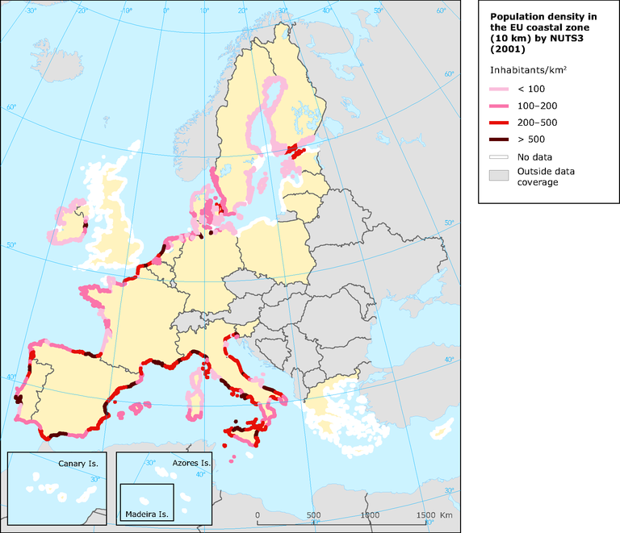
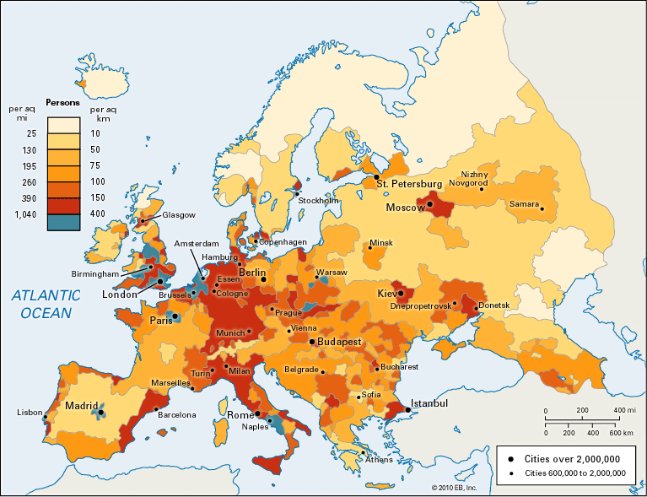
Europe has been the heart of western civilization for thousands of years. Europe was home to the Ancient Romans, Greeks, and many Kingdoms far and wide. Although Europe’s history is often intertwined and hard to follow, one true consistency is that Europe has been a pull for various people and cultures. In modern day Europe we see an influx of migrants and people centered around traditional cities. Europe’s modern population is centered around resource rich areas, like those of Great Britain, home to the original Industrial Revolution. The Population Density of a country or continent is determined by the number of people who live within an area. The more people who live in an area are represented by darker shades on the map. The population distribution of an area is where people live within a country or around the world. The availability of resources and proximity to the Middle East and Asia are just part of the reasons as to why Europe has a high population density and distribution. In addition, much of the European population is found within urban areas. These areas see high standards of living and can be very costly.
Coastal Densities of Europe
Population Density Map of Europe
Europe is a peninsula of peninsulas! Compared to its relative small size, Europe has a large amount of accesibly coast lines. These coast lines provide ample opportunity for trade and shipping, increasing the overall economic stability of the continent. The Mediterranean coast receives warm weather and favorable climates, increasing their overall populations. This also directly correlates to their economic well being.
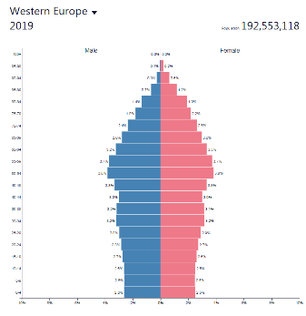
Due to their overall development and standards of living, Western Europe is highly urbanized. The majority of Europe’s population lives in large cities. These cities have longe provided jobs and economic opportunities for millions of people across Europe. Due to the high concentration of resources, the United Kingdom was home to the first Industrial Revolution. The pie chart below shows the ratio of urban and rural dwelers in the United Kingdom, though much of Europe follows the same trend. Because so many people call the cities home, the cost of living of Europe is very high. With limited space to build and live, the cost of basic apartments, housing, and office buildings is at a premium. With these high costs, most European nations are seeing a sharp decline in populations. The Population pyramid is a current representation of their stage of population growth. Due to the decline of births, some nations are earging their own populations to have more children to prevent an extreme aging population. If the population does not increase, there will not be enough people to fulfill current jobs, bringing down the economy of Europe.
Name___________________________________________Date_____________Period_____________ISN#5.7
European Settlement Patterns and Migration Pre-AP
1. Using regional terminology, in which area of Europe do we see the highest densities of people?

2. Which peninsula has the lowest population density?

3. Which two major Scandinavian cities have higher population densities than the rest of the region?

4. What causes a change in population density between Milan, Italy and Munich, Germany?

5. Why is it important to understand population distribution of an area and not just population density?

6. Where are many of Europe’s largest cities located?

7. What causes Mediterranean coast lines to be more desired than the Baltic coast lines?

8. Explain how the Industrial Revolution changed settlement patterns in the United Kingdom.

9. Why is the cost of land and space so expensive in Europe?

10. What stage of pyramid growth is most of Europe in today? How can you tell this?

11. What economic concerns may Europe face in the future if the growth rate remains the same?

12. Which country, Spain or France, has a more diverse population distribution? How do you know this?

13. Name two major cities of Europe that are not found within 100 miles of a coast line.

14. Which country, Germany, Poland, or the United Kingdom has the densest populations based on the map?

Name___________________________________________Date_____________Period_____________ISN#5.7
European Settlement Patterns and Migration On Level
1._____ In which area of Europe do we see the highest densities of people throughout Europe?
A. Northern B. Central C. Southern D. Western

2. ______Which peninsula has the lowest population density?
A. Iberian B. Balkan C. Apennines D. Scandinavian

3._____ Which Scandinavian city has a higher population density than the rest of the region?
A. Copenhagen B. Denmark C. Milan D. Paris

4._____ What causes a change in population density between Milan, Italy and Munich, Germany?
A. Northern European Plain B. Alps Mountains C. Black Sea D. Danube River

5._____ Why is it important to understand population distribution of an area and not just population density?
A. To see where people live throughout a country B. To see how many people live in an area.
C. To know the total population of an area D. To have the largest population in Europe

6._____ Where are many of Europe’s largest cities located?
A. Interior parts of the country B. On top of Mountains
C. Near coasts and waterways D. Along the Prime Meridian

7.______ What causes Mediterranean coast lines to be more desired than the Baltic coast lines?
A. Larger Size B. The Culture C. Distance from Berlin D. Warm Climate

8.______ Explain how the Industrial Revolution changed settlement patterns in the United Kingdom.
A. People moved to cities B. People moved back to farms
C. The overall population decreased D. the population did not change

9.______ Why is the cost of land and space so expensive in Europe?
A. Readily available land B. Not enough people to buy the land
C. Many people in a small area D. Queen increases the price

10.______ What stage of pyramid growth is most of Europe in today?
A. Rapid Growth B. Slow Growth C. Zero Growth D. Negative Growth

11._______ What economic concerns may Europe face in the future if the growth rate remains the same?
A. Young Population B. Elderly Population C. Overpopulation D. Sparse Population

