Name_____________________________________Period_____________Date________ISN#____________

The Scramble for Africa
Warm-Up: Using context clues and prior knowledge, answer questions 1-3.
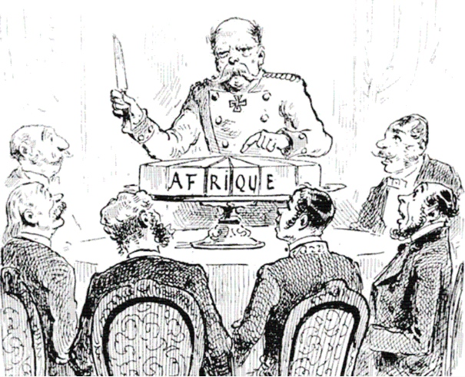
1. Who do you think is in this picture (how do you know)?

2. What are they cutting?

3. Create a caption for the political cartoon to the left.

-----------------------------------------------------------------------------------------------------------------------------
Summarize Why Europe was interested in Africa?  (Section A) | Summarize how colonial leaders ‘scrambled’ Africa.  (Section B) | Summarize how colonial legacies left lasting conflict within Africa. (Section C)

A. Background
1. Africa first peaked _______________ and ____________ interests during the slave trade in the 1700’s.
2. Not much (if anything) was known about _________________ Africa.
3. As ____________ territories became ‘set’, Kings and Queens wanted to ______________their __________________.
4. Africa was the obvious choice, as it was ________and held many ________________________
~Europeans did ____________consider Native Africans as____________, so they saw ______________________in taking over their territory
B. Early Colonial Rule
1. In 1884 the major European Powers met to discuss how they would __________________
2. This became known as the______________________________________.
~ African Natives were __________________to the conference
3. The major powers, ____________, ___________, _____________, __________, ___________, and ________________divided the territory to best serve their needs.
~These European Boundaries often crossed __________________and ___________________ boundaries, leading to internal conflict
4. As _____________conflicts increased amongst native groups, the European powers were able to _______________their _____________and power, taking advantage of_________________________.
5. By____________, all of Africa was controlled by European leaders, except _____________.
6. Liberia had been _________________by the _______________________during the Berlin Conference.
~Once slaves were __________in the United States, they had the _____________to move back
to _______________and be given _____________to live off
C. End of Colonial Rule
1. Colonial Rule in Africa is_______________________.
2. By 1950- almost all areas were actively seeking _______________________from European Powers.
~Some _________________, others through ___________________
3. The Independence movement brought to light many _____________________________in Africa.
~_____________________ were built around ______________________ Not African
~Borders were in __________________(Traditional vs European)
~______________________________ amongst Natives over who would gain control
~_______________ occurred due to differences in________________, __________________ , and ____________________
4. ___________________became known as the ‘_____________________________________’, as most countries were granted their freedom.
~Once a few European powers left, ______________________and _______________went down
5. Today, Sudan, ___________________, Ethiopia, and __________________are still fighting battles due to territory disputes created by_____________________________.
6. The legacy of the colonial rule on Africa has a_________________________.
~________________________ are French and English (due to colonial rule)
~Many names and places have ___________________________
7. Economies of_______________, the_____________________, and _______________________ nations are__________________________, as Africa is a main exporter of Uranium, ________________, Coal, and________________________, which are sold mostly to their old colonial empires, because they have ______________________________to these countries.

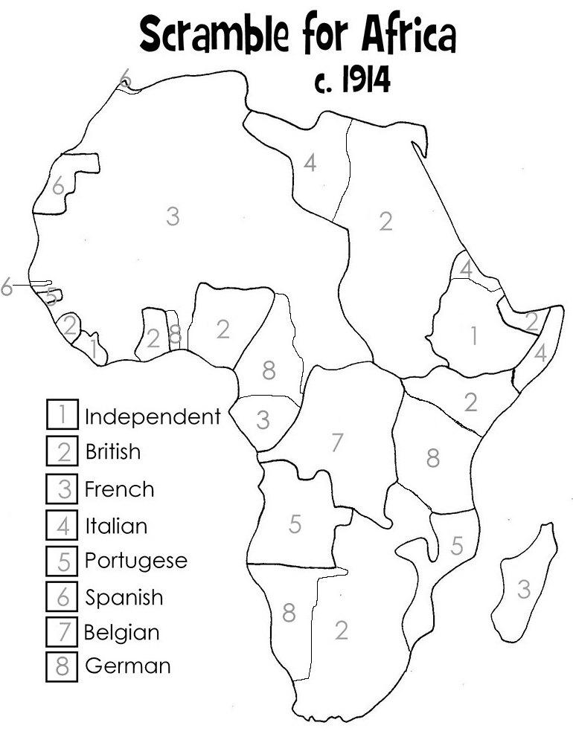
1. Color the Map of Colonial Control of Africa.
2. Compare the Colonial Map to a modern day map of Africa.
3. Write down a minimum of two similarities and two differences.

Name:__________________________________ Period__________Exit Ticket: The Scramble for Africa

Name:__________________________________ Period__________Exit Ticket: The Scramble for Africa
1. Color the Map of Colonial Control of Africa.
2. Compare the Colonial Map to a modern day map of Africa.
3. Write down a minimum of two similarities and two differences.

