Name_________________________________________________Date_____________Period_____________
Russian Core Interactive Notes
A. Physical Geography
1. Label the following features on the map below. Use page 262 in text to locate them. Questions marked with a © will need critical thinking, as the answers will not be found in the text.
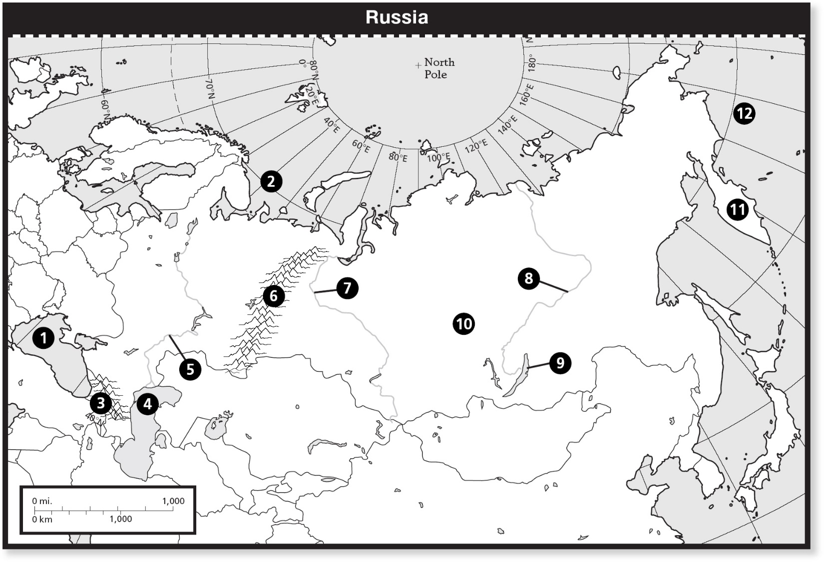
1._________________________________ 7.__________________________________
2._________________________________ 8.__________________________________
3.__________________________________ 9.__________________________________
4.__________________________________ 10._________________________________
5.__________________________________ 11._________________________________
6.___________________________________ 12._________________________________

13. What physical feature divides the European and Asian continents? _______________________________
©14. Other than a physical reason, why would the Ural Mountains be used as a barrier? __________________ ____________________________________________________________________________________________________________________________________________________________________________________
15. About how wide (west to east) is the country or Russia? _________________________________________________
16. What importance does the Volga River have on the population, industry and agriculture of Russia? (pg.360)
Agriculture:

Industry:

Population:

B. History and Government (pg. 363)
1. ©Why would many Russian leaders need a policy of Russification? _________________________________ ____________________________________________________________________________________________________________________________________________________________________________________

2. How did Russia become the USSR (Union of Soviet Socialist Republic)?
A. Russia was taken over during the first World War.
B. The economy improved and people wanted to become a better nation.
C. During a downturn in economy, the Czar was murdered and the country became the USSR.
D. Communist Party invaded and forced Russia to change their government systems.

3. Vocabulary
Word | Meaning or Definition | Illustration
Satellites
Perestroika
Glasnost

4. © Examine the timeline on 363-364 and describe the shift that occurs between the years 1939 and 1941.
______________________________________________________________________________________________________________________________________________________________________________________________________________________________________________________________________________

5. Below is an image of the former Soviet Union. Color the countries by the key below.
Russia – Red Baltic States- Green Breadbasket- Yellow Caucuses-Purple Central-Brown
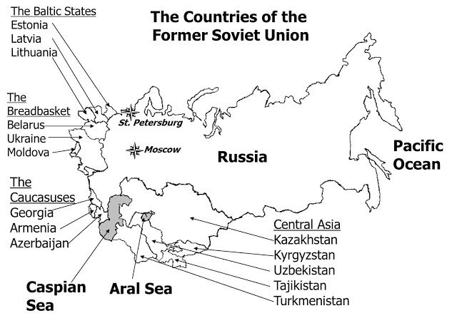
6. From viewing the map above, what happened to the size and territory that was once the USSR? ____________________________________________________________________________________________________________________________________________________________________________________
__________________________________________________________________________________________

7. ©Culturally, why were so many different countries carved out of the former USSR?
____________________________________________________________________________________________________________________________________________________________________________________
C. Population Patterns pg. 366
1. Create the population pie charts below to represent the following ethnic compositions of Russia Core Countries. Make sure to label them on the line below.

_____________________ ________________________ _______________________

2. ©After viewing the pie charts above, why do you think various minority groups have turned to violence or terrorism in certain areas? ______________________________________________________________________________________________________________________________________________________________________________________________________________________________________________________________________________

3. Read the paragraphs about population patterns and create a population pyramid to represent the current state of Russia today. Don’t forget to title and add a Key to your population pyramid.

D. Economic Activities (pg. 367)
1. In a command economy the government owns _________, _____________, _____________, _____________, and ___________________________________________.

2. Who decides what, when, and how much of an item is produced? ____________________________

3. What were some of the problems faced with the command (communist) system during the Soviet Union?
a.
b.
c.
d.

4. In 1998, the Russian economy started to improve. Why?__________________________________________ ____________________________________________________________________________________________________________________________________________________________________________________

E. Arctic Oil Frontiers (pg. 370)
1. Describe Russian Arctic oil territories by size.

2. How can Natural resources help your economy?

Complete the diagram below-
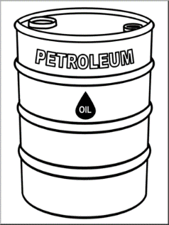

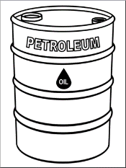

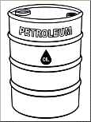
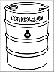

__________________ ____________ _________ ________

3. What do the barrels above represents?________________________________________________

4. ©How has oil production helped Russia to become an influential country around the world?____________ ____________________________________________________________________________________________________________________________________________________________________________________

F. Environmental Impacts (pg.374-375)
1. What was the Chernobyl event? _____________________________________________________________ ____________________________________________________________________________________________________________________________________________________________________________________

Complete the map below over the Spread of Radioactivity Materials from Chernobyl

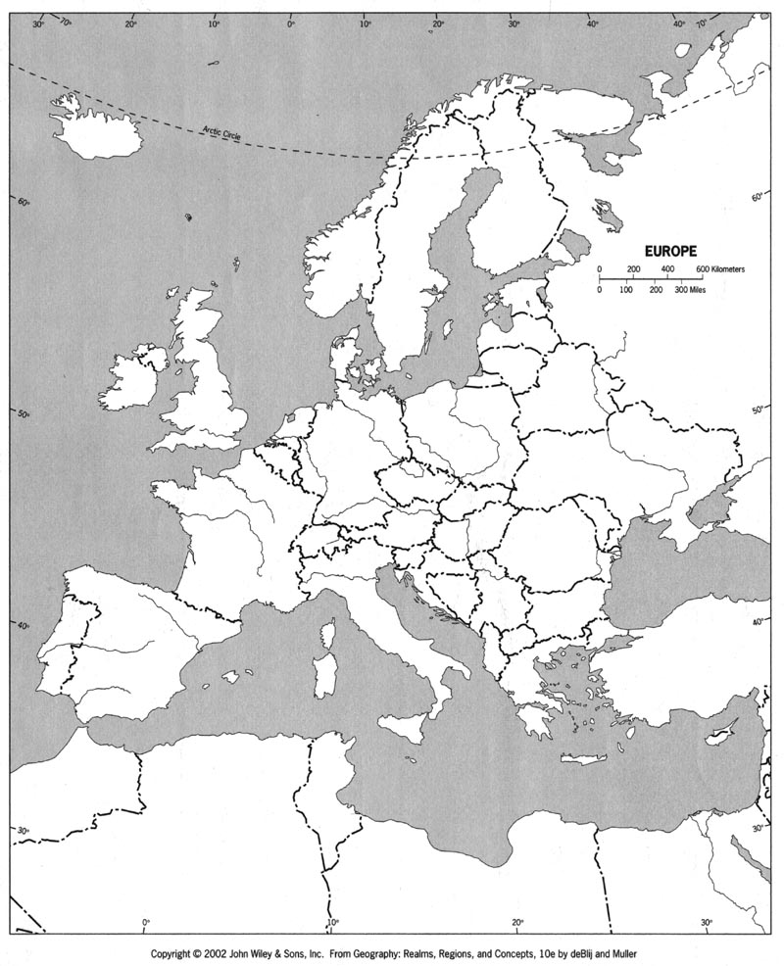
1. Place a Bold Red X at the site of the Chernobyl disaster.
2. Identify the following countries by placing the first letter of their name on the map.
- Russia
- Ukraine
- Belarus
- Austria
- Finland
- Sweden
- Norway
3. Color in all areas with over 431 Kilobecquerels PSF Purple.
4. Color all areas with under 431 Kilobequerels PSF Yellow.
5. Color the countries with no data Gray.
2. Which countries outside of the Russian Core had Kqb levels of 431-1991 or greater?
_____________________, _________________________, _____________________, ___________________

3. Based on the map, in which direction do most of the winds blow across Europe? _____________________

4. ©Radiation has been found in water, plants, animals, and now in people. Radiation causes illness, cancers and death. All though it’s been more than 30 years since the disaster, how does it still effect the people, surrounding countries, and livelihood of the area?
______________________________________________________________________________________________________________________________________________________________________________________________________________________________________________________________________________

