Name_______________________________________________Date___________Period__________Due Date________

Regions of the Rio Grande Valley
When studying regions of the Rio Grande Valley (RGV) we need to remember that any one area can fit into multiple regions, or that many regions may overlap a single area. For this case study, we will be examining the RGV and some of its unique factors when analyzing its type of region.
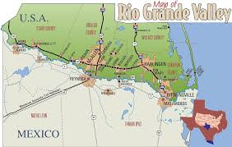
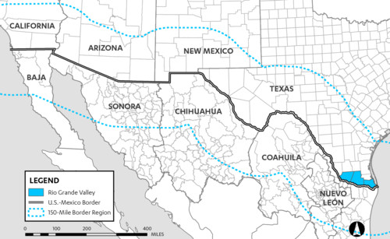
There are three types of regions: formal, functional, and perceptual. Formal regions have distinct boundaries which make them easy to identify, such as counties or states. Examples of formal regions are Europe, Africa, United States, and Canada. One formal region within the Rio Grande Valley is defined by the border between the United States and Mexico. This is as formal region since the two countries are independent and are easily divided by the natural Rio Grande. It is accurate and possible to say that the formal region can extend from the Pacific Ocean to the Gulf of Mexico, or just the division between Texas and Mexico.

A functional region is an area organized to function politically, socially, and economically as a single unit. Functional regions are centered on a focal point that connects other areas by various systems, such as transportation, communication, or economic activities. Cities can be considered functional regions because highways, railroads, subways, and buses move people from the suburbs to the central areas of the city. Other examples of functional regions are television signal areas, Wi-Fi hotspots, or pizza delivery areas. A functional region within the RGV would be found on both the United States and the Mexico side, as commerce, people, trade, and people use both sides for their needs. To simplify this situation, we will call this functional region the ‘Economic RGV’. The Economic RGV extends from the mouth of the Rio in the Gulf, all the way past Laredo, some even arguing that it would could be to El Paso, Texas.
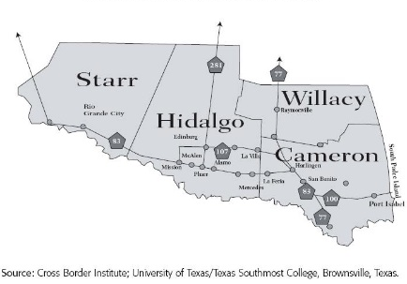
A perceptual region is based on the shared feelings and attitudes of the people who live in the area. Perceptual regions reflect the cultural identity of the people in the region. The boundaries of perceptual regions are not always distinct, as they may be perceived differently from person to person. Perceptual regions are also called vernacular regions. The RGV itself is often broken up into three sub-regions of the lower, middle, and upper valley. The lower valley is usually designated for Brownsville (population 183,000), the mid valley from Harlingen (population 65,000) through Weslaco (population 40,000) , and the upper up through McAllen (population 142,000). The RGV usually is considered to be most parts of Cameron, Hidalgo, Willacy, and Starr counties, but not everyone agrees. Many people group additional counties into the RGV.
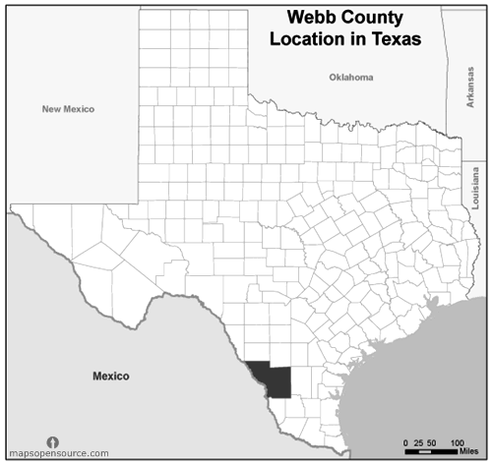
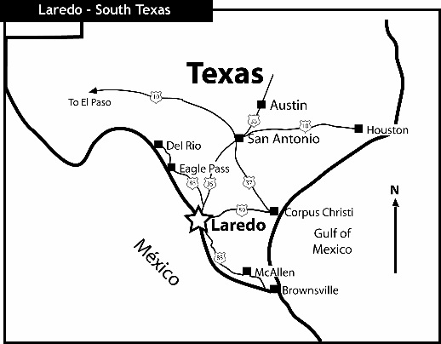
Case Study The city of Laredo (population 257,000) is located along the Rio Grande in Webb county Texas. It shares similar culture, language, trade, and ways of life as those in McAllen, Brownsville, Harlingen, and other RGV locations. If you were not from the RGV and visited Laredo you may say that you were visiting another part of the RGV. If you were a resident of Laredo, you may not consider yourself part of the RGV due to the fact that it resides outside of Cameron, Willacy, Hidalgo, or Starr counties. Laredo is connected commercially and economically to Corpus Christy Texas. Their climate, language, international relationships are similar to those of the rest of South Texas, but are centered more north. Laredo, as the largest city of deep south Texas, has its own medical centers, and communication hubs, but due to their proximity, they share phone area codes with areas as far away as Brownsville. Texas A&M International University also calls Laredo home, creating its own central education center for the area. Due to these factors and others, some argue that Laredo is part of the ‘RGV’, while others see the differences Laredo brings and does not call it part of the RGV.

Summary and Critical Thinking
1. Other than the country divisions of the United States and Mexico, what other types of formal regions were discussed?
______________________________________________________________________________________________________________________________________________________________________________________________________________________________________________________________________________________________________

2. Explain how the functional region of the Rio Grande Valley extends to both Mexico and the United States.
______________________________________________________________________________________________________________________________________________________________________________________________________________________________________________________________________________________________________

3. As a whole, what evidence suggests that the RGV is a perceptual region?
______________________________________________________________________________________________________________________________________________________________________________________________________________________________________________________________________________________________________

Case Study- Thinking about Laredo, fill in the chart below
Evidence to Support Laredo IS NOT part of the RGV | Evidence to Support Laredo IS part of the RGV
1.  2.  3.  4. | 1.  2.  3.  4.

4. Do you think that Laredo should or should not be part of the Rio Grande Valley? Use Evidence to support your claim.
______________________________________________________________________________________________________________________________________________________________________________________________________________________________________________________________________________________________________
Mapping
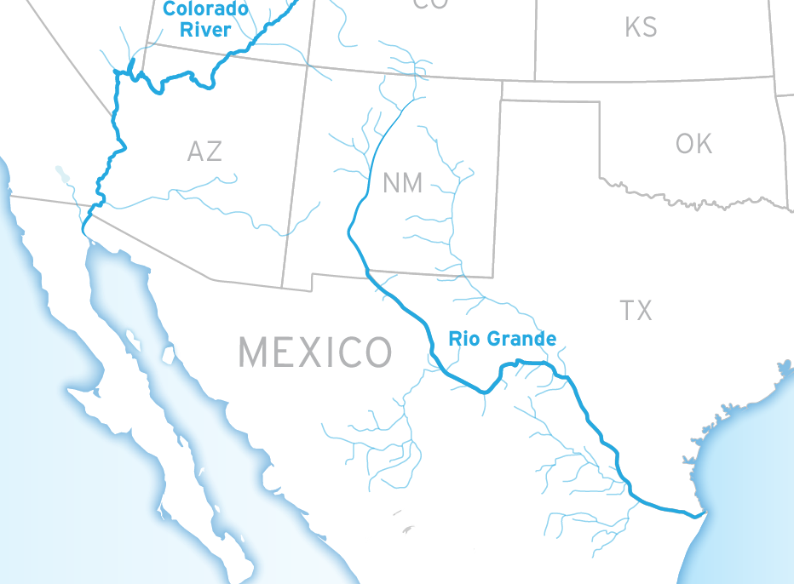
Map Key

1. Using the proportional dot method, label the following cities on the map based on their populations.
City | Total Population
Brownsville
Harlingen
Laredo
McAllen
Weslaco

2. Outline all Texas formal regions on the map in purple.
3. Use yellow to color in the following counties: Cameron, Willacy, Hidalgo, Starr.
4. Use orange to color in Webb County.
5. Shade in the functional region of the RGV in green.
6. Based on your answer to number 4 above in the free response, use Red lines to represent the perceptual region of the RGV.

