Name______________________________________________Date________________Period_________Due__________
Regions of Asia
Directions: Read the information about each region of Asia. Then label and color the map accordingly. Once you have an illustrated map, use your social studies knowledge and the readings to answer the critical thinking questions that follow.
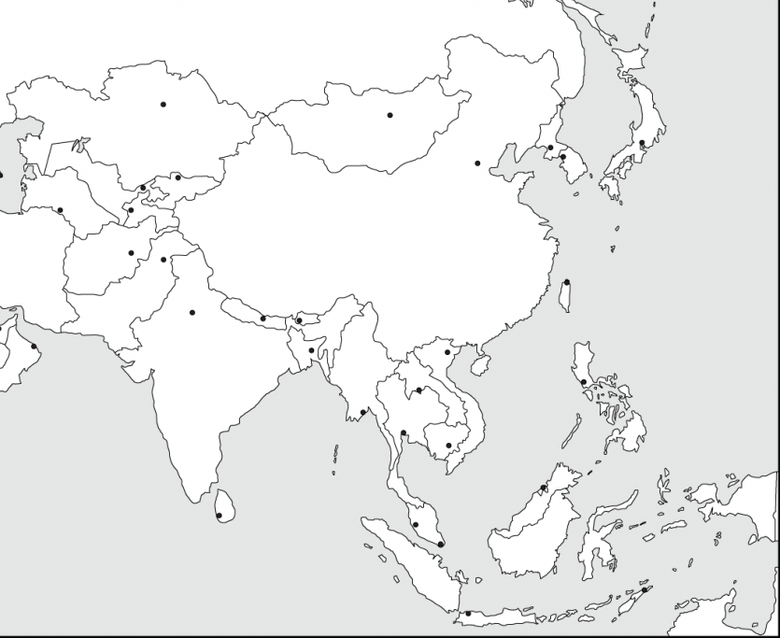
Key

Asia is the largest continent in the world in terms of both land area and population. It covers around 17 million square miles and is home to over four billion individuals. Asia is divided into 48 countries, three of them trans-continental.
Central Asia is west of China, south of Russia, and north of Afghanistan. The western border of this region runs along the Caspian Sea. Central Asia is politically divided into five countries: Tajikistan, Uzbekistan, Kazakhstan, Turkmenistan, and Kyrgyzstan. Given that the name of each of these countries ends in "-stan," Central Asia is sometimes informally referred to as "The Stans." The region covers a total area of 1,545,741 square miles and has a population size of just over 69.78 million individuals. Central Asia played an important role in the transportation of goods between China and Europe during the Silk Road trading era.
East Asia is located east of Central Asia, with its eastern border running along the East China Sea. East Asia is politically divided into six major countries and regions: China, Mongolia, North Korea, South Korea, Japan, and Taiwan. This region covers more than 4 million square miles and has a population size of more than 1.641 billion (22% of the global population and 38% of Asia's total population).
The geography of East Asia varies depending on the zone. The inner continental area experiences a temperate climate, while Mongolia is covered by the arid Gobi desert. China, the largest country in the region, is home to both mountains and plateaus, while Japan is characterized by thousands of islands and coastlines. Today, East Asia is believed to have some of the most advanced technologies in the world, which fosters economic development, and is the leader in world trade.

South Asia has a peninsula-like shape that is bordered by three bodies of water: the Indian Ocean to the south, the Bay of Bengal to the east, and the Arabian Sea to the west. The region includes the Indian subcontinent and surrounding countries. South Asia is politically divided into eight autonomous countries: Sri Lanka, Bangladesh, India, Afghanistan, Pakistan, Bhutan, Nepal, and the Maldives. The region covers a total area of roughly two million square miles and has a population size of more than 1.74 billion, which is nearly a quarter of the global population. Additionally, South Asia has the distinction of being the most densely populated area in the world.

Southeast Asia is located north of Australia, south of East Asia, west of the Pacific Ocean, and east of the Bay of Bengal. It encompasses a number of island and archipelago nations that stretch between the northern and southern hemispheres, making it the only Asian region located on both sides of the equator. Southeast Asia is politically divided into various countries and territories, some of which are: Brunei, Cambodia, Indonesia, Laos, Malaysia, Myanmar, Philippines, Singapore, Thailand, East Timor, and Vietnam.
Southeast Asia covers a total area of 1,735,121 square miles and has a population size of more than 641 million individuals. The geography of Southeast Asia is characterized by a large number of archipelagos. The Indonesian Archipelago is the biggest in the world and is home to the largest number of active volcanoes in the world. The region's importance in global trade began during the spice trade, which started prior to European exploration. Today, the economy of Southeast Asia is rapid developing. Indonesia is considered the largest economy in the region.

Mapping Instructions
- Place a Compass Rose in the Indian Ocean
- Color all countries of Central Asia orange and add Central Asia to your Key
- Color all of East Asia green on your map and add East Asia to your Key.
- Color all nations of South Asia yellow and add South Asia to your Key.
- Color all of Southeast Asia purple and add Southeast Asia to your key.

1. Which three nations are considered Trans Continental (in Asia and Europe/Africa)?
A.__________________________B.__________________________C._______________________

2. Persian languages use the suffix ‘stan’. What do you think ‘stan’ means?
3. What nation is found north of Central and East Asia? _____________________

4. Why does the climate vary so much within the region of East Asia?

5. Which country dominates South Asia? _______________________________

6. Which two nations of South Asia are landlocked? _______________________and ____________________

7. What is unique about the region of Southeast Asia in comparison to all of the others?

8. What sorts of difficulties would nations like Indonesia and the Philippines have in regards to defense and government?

9. What type of climate is most commonly found throughout Southeast Asia?

