What is the European response to Syrian Refugees and Migrants?
1- Britain
Speaking during a visit to Vietnam, Cameron told ITV News attempts [by migrants & refugees] to enter the UK had increased because “you have got a swarm of people coming across the Mediterranean, seeking a better life, wanting to come to Britain because Britain has got jobs, it’s got a growing economy, it’s an incredible place to live”. He added: “But we need to protect our borders to prevent new refugees by working hand in glove with our neighbors, the French, and that is exactly what we are doing.” The Independent, Sept. 2, 2015

2- Denmark
The Danish government has placed advertisements in Lebanese newspapers aimed at deterring [discouraging] potential migrants. "Denmark has decided to tighten the regulations concerning refugees in a number of areas," the advert begins. It warns that Denmark has recently passed legislation cutting benefits by up to 50% for newly arrived refugees. The governing Venstre (Liberal) party won power in June after running on an anti-immigration platform. BBC News. Sept. 7, 2015

3-Germany
Germany is regarded by some as an example of how to treat people coming from different countries with acceptance and empathy. Germany is expecting to receive 800,000 asylum-seeking migrants this year. The UK accepted just 10,050 asylum cases last year, according to Eurostat. Yet, German Chancellor Angela Merkel has taken a firm stance on migration - making it clear she feels it is her country's duty to help those genuinely claiming asylum from war-torn countries like Syria, and calling on Europe to step up and share responsibility for the huge number of people moving across the region. The Huffington Post. Oct. 2017

4-Slovakia
Slovakia has announced it will only accept Christian migrants when it takes in Syrian refugees under an EU relocation plan. Interior Ministry spokesman Ivan Metik said the Eastern European nation will accept 200 Christian migrants from camps in Turkey, Italy and Greece, as Muslim migrants would not integrate as easily into Slovakia's predominantly Christian population. Metik told the BBC: “We could take 800 Muslims, but we don’t have any mosques in Slovakia, so how can Muslims be integrated if they are not going to like it here?”
He added that the country wanted to assist Europe during this wave of migration but that Slovakia was a “transit country” where people did not want to relocate permanently. The Independent. August 2016

5- Hungary
The mayor of one small town in the south of Hungary remains concerned that his nation might still seem too welcoming to those fleeing war or poverty. To remedy this, Laszlo Toroczkai, an ultranationalist with a flair for the dramatic, released a personal “Message to illegal immigrants from Hungary” on Facebook and YouTube, threatening them with arrest in a video edited in the style of a big-budget action movie. The New York Times. March 2017

6-Greece
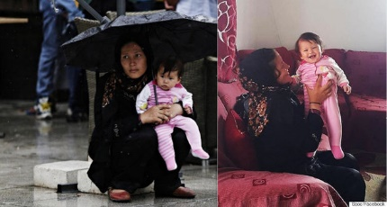
The photo on the left was taken by SOOC photographer Alexandros Michailidis in Victoria Square, where many migrants and refugees stop before continuing their journey into Europe toward a better life. It's a photo like countless others, depicting the despair of people who have lost everything. The photo on the right was shot in Athens in a local Sepolia neighborhood. The same family that was getting drenched in Victoria Square, was welcomed into a locals home, and offered food, a warm bath and, most importantly, compassion. The World Post. June 2016

