Name:_______________________________________________________ Date:_________________Period____________________

Pre and Post World War I: Geographic Implications-Pre-Ap

Directions: Using the maps below and your social studies skills, answer the following questions. These questions will use critically thinking skills. You are high school students; please answer all questions in complete sentences.

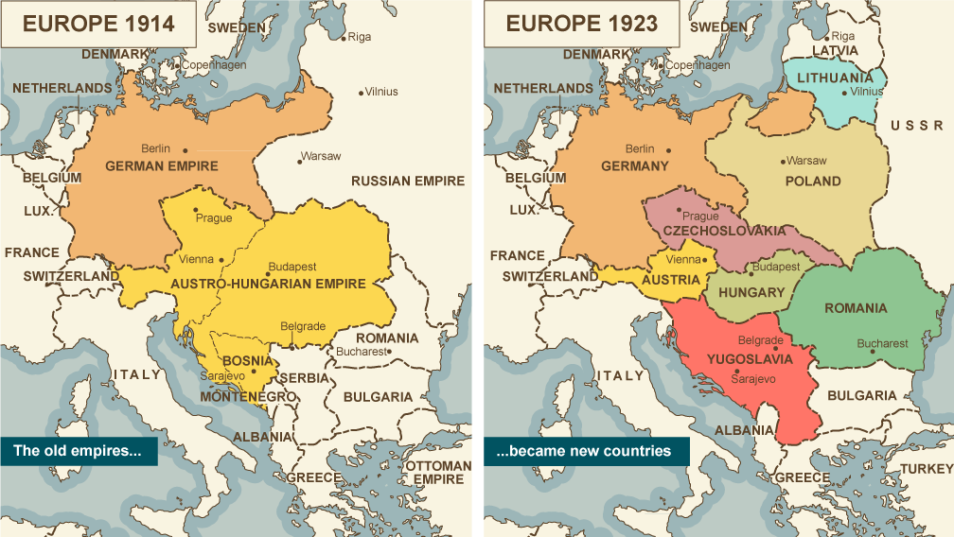
- Politically, what is the main difference between Europe in 1914 vs. Europe in 1923?
____________________________________________________________________________________________________________________________________________________________________________________________________________________________________________________________
- Knowing that Germany was one of the biggest causes of World War One, why do you think France and Russia decided to become allies against Germany?
____________________________________________________________________________________________________________________________________________________________________________________________________________________________________________________________

- In response to the Allied Powers (France, United Kingdom, and the Russian Empire), why do you think the Central Powers of Germany, Austria-Hungary, and the Ottoman Empire banded together?
____________________________________________________________________________________________________________________________________________________________________________________________________________________________________________________________

- Socially, what impact did the end of World War One have on people (think about governments and country ties)? ____________________________________________________________________________________________________________________________________________________________________________________________________________________________________________________________

- The USSR helped establish the countries of Latvia, Lithuania, and Poland after WW1. Why do you think these countries were formed as a geographic boundary?
____________________________________________________________________________________________________________________________________________________________________________________________________________________________________________________________

- Yugoslavia, once created, was economically and political unstable, eventually breaking up at the end of World War Two. What possible issues would have led to its prolonged weaknesses?
____________________________________________________________________________________________________________________________________________________________________________________________________________________________________________________________

- World War Two was roughly 20 years after the end of World War One. What would have caused post WW1 to lead to conflict instead of peace?
____________________________________________________________________________________________________________________________________________________________________________________________________________________________________________________________

- Why was the United Kingdom not as economically or geographically hurt, compared to other nations like France or Germany, after World War One?
____________________________________________________________________________________________________________________________________________________________________________________________________________________________________________________________

- Why would the people of Warsaw be excited about the new boundaries of post WW1?
____________________________________________________________________________________________________________________________________________________________________________________________________________________________________________________________

- What economic and geographic factors would have lead Germany to keep a portion of its disconnected territory post WW1?
____________________________________________________________________________________________________________________________________________________________________________________________________________________________________________________________
- Switzerland has historically been a neutral territory. Why do you think they did not join either the Allied or Central powers in World War One?
____________________________________________________________________________________________________________________________________________________________________________________________________________________________________________________________

Name:_______________________________________________________ Date:_________________Period____________________

Pre and Post World War One Geographic Implications-On Level

Directions: Using the maps below, and your social studies skills answer the following questions. These questions will need critically thinking to be answered. You are high school students; please answer all questions in complete sentences.

1. What is the main difference between Europe in 1914 to Europe in 1923?
____________________________________________________________________________________________________________________________________________________________________________________

2. What happened to Russia after the end of World War One?
____________________________________________________________________________________________________________________________________________________________________________________

3. How many nations were carved out of the Austro-Hungarian Empire?
___________________________________________________________________________________________________________________________________________________________________________________

4. With so many new nations, what problems could have arose due to many inexperienced governments?
____________________________________________________________________________________________________________________________________________________________________________________

5. What happened to some of the former Russian territory after WW1?
____________________________________________________________________________________________________________________________________________________________________________________

6. The people of Warsaw went through what changes due to the ending of WW1?
____________________________________________________________________________________________________________________________________________________________________________________

7. What was unique about post war Germany compared to the other nations?
____________________________________________________________________________________________________________________________________________________________________________________

8. Which country shared borders with 6 other nations?
____________________________________________________________________________________________________________________________________________________________________________________

9.Which countries were created to form a border between Germany and the USSR post WW1?
____________________________________________________________________________________________________________________________________________________________________________________

10. Name 5 European nations whose borders did not change due to WW1?
____________________________________________________________________________________________________________________________________________________________________________________

