Name________________________________________________Date________________Period_____________ISN#5.11
Population Pyramids of Europe Pre-AP
Directions: Go to www.populationpyramid.net and view the population pyramid for Western Europe.
Step 1: Create- In the space provided, create a detailed population pyramid of Western Europe for 2019.
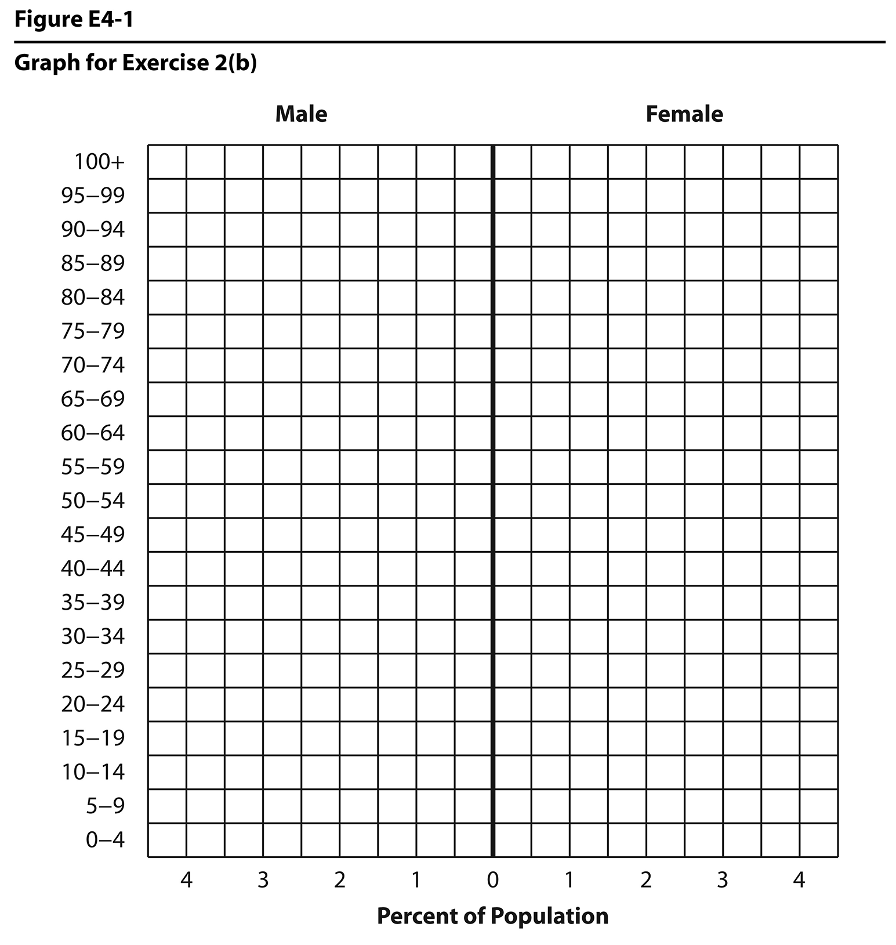
Step 2: Divisions- Add in brackets to the side of your population pyramid that represent the following age groups and label them.
0-24: Underage Population
25-64: Working Population
65+: Aged Population

Step 3: Comparisons: Look up the Population Pyramid for Latin America and the Caribbean on the same website. Quickly sketch it out below. How do these two pyramids differ?

Step 4: Critical Thinking Questions
1.Which stage of growth is Western Europe currently in?

2. Which age group has the largest amount of people in it?

3. In 40 years, which age group will have the most people in it?

4. What is currently happening to Europe’s birth rate?

5. What level of development is Western Europe in based on the population pyramid?

6. What future expenses in 20 to 30 years will Europe have based on its population trend?

7. What could be one reason as to why the populations of Europe are shrinking?

8. Explain how there are more people, aged 90 or above, in Europe than ever before.

9. When looking at the female to male rations, what could possibly account for a higher percentage of aged women remaining in the population than aged men?

10. What is Europe’s biggest concern about their population for the future?

11. If your job was tracking the population trends of Europe, what might you do throughout the continent to increase the birth rates (keep it PG)?
Name________________________________________________Date________________Period_____________ISN#5.11
Population Pyramids of Europe
Directions: Go to www.populationpyramid.net and view the population pyramid for Western Europe.
Step 1: Create In the space provided, create a detailed population pyramid of Western Europe for 2019.
Step 2: Divisions Add in brackets to the side of your population pyramid that represent the following age groups and label them.
0-24: Underage Population
25-64: Working Population
65+: Aged Population

Step 3: Comparisons: Look up the Population Pyramid for Latin America and the Caribbean. Quickly sketch it out in the box below. How do these two pyramids differ?

Step 4: Critical Thinking Questions – Fill out the scantron!
1.______Which stage of growth is Western Europe currently in?
A. Rapid B. Slow C. Zero D. Negative
2.______ Which age group has the largest amount of people in it?
A. Underage Population B. Working Population C. Aged Population D. Migrant Population
3.______ In 40 years, which age group will have the most people in it?
A. Underage Population B. Working Population C. Aged Population D. Migrant Population
4.______ What is currently happening to Europe’s birth rate?
A. Increasing B. Declining
C. Staying the Same D. Doubling

5.______ What level of development is Western Europe in based on the population pyramid?
A. More Developed B. Newly Industrialized C. Less Developed D. Primary Sector
6.______ What future expenses in 20 to 30 years will Europe have based on its population trend?
A. Day Care B. Elementary Schools C. College D. Nursing Homes
7.______ What could be one reason as to why the populations of Europe are shrinking?
A. Living expenses are Low B. Governments do not allow families to have kids
C. Living expenses are high D. There is no room to have family homes in Europe

8.______Explain how there are more people, aged 90 or above, in Europe than ever before.
A. Medical treatments are improving B. There have been no more major wars
C. Older people are moving into Europe D. Literacy rates are improving throughout Europe

9.______When looking at the female to male rations, what could possibly account for a higher percentage of aged women remaining in the population than aged men?
A. Men do not live as long as women B. Women outlive males
C. No major wars in the last 70 years killing off young men D. All of the above

10._______What is Europe’s biggest concern about their population for the future?
A. Rapidly growing population B. Rapidly declining population
C. Large influx of the working class D. Too many babies to care for

11._______If your job was tracking the population trends of Europe, what might you do throughout the continent to increase the birth rates (keep it PG)?
A. increase the cost of family homes B. Have free day care for young children
C. Encourage retired people to move into Europe D. Punish people who have two children

