Name_________________________ Date______Period_____ISN#
Population of Russia (warm-up)
Where do most people in Russia live?
What factors cause people to live there?
- ______________________________________________________________________________
- ______________________________________________________________________________
- ______________________________________________________________________________
- ______________________________________________________________________________
- ______________________________________________________________________________

Population Pyramids / HDI
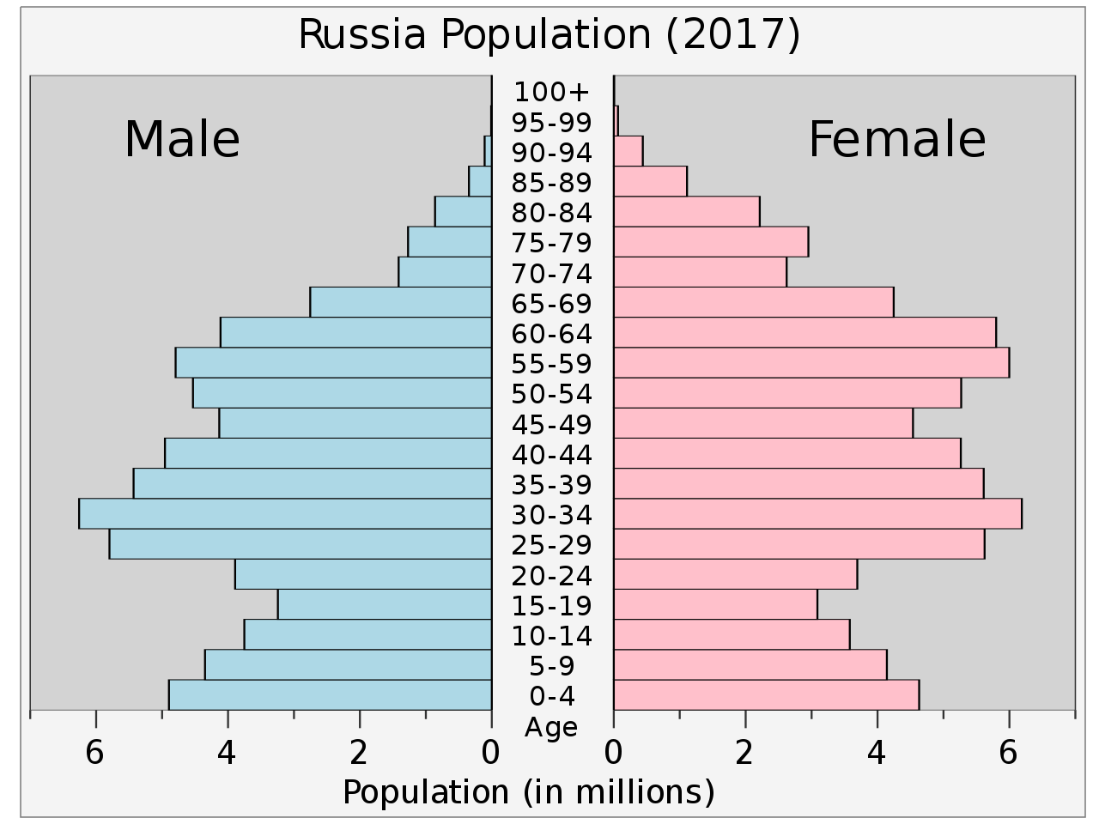 | Russia HDI Information  Country Russia  GDP per capita $28,797  Life Expectancy 71.3 years  Infant Mortality Rate 6.8 per every 1,000 live births  Literacy Rate 99.6%  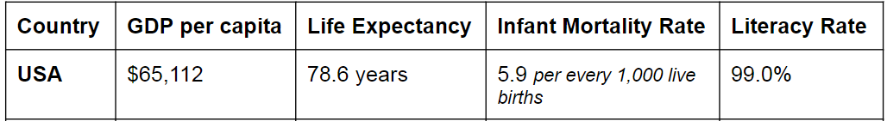
Russia has undergone significant changes since the collapse of the Soviet Union, moving from a centrally planned economy towards a free market based system. Both economic growth and reform have stalled in recent years, however, and Russia remains a mostly stationary economy with a high level of wealth in officials' hands. Economic reforms in the 1990s privatized most industry, with exceptions in the energy, transportation, banking, and defense-related sectors. The protection of property rights is still weak, and the state continues to interfere in the free operation of the private sector.

Russia is one of the world's leading producers of oil and natural gas, and is also a top exporter of metals such as steel and primary aluminum. Russia is heavily dependent on the price and movement of goods around the world as the dependence on exports makes it vulnerable to boom and bust cycles that follow the swings in global prices. The economy, which had averaged 7% growth during the 1998-2008 period as oil prices rose rapidly, has seen slowing growth rates since then due to the exhaustion of Russia’s goods-based growth model.

A combination of falling oil prices, international sanctions, and structural limitations pushed Russia into a deep recession in 2015, with GDP falling by close to 2.8%. The downturn continued through 2016, with GDP contracting another 0.2%, but was reversed in 2017 as world demand picked up. Government support for import substitution has increased recently in an effort to diversify the economy away from extractive (where they pull resources like oil, gas, aluminum, etc out of the ground) industries.

Russia Population Pyramid / HDI Information Analysis
- Is the population of Russia Growing, Shrinking, or Stable?

- What effects will this stage of growth have on the country in the future?

- Does their GDP indicate that they are an MDC, NIC, or LDC?

- Based on the population pyramid, what can you tell me about their overall healthcare?

- Critical Thinking: Why do you think Russia’s Economy has struggled so much?

Ukraine Population Pyramid / HDI Information Analysis
- Is the population of Ukraine Growing, Shrinking, or Stable?

- What effects will this stage of growth have on the country in the future?

- Does their GDP indicate that they are an MDC, NIC, or LDC?

- Based on the population pyramid, what can you tell me about their overall healthcare?

- Critical Thinking: Why do you think Ukraine’s Economy has struggled so much?

Mini-Essay Question
Is the Russian population affected more by physical factors (climate, resources, and landforms) or is it affected more by economic factors (proximity to markets)? Explain your answer using at least two examples in the ABE format.
________________________________________________________________________________________________________________________________________________________________________________________________________________________________________________________________________________________________________________________________________________________________________________________________________________________________________________________________________________________________________________________________________________________________________________________________________________________________________________________________________________________________________________________________________________________________________________________________________________________________________________

Name_________________________ Date______Period_____ISN#
Population of Russia (warm-up)
Where do most people in Russia live?
What factors cause people to live there?
- ______________________________________________________________________________
- ______________________________________________________________________________
- ______________________________________________________________________________
- ______________________________________________________________________________
- ______________________________________________________________________________

Population Pyramids / HDI
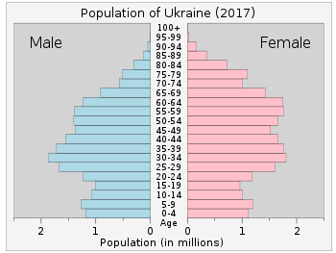 | Ukraine HDI Information  Country Ukraine  GDP per capita $9,287  Life Expectancy 71.6 years  Infant Mortality Rate 7.4 per every 1,000 live births  Literacy Rate 99.7%
After Russia, the Ukrainian Republic was the most important economic part of the former Soviet Union, producing about four times the output of the next-ranking republic. Its fertile black soil accounted for more than 1/4th of Soviet agricultural output, and its farms provided substantial quantities of meat, milk, grain, and vegetables to other republics. Also, its diversified heavy industry supplied unique equipment such as large pipes and vertical drilling tools, and raw materials to industrial and mining sites in other regions.

Ukraine’s oligarch-dominated economy grew slowly from 2010 to 2013, but remained behind peers in the region and among Europe’s poorest. After the former president fled the country during the “Revolution of Dignity”, Ukraine’s economy fell into crisis because of Russia’s annexation of Crimea, military conflict in the eastern part of the country, and a trade war with Russia, resulting in a 17% decline in GDP, inflation at nearly 60%, and shrinking foreign currency reserves. The international community began efforts to stabilize the Ukrainian economy, including a March 2014 assistance package of $17.5 billion.

Ukraine has made significant progress on reforms designed to make the country prosperous, democratic, and transparent, including creation of a national anti-corruption agency, overhaul of the banking sector, establishment of a transparent tax refund system, and increased transparency in government spending. But more improvements are needed, including fighting corruption, developing more free markets, improving the business environment to attract foreign investment, privatizing state-owned companies and enterprises, and land reform.

Russia Population Pyramid / HDI Information Analysis
- Is the population of Russia Growing, Shrinking, or Stable?

- What effects will this stage of growth have on the country in the future?

- Does their GDP indicate that they are an MDC, NIC, or LDC?

- Based on the population pyramid, what can you tell me about their overall healthcare?

- Critical Thinking: Why do you think Russia’s Economy has struggled so much?

Ukraine Population Pyramid / HDI Information Analysis
- Is the population of Ukraine Growing, Shrinking, or Stable?

- What effects will this stage of growth have on the country in the future?

- Does their GDP indicate that they are an MDC, NIC, or LDC?

- Based on the population pyramid, what can you tell me about their overall healthcare?

- Critical Thinking: Why do you think Ukraine’s Economy has struggled so much?

Mini-Essay Question
Do people in Russia live where they live more because of physical geography factors (think: climate, resources, etc.) or economic factors (close proximity to global markets)?
________________________________________________________________________________________________________________________________________________________________________________________________________________________________________________________________________________________________________________________________________________________________________________________________________________________________________________________________________________________________________________________________________________________________________________________________________________________________________________________________________________________________________________________________________________________________________________________________________________________________________________

