Name_______________________________________________________Date__________Period___________ISN# 5.1
European Mapping Lab
Directions: Label and color the entire feature listed below. Use the colors provided and create a Key. Use the textbook, page 262 as your guide.
1. Baltic Sea (Blue) 2. Northern European Plain (Green Dots) 3. Iberian Peninsula (Orange Dots) 4. Alps Mountains (Purple Triangles) 5. Danube River (Blue) 6. Apennines Peninsula (Red Dots) 7. Scandinavian Peninsula (Brown Dots) 8. Black Sea (Blue) 9. Mediterranean Sea (Blue) 10. Balkan Peninsula (Yellow Dots) 11. Atlantic Ocean (outline in Blue) 12. Arctic Ocean (outline in Blue) 13. Ural Mountains (Purple Triangles)  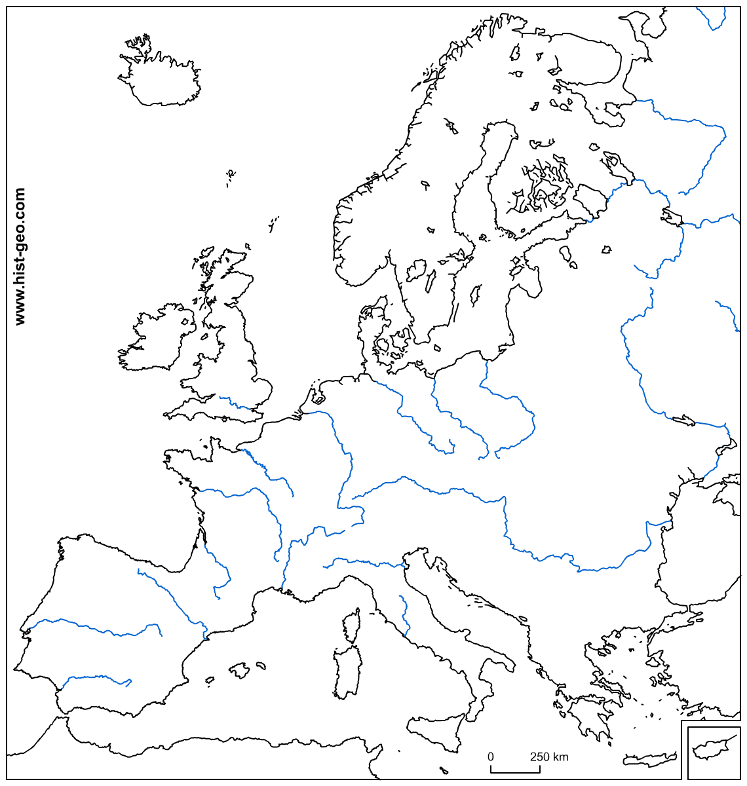 | Color in and LABEL the following regions of Europe.  1. Northern Region- Purple. Use page 283 in text; 5 countries.  2. Western Europe-Green. Use page 308 in text; 11 countries.  3. Southern Europe- Orange. Use page 328 in Text; 8 countries.  4. Eastern Europe-Yellow. Use page 344 in text; 18 countries  5. Russian Core-Red. Use page 373 in text; 3 Countries  *If a country was left out, critically think what region it should belong to and color it in using the key above.  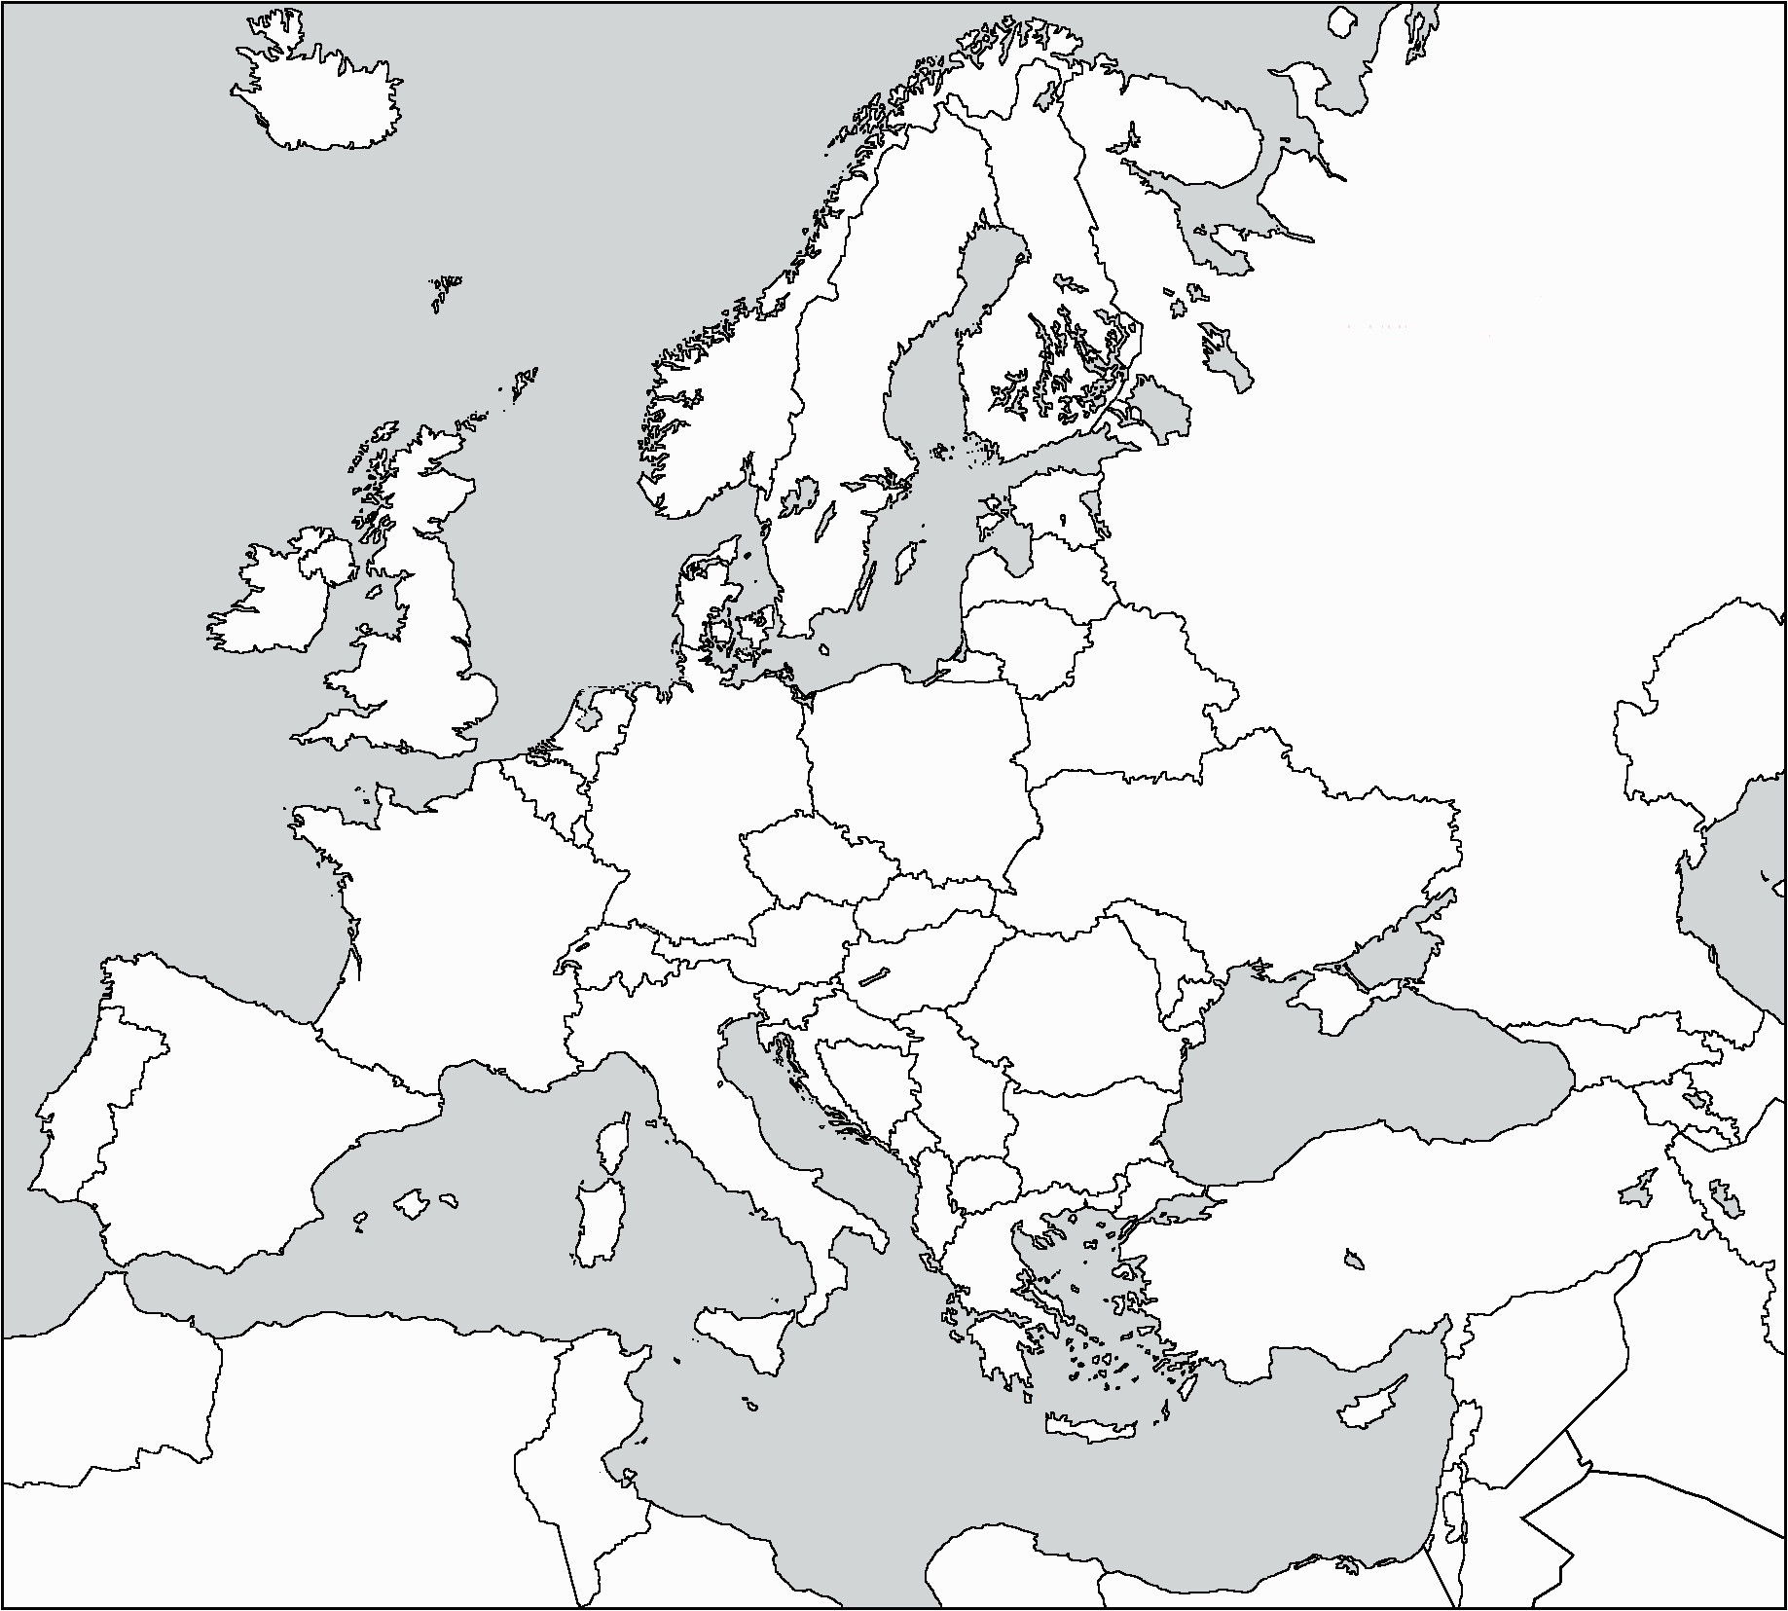

# | Question | Answer
1 | In which region of Europe can you find more canal systems than any other region?
2 | What highly populated city of Europe lies on the Prime Meridian?
3 | What mountain range runs north and south, along 60’E Longitude and separates European Russia from Asian Russia?
4 | Which Region of Europe has the overall lowest population density?
5 | What commonality do you see in areas that have the highest amounts of precipitation?
6 | What is the most common type of land use in Europe?
7 | What river runs through the center of Hungary, into Serbia, and then runs along the border between Romania and Bulgaria?
8 | What causes Italy to have an average of 8-12 month growing season? Use geographic terminology to support your answer.
9 | Why does Northern Italy and Southern Austria have an arctic like climate?
10 | Why is the population density so different from Western Europe to Russia?
11 | Between which two latitude zones does most of Europe lay between?
12 | Why is there more trade in the Mediterranean Sea than the Baltic Sea?

