Name__________________________________________________Date_________________Period_______________
Natural Features of Africa
Directions: Using the textbook (various pages) and the reading supplements, map in and answer the questions that follow for each of the identified natural features of Africa while focusing on their geographic and human impact.

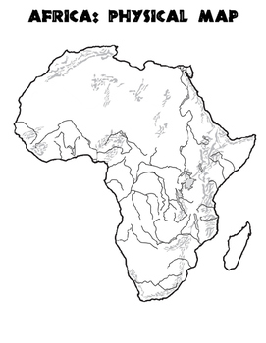
1. The Sahel’s Vulnerable Zone (522-orange)
Location (relative):
What is it:
Human Impact:
Geographic Impact:
2. Great Green Wall (524-light green)
Location (relative):
What is it:
Human Impact:
Geographic Impact:

3. The Great Rift Valley (533-purple)
Location (relative):
What is it:
Human Impact:
Geographic Impact:

4. Ecosystems (535-brown)
Location (relative):
What is it:
Human Impact:
Geographic Impact:

5. Congo Rain Forest (580/583-dark green)
Location (relative):
What is it:
Human Impact:
Geographic Impact:

6. Coastlines (critical thinking-dark blue)
Location (relative):
What is it:
Human Impact:
Geographic Impact:
7. Great Lakes of Africa (supplemental reading-light blue)
Location (relative):
What is it:
Human Impact:
Geographic Impact:

