Name________________________________________________Date__________Period__________ISN# 5.7
National Geographic Expeditions
Directions: Using the National Geographic Expeditions Website (linked on the home page of my website @ Www.WorldGeoJLo.Weebly.com). Here you will view all of the current expeditions of Europe that National Geographic offers and find out about the Human and Physical Geography of the area.
Step One: Quickly view the various Expeditions offered by Nat Geo and pick the one you would be most interested in if money WERE NO OPTION!
Step Two: Map Your Itinerary (it may be small, so do your best). Label all countries and draw in the route. (20 points)

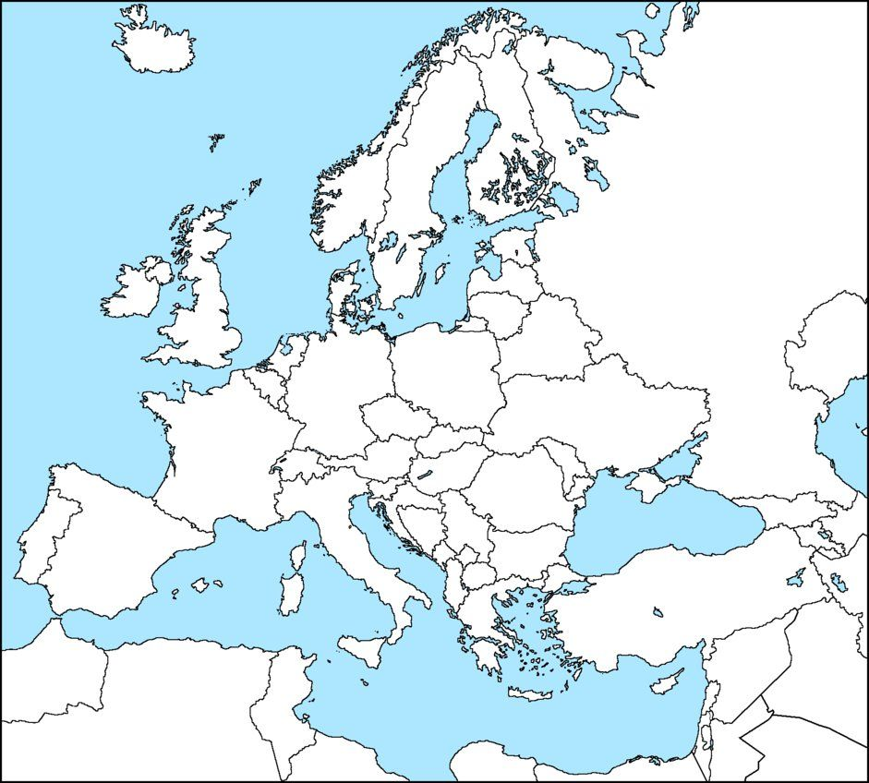
Key

Step Three: Physical Geography (google may be your friend) (20 Points)
A. What types of clothing should you pack for your trip? ____________________________________________________
B. What is the average temperature for your destination for the month of November? ____________________________
C. Is your destination closer to the Arctic Circle or the Tropic of Cancer? circle one
D. Which major body of water is your trip nearest/on?______________________________________________________
E. Which peninsula is your trip nearest/on?_______________________________________________________________

Step Four: Human Geography (google may be your friend) (20 Points)
A. What language would be spoken most on your trip (you may have more than one)._____________________________
B. What types of governments would you be traveling through (provide at least two). ____________________________
C. What common foods would you most likely be eating throughout your trip?__________________________________

Step Five: Post Card Home (in the blank space provided) (40 Points)
A. Create a Post Card that highlights your countries name and a specific city
B. Natural landscapes (river, mountain, valley)
C. Human Elements (food, language, flags…)
D. Write about your ‘experience’ of your trip to family or friends back home. Your post cards will be posted in the hallway, so make them GREAT.
E. Use color and your best handwriting.

