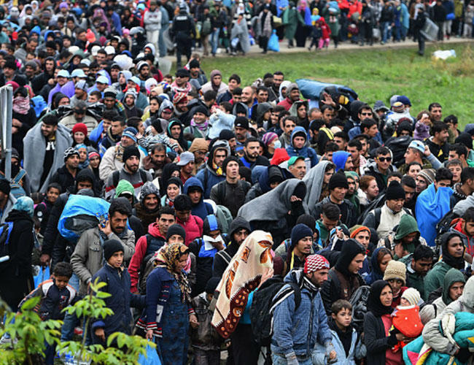
EU Migration Crisis
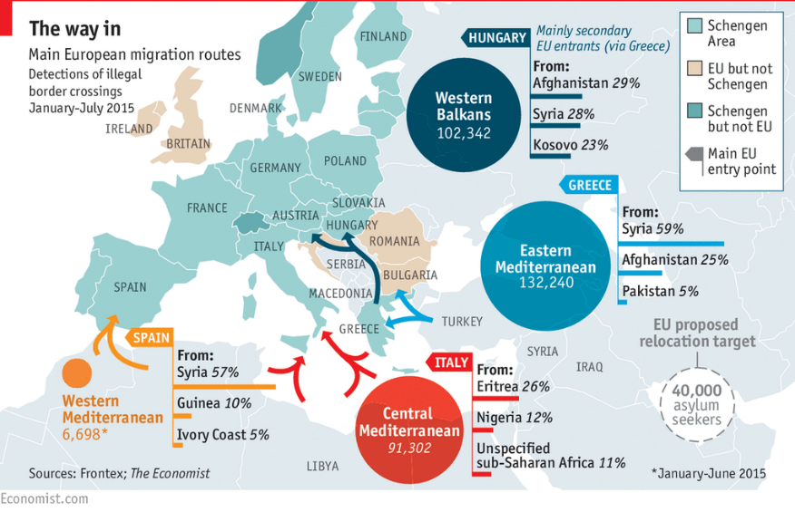

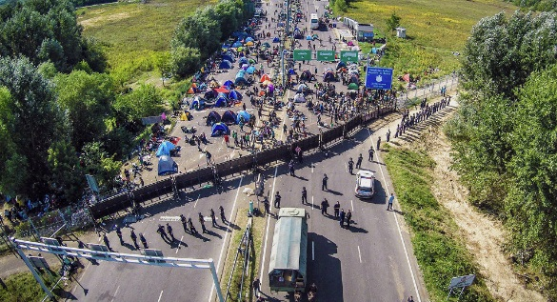

The European Union, or EU, saw more than 1 million migrants in 2018. Most of these migrants came from boat from Northern Africa and the Middle East due to conflicts in both areas. This label as an asylum seeker is what is causing problems in the EU. Under EU terms and agreements, asylum seekers can stay in the country in which they land.
Italy- Italy is closest to North Africa and saw many more migrants than most other EU nations. Therefore, the Italian Minister has advocated that the EU change its policy to ensure that all EU nations take in a proportionate amount of asylum seekers. He was so adamant about this, that after taking in 60,000 refugees, he closed his ports to all nonresidents.
Germany-Although not on the coast, Germany has a strong economy and is a beacon for refugees. However German political leaders are fighting the EU, by enforcing the “First Country of Arrival” law, which makes it practically impossible for refugees to be allowed to stay in Germany. Although a member of the EU, Germany has made it very apparent that they want little to do with the asylum seekers and refugees, even if their EU funding is cut.
Hungary, Poland, Czech Republic, and Slovakia- All of these countries have acted out directly against the EU and have officially closed all borders to non EU migrants, asylum seekers, and refugees. It is thought that Austria will soon follow suit. Due to this, countries that are still accepting migrants are seeing even higher numbers than in the years past.
France- France is trying to meet the needs of both the EU and the Asylum Seekers. Therefore they have proposed an offsite processing center in North Africa where migrants would be funneled to and then sent to an available or accepting country if approved. If not approved they would not be permitted into Europe. Although this would help by dividing the number of migrants, it would also be a financial and logistical problem. Having to staff, fund, and create collection centers in different countries has not been done before by the EU.
What will Come? Most countries agree on measures to tighten Europe’s external borders by boosting the EU’s frontier and coastguard. They also back giving more money to other countries, mainly in Africa, to dissuade migrants from trying to reach Europe, and setting up controversial “disembarkation” centers outside the EU.
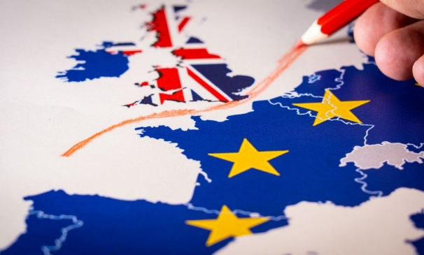
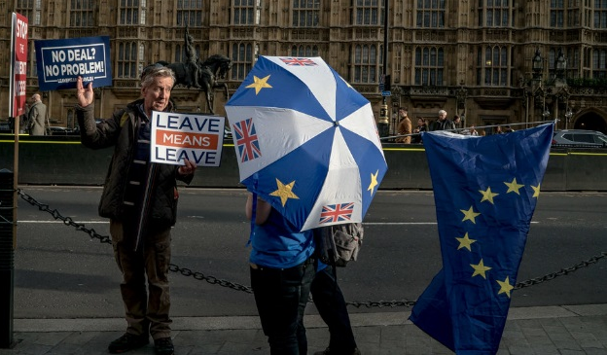
Brexit
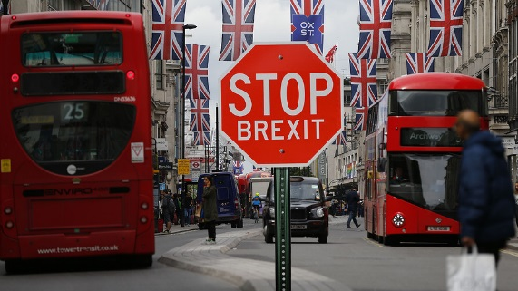

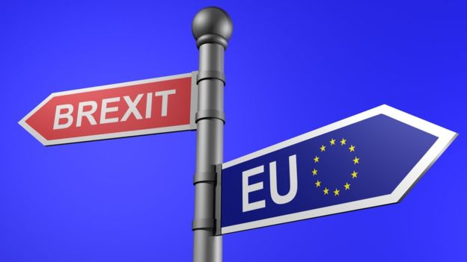

By BENJAMIN MUELLER UPDATED Jan. 30, 2019
A portmanteau of the words “Britain” and “exit,” Brexit is shorthand for Britain’s split from the European Union, changing its relationship to the block on trade, security and migration created by the EU.
Britain has been debating the pros and cons of membership in a European community of nations almost from the moment the idea was broached. (It held its first referendum on membership in 1975, less than three years after it joined.) In 2013, Prime Minister David Cameron promised a national referendum on EU membership with the idea of settling the question once and for all. The options it would offer were Remain or Leave, and Mr. Cameron was convinced that Remain would win handily. He was wrong. England and Wales voted for Brexit, overcoming support to remain in the European Union in London, Scotland and Northern Ireland.
Why is it such a big deal? If England decides to leave, they would lose their biggest trading partner (Europe) and would potentially lose 9% of future industrial growth. Parliament is also promising to end free movement of EU citizens, which is good for those worried about their jobs, but bad for those who would like to move elsewhere for jobs or education.
Borders-Usually when we think of the United Kingdom, we think Island nation. However, the UK does share a border with Ireland, and this border brought many years of conflict. Today the border is open and safe but many from Ireland worry about border issues once the UK is out of the EU.
Population and Resources- Due to the UK’s current standing in the EU, they are seeing an increase in population and use of resources from people who have moved in (health care, education, housing). This has caused a strain on the country financially, as it is having to support more people with less individual wealth. For those who support Brexit, they hope to control the number of people who enter the country and rely upon the nations services.
As of now, Parliament has until March 29th, 2019 to make a final decision. One that will not be easy to do and one that will can cause economic, political, and social unrest. Some politicians are asking for a second vote, or even introducing a ‘Soft Brexit’ to buy more time. Britain now has a small window to try to get the Europeans to budge before the issue comes back to Parliament for yet another showdown in the middle of February.

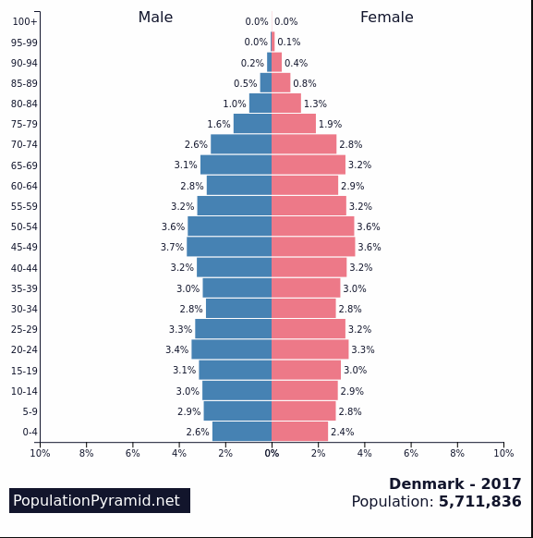
Population Decline- Denmark
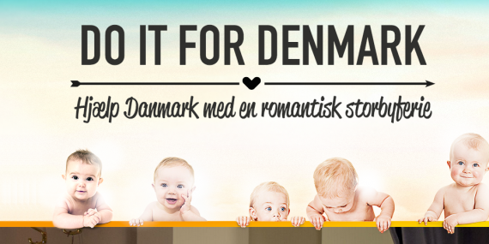

Denmark has a lot of things going for it. Last year, the UN’s World Happiness Report crowned it the globe’s happiest country, citing the nation’s commitment to maternity leave, gender equality, biking, and overall happiness (due to job availability and high educational opportunities).
Its economy is also top of the charts, producing $211 billion in annual GDP despite its relatively small population of 5.6 million. Economic inequality? Not a problem. Income distributes more evenly there than most places.
But Denmark Has A problem-A baby problem. According to government statistics, Denmark posted a birth rate of 10 per 1,000 residents in 2013 — its lowest in decades. The nation’s birthrate was 9.9 in 1983.
Denmark’s perennially low birth rate places it with Germany (8.33), Japan (8.39) and Singapore (7.72). And the downward trend has left people worried in Denmark. Most couples say they want two or three kids, according to the Copenhagen Post, but one in five couples wind up childless. Low birth rates have far fetching problems, especially when considering Denmark’s current high standings.
Recently, a bold campaign emerged in Denmark to reverse the trend. For the salvation of the country, a movement called “Do it for Denmark!” wants Danes to act and act now. “Denmark is facing a crisis,” the company, Spies Rejser, says. “We are concerned. The fewer Danes means fewer people to support the aging population”.
Denmark wants to ensure that it will have a healthy and growing population, or at least a stable population in the future. To ensure this the country is offering tax breaks and incentives for larger families. Child care, medical treatment and tuition (public education requires tuition in Denmark) are all part of the plan. In the future if this campaign doesn’t work, Denmark may even instill a tax or fee for families that are not reproducing.
What’s Causing the Change? As with young millennials around the world, many young adults are deciding to travel, complete their education, or just be ‘untied’, therefore they are not settling down and having children. This world trend is causing population decreases in modernized and developed nations, with a negative impact on jobs and manufacturing. Denmark wants to stay ahead of the curve and has used this campaign to ensure that future generations will be able to support and maintain the great country of Denmark.

For and Against Turkey’s EU Membership

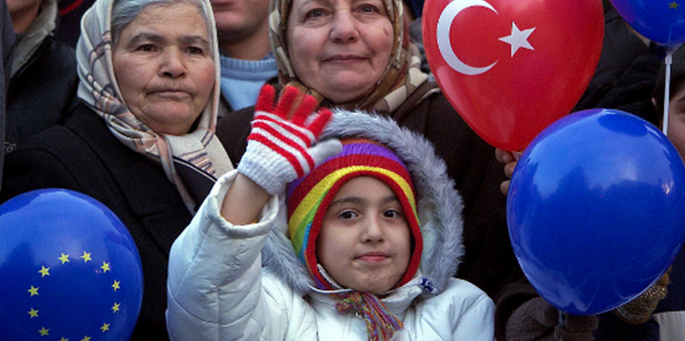
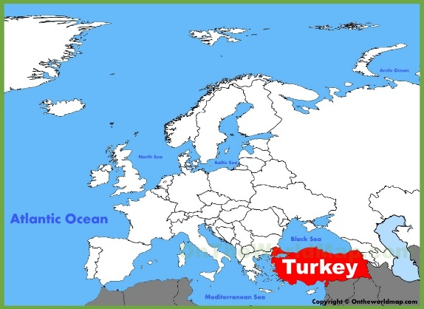

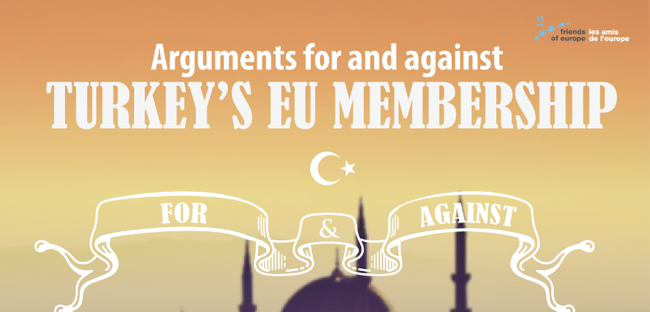

For | Against
Geography-Istanbul is a great European city that lies at the economic and cultural heart of Turkey. The country is an invaluable bridge between Europe and Asia. As a member, it would re-invigorate Europe’s relations with this area. Turkey’s unique geo-strategic position, plus the strength of NATO’s second-largest army would greatly add to European security.  Economics-The Turkish economy is thriving. Its GDP growth average for 2017 was around 3.5% and it weathered the global financial downturn much better than most EU nations. Its public finances are the envy of Southern Europe. Per-capital income has increased six-fold and the average Turk is now better off than his or her Romanian and Bulgarian counterparts in the EU. Only New York, London and Moscow have more resident billionaires than Istanbul. Bringing in such a dynamo would inject new life into the EU economy, as well as adding 75 million consumers to the single market. | Politics-The 2016 coup attempt demonstrates that Turkey is not a mature European-style democracy. Human rights are routinely abused. Dozens of journalists languish in jail. Amnesty International’s annual report is filled with accounts of torture, free speech violations, denial of minority rights, unfair trials, and failure to protect women. Public opinion in the EU is overwhelmingly opposed and the Turks are only lukewarm about joining.  History and Culture-Turkey’s historic and cultural roots lay in Central Asia and the Middle East. It missed the shared experiences that bind Europeans together, from the cultural legacy of Renaissance and Enlightenment, to the horrors of the Second World War which galvanized the drive for united Europe. As an overwhelmingly Muslim nation, Turkey’s cultural traditions are fundamentally different from those of Christian Europe.

Name_____________________________________________________Date__________Period_____________
European Station Notes
Migration Policy
1. Read the station notes and create your own Immigration Policy for the EU based on both the For and Against arguments. Your answer should be in complete sentences while addressing your position and understanding the counter claim. Your policy must be something that would fit the ‘real world’; avoid ethnocentric ideas.

Brexit
1. Create a T Chart that outlines the Pros and Cons of the Brexit Issue. Include at least 4 for each side.
2. Decide if you think the United Kingdom should stay or leave the EU by supporting your opinion in complete sentences. Stay Leave
I think Britain should (stay or leave) because:

Population Decline
1. In the space below create a detailed population pyramid of Denmark.

2. Why is Denmark pushing the campaign for a higher population?

3. What changes would Denmark have to do if they did not see any major population changes?

Turkey and the EU
1. Why do you think many Turkish people do not consider themselves as European or Middle Eastern?

2. Map Directions
- Color Turkey Yellow
- Place black dots on the Middle Eastern parts of Turkey
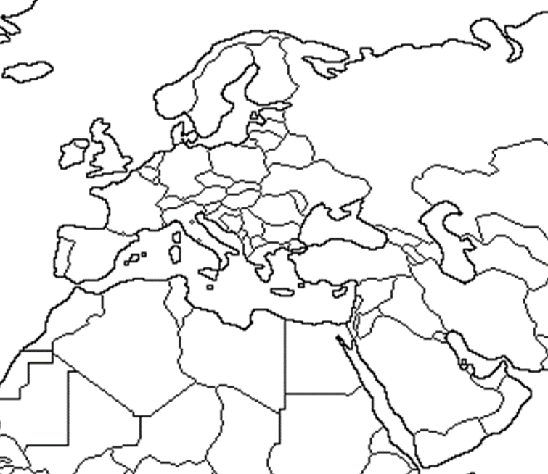
- Place Black lines on the European side of Turkey
- Label Europe
- Color Europe Purple
- Label the Middle East
- Color the Middle East Green

3. Why do you think many Europeans are hesitant to allow
Turkey into the Middle East?

