Name__________________________________Date__________________Period_______________
Culture of the Middle East and North Africa
Directions: Read each of the passages below while analyze the corresponding images, then answer the questions that follow in complete sentences. Be sure to include the academic vocabulary (Cultural hearth, Cultural diffusion, Cultural convergence, and Cultural divergence).
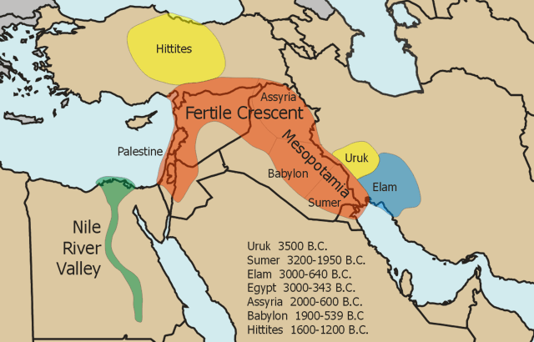
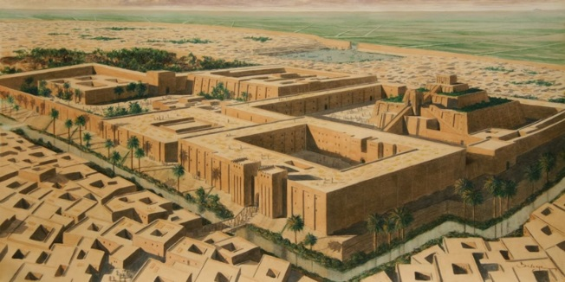
Cultural Hearth

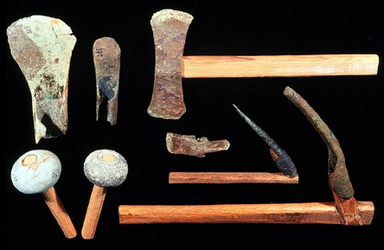

A Cultural hearth can be defined as the center or origin of an ancient civilization whose culture continues to influence or leaves a lasting impact on modern societies. The importance of the Middle East and North Africa is that this region is home to two of the world’s earliest cultural hearths. Both Mesopotamia (modern day Iraq) and the Nile River Valley (modern day Egypt) are both the earliest cultural hearths. As early humans made the transition from hunter-gatherer to the domestication of plants and animals they soon discovered that they had time to develop their culture and create new inventions. The most important cultural element that came out of the MENA was the invention of writing. Writing is important because it allowed peoples to be able to keep records and preserve their history. The Sumerians were an early civilization that developed in Mesopotamia from circa (approximately) ca 3200-2200 B.C.E who created cuneiform, (from the Latin term meaning wedge-shaped,) was the method of writing that the Sumerians invented. Cuneiform could be described as symbols/shapes that represented either a word or phrase. The Sumerians would use soft, wet clay tablets to draw their writing. In order to preserve these tablets, they would bake them to make them rock-hard. As for the Nile River Valley civilization, they too had their own form of writing know as hieroglyphics. Early writing is was the beginning of a lasting civilization. Modern day anthropologists (people who study ancient people) still use these tablets to learn about our past. Both cultural hearths have become the centerpieces of civilizations, religions, education, and advancements for societies around the world.

- What is the importance of writing in relation to cultural hearths?

- Why were the earliest cultural hearths located in Mesopotamia and along the Nile River Valley?
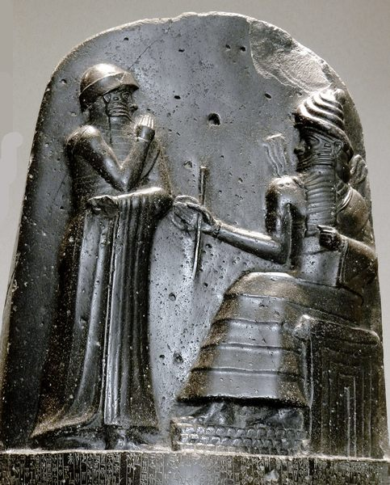
Early Governments
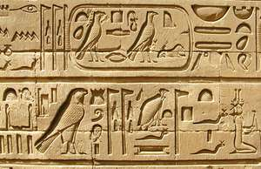

One early civilization, the city of Babylon, was centered along the center of the Euphrates River. Babylonians were fortunate, in that they had a wise king, Hammurabi (r. 1792-1750 B.C.E.) to rule over them. Hammurabi is well-known for the enactment of a law code. Hammurabi’s law code tells us a wealth of information about daily life in Mesopotamia. Furthermore, the purpose of Hammurabi’s code was “to establish law and justice in the language of the land, thereby promoting the welfare of the people.” The code of Hammurabi was also known to contain two striking characteristics.
- First, the severity of the punishments enacted by the law was based on a person’s social class.
- Next, the code required that the punishment fit the crime.

The punishments administered by the law code could be severe; such penalties could include mutilation, whipping, and burning. The code called for “an eye for an eye, and a tooth for a tooth,” at least among peoples from the same social class. The statements below are taking from Hammurabi’s Code.

200. If a man has knocked out the teeth of a man of the same rank, his own teeth shall be knocked out.

201. If he has knocked out the teeth of peasant, he shall pay one-third of a mina of silver.

Hammurabi’s code, although considered ancient was one of the major building blocks of early government. As his civilization and kingdom grew, he realized early on that without a code of conduct, his people would grow violent and would lose respect for authority. Hammurabi used this law as the earliest forms of government and control. All lasting civilizations have had some sort of code put into place as well.

- Analyze the primary source from Hammurabi’s code, what is the correlation between a citizen’s social class and the punishment for crimes?

- Explain why Hammurabi’s code was important to early civilizations like that of Babylon.
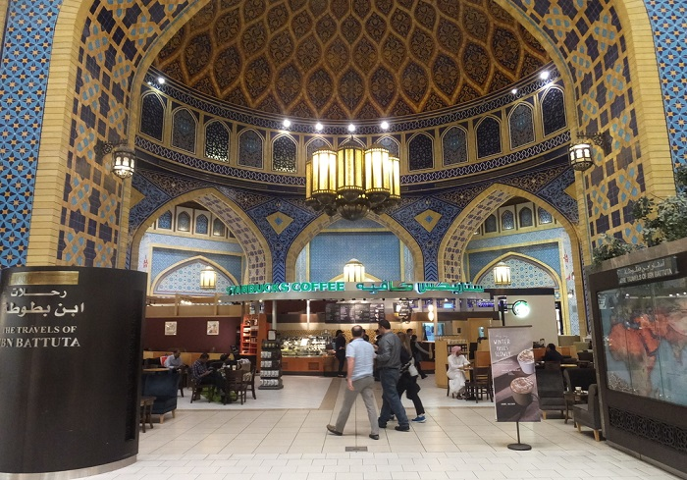
Cultural Divergence

Saudi Starbucks Welcomes Women After ‘Gender Wall’ Construction
Mike Pomranz June 22, 2017

Controversy erupted last week after social media began spreading images of a sign posted at a Starbucks in Saudi Arabia that banned entry to women. Yesterday, however, it was reported that women are being allowed in the coffee shop—assuming the newly installed “gender wall” keeps doing its job.
Apparently, the sign—which read “please no entry for ladies only send your driver to order thank you”—became necessary after an issue with a dividing wall, intended to separate single men from women and families in accordance with local religious law was not being effective. Without a proper “gender wall,” as it is sometimes called, authorities barred women from entering the Starbucks.
Now, according to Starbucks, the wall is up and running and everything is back to normal, at least by Saudi Arabian standards. “Starbucks welcomes all customers, including women and families, to enjoy the Starbucks experience. We have worked with local authorities to obtain approval to refurbish one of our stores in Jarir, which was originally built without a gender wall. That meant it could only accommodate men in accordance with local law,” the coffee giant said, according to CNN. “This was the only such Starbucks store in Saudi Arabia. During construction, the store could only accommodate and serve single men, and a poster was placed at the store entrance as required by local law.”
Starbucks later elaborated further in the same statement. “We are pleased to share that the store is now accessible to single men on one side as well as women and families on the other side,” the company continued. “Starbucks now has 78 stores in Saudi Arabia and all stores cater to both families and singles, except for one that is exclusively reserved for women and families.”
This is a reminder as to how different countries and cultures are. In America anyone can walk into any establishment and expect equal treatment. As Americans it is easy for us to forget how different other countries can be. This rule in Saudi Arabia is not meant to be a punishment for women or families, but it is used to maintain the modesty and traditional cultures of its people.

5. Explain how the Starbucks in Saudi Arabia is an example of cultural divergence? Be specific.

6. Using your knowledge of the Islamic religion why would these be accepted practices for the region?

