M | - M Stands for Mountains  - Mountains create a natural ‘curtain’ blocking wind and rain
Mountains  Block Precipitation | 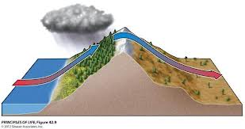

1. Why would one side of a mountain be dry and another side have rain?

E | - E Stands for Elevation  - The higher the landform the colder  - Even places on the Equator can have snow if they are tall enough  Ex: Mt Kilimanjaro in Africa
Elevation  Mt. Kilimanjaro | 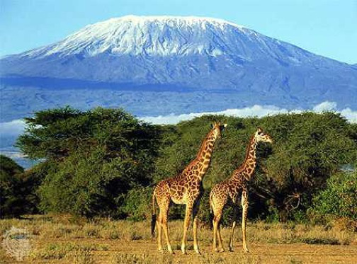

2. How is it possible to have snow near the Equator?

L | - L stands for Latitude  - The closer you are the equator, the warmer your temperature  - Latitude Zones: Tropic, Temperate, Arctic
Latitude  Latitude Zones | 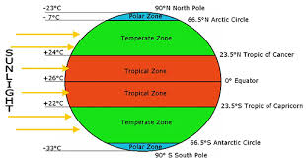

3. What lines of Latitude divide your latitude zones?

C | - C Stands for Continental  - The further away from an ocean, the more extreme the temperatures  - Interior locations are much colder
Continental  Great Plains | 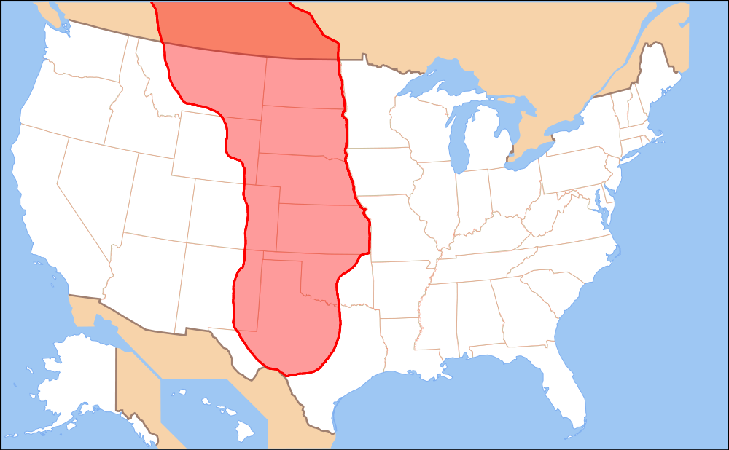

4. Why do the Great Plains have such extreme weather?

O | - O is Ocean Currents  - The Oceans keep coastal areas much more temperate  - Less extreme temperature changes due to warm ocean currents
Ocean Currents  Keep areas Temperate | 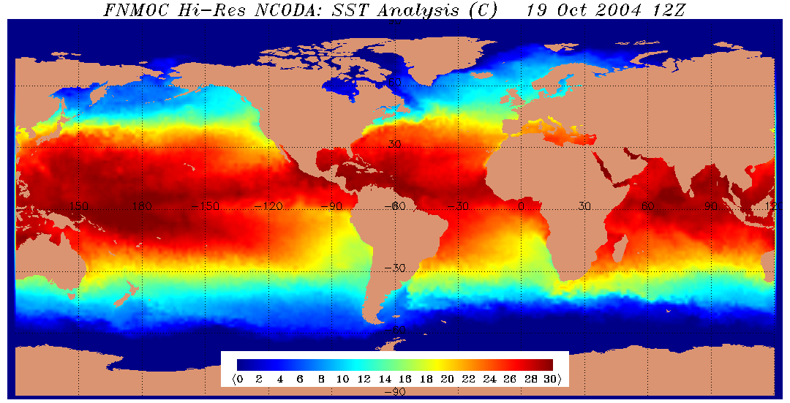

5. Explain why the Gulf coast has a mild seasonal changes.

Name_____________________________________________________________Date__________________Period_____________

MELCO Factors of Climate

M | - M Stands for _____________________________  - Mountains create a ________________________________blocking _____________and _____________________  1.
E | - E Stands for _________________________________  - The ________________the ____________________the _________________  - Even places on the _______________________________can have ____________________if they are _____________________________  Ex:______________________________________in Africa  2.
L | - L stands for ______________________________  - The closer you are the________________________________, the _____________________your __________________________  - _____________________________________: Tropic, Temperate, Arctic  3.
C | - C Stands for ______________________________  - The _____________________away from an________________, the more ________________the ___________________________  - ___________________________are much ________________________  4.
O | - O is __________________________________________  - The Oceans keep coastal areas much more ____________________________________  - ______________________________temperature changes due to ________________________________________________________  5.

