Name_________________________________________________________________________________Date______________________________Period_________________________

Marvels of the United States and Canada

Directions: Identify the following places on the US and Canada map by using different colors to represent each image. Then, fill in the chart on the back with the missing information. You will need to use my website for the information at Www.WorldGeoJLo.Weebly.com and then click on the Marvels Tab.
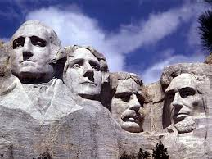
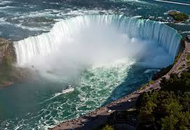
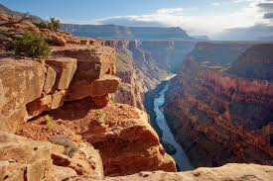
Grand Canyon- Yellow
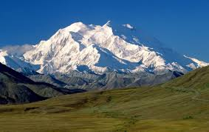
Mt. Denali- Blue
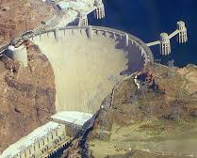

Niagara Falls- Black
Mount Rushmore- Gray
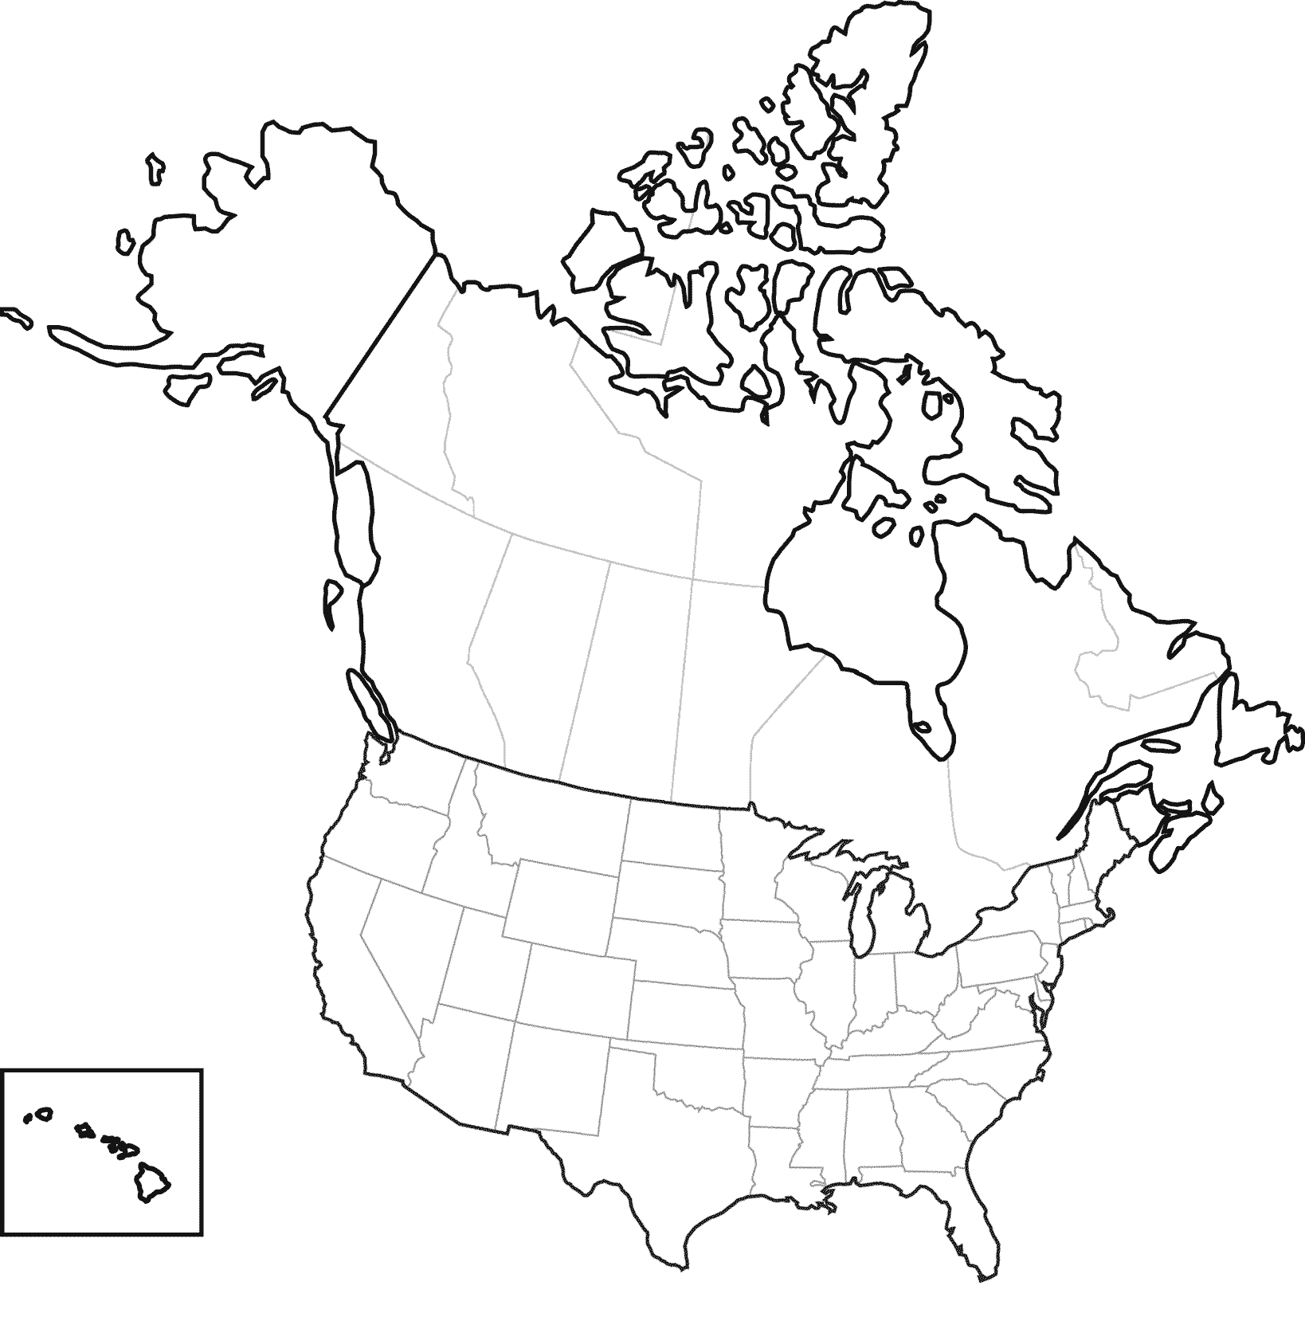

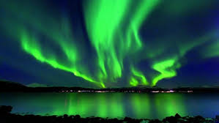

Hoover Dam-Purple
Northern Lights-Green

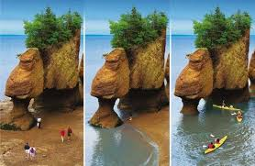
Erie Canal-Red
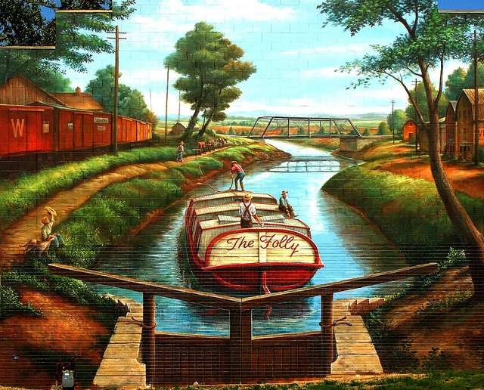

Bay of Fundy-Orange

Marvel | Location | Natural or Man Made | Marvel Fact #1 | Marvel Fact #2
Grand Canyon |  | Natural Feature
Niagara Falls | Divides New York City and Ontario Canada
Mt. Rushmore |  |  | In 1927 President Coolidge decided to carve Washington, Roosevelt, Jefferson, and Lincoln into the mountain as an American monument.
Mt. Denali |  |  |  | Mt. Denali was formerly knowns as Mt. McKinley, names after US President William McKinley.
Hoover Dam |  | Man Made
Erie Canal |  |  | Connects the Atlantic Ocean to the Great Lakes connecting transportation and trade to the American Mid-West.
Northern Lights | Found all over Northern Canada and Alaska; most often seen in the winter season.
Bay of Fundy |  |  |  | Highest change of tides (almost 53 feet each day). When tides are high deep pools and lagoons are created.

Name_________________________________________________________________________________Date______________________________Period_________________________

Marvels of the United States and Canada Pre-AP

Directions: Identify the following places on the US and Canada map by using different colors to represent each image. Then, fill in the chart on the back with the missing information. You will need to use my website for the information at Www.WorldGeoJLo.Weebly.com and then click on the Marvels Tab.
Grand Canyon- Yellow
Mt. Denali- Blue

Niagara Falls- Black
Mount Rushmore- Gray

Hoover Dam-Purple
Northern Lights-Green

Erie Canal-Red

Bay of Fundy-Orange

Marvel | Location | Natural or Man Made | Marvel Fact #1 | Marvel Fact #2
Grand Canyon
Niagara Falls
Mt. Rushmore
Mt. Denali
Hoover Dam
Erie Canal
Northern Lights
Bay of Fundy

