Name____________________________________________________Date___________Period_____________
US and Canada Mapping Lab
Directions: Using the textbook and atlas sources complete the following mapping lab. Following directions, IN ORDER, will be a large part of this grade. Neatness will also count as part of the final assessment.
Political Map Directions
1. Title your map: Political Map of the United States and Canada
2. Label the United States and Canada in a central location.
3. Create and label a compass rose in the north eastern section of the Pacific Ocean.
4. Use a star and label Washington D.C. and Ottawa, Canada as capitals of their respective nations.
5. Locate and Label the following cities. Use the Proportional Symbol System. Use page 124 in text.
- Las Angeles  - Chicago  - Toronto  - New York | - Houston  - Atlanta  - Denver  - Miami | - Calgary  - Montreal  - Vancouver
6. Using a series of dotted black lines, draw in the formal regions of -
US and Canada
US and Mexico
Alaska (US) and Canada
7. Using a red line draw in the Erie Canal.
8. Color all of Canada pink.
9. Color all of the South Green.
10. Color all of the North East Purple.
11. Color all of the Mid West Yellow.
12. Color all of the West Brown.

Physical Map Directions
1. Label and color or trace in blue the Following Bodies of water.
- Great Lakes (as a whole)  - Rio Grande  - Mississippi River | - Yukon River  - St. Lawrence River  - Ohio River | - Hudson Bay  - Atlantic Ocean  - Arctic Ocean  - Pacific Ocean  - Gulf of Mexico
2. Using page 130 in the textbook, create and color in the following:
- Continental Divide (Red Line)
- Fall Line (Yellow Line)

3. Label and draw in the following landforms accordingly.
- Rocky Mountains (Brown Triangles)  - Appalachian Mountains (Brown Triangles)  - Mt. Denali (Blank Triangle) | - Canadian Shield (Purple Triangles)  - Death Valley (Inverted Orange Triangle)  - Great Plains (series of thin dotted lines)

4. Create a compass and label all four major directions.
5. Title your map.

Title:_______________________________________________________________________________

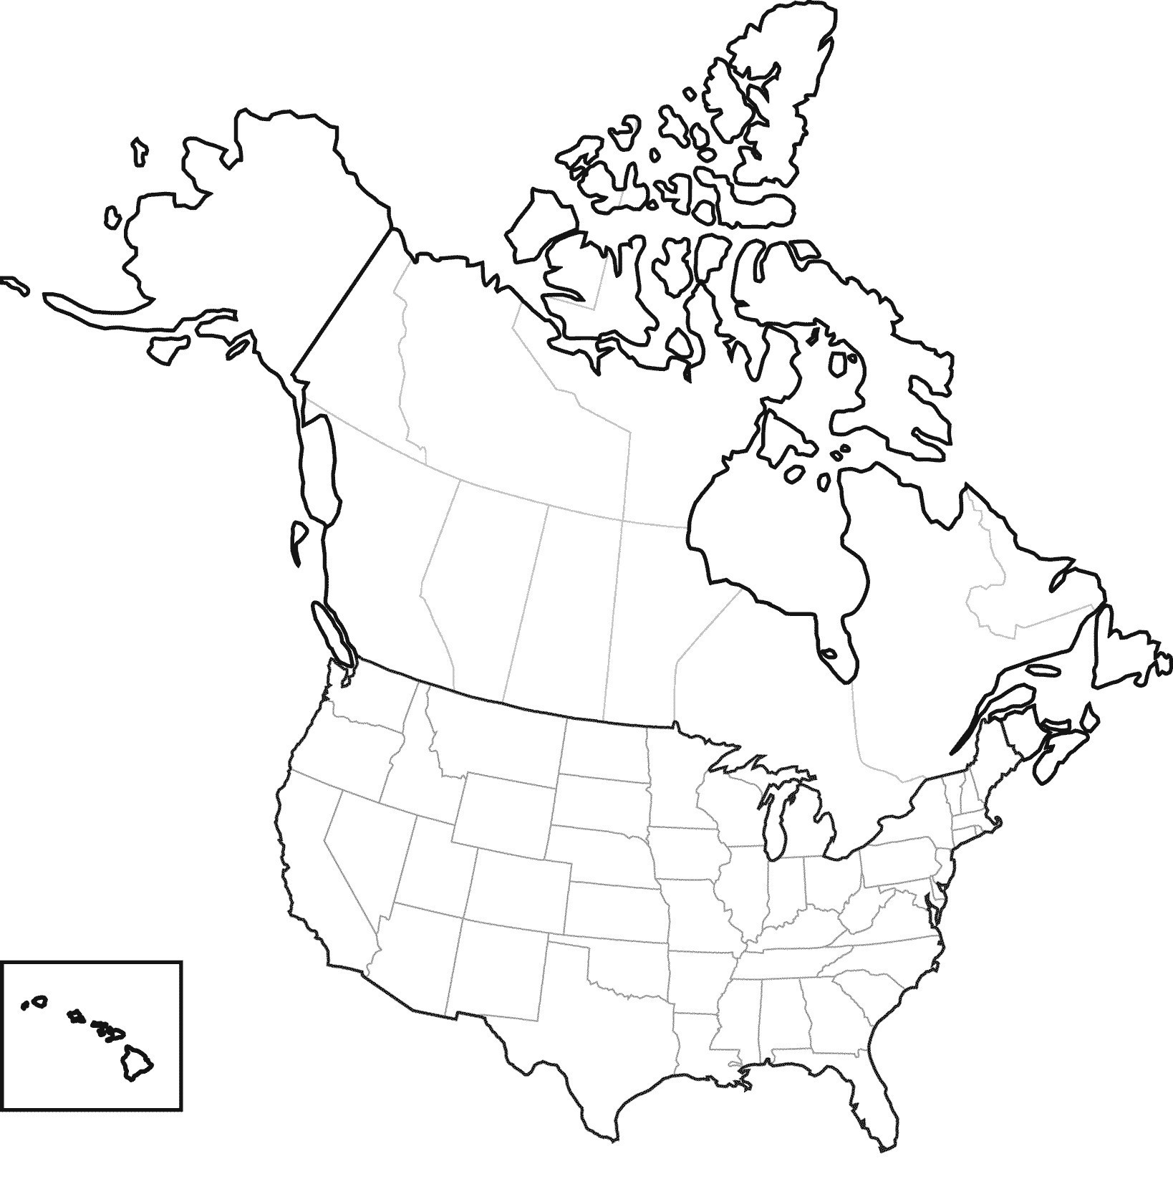

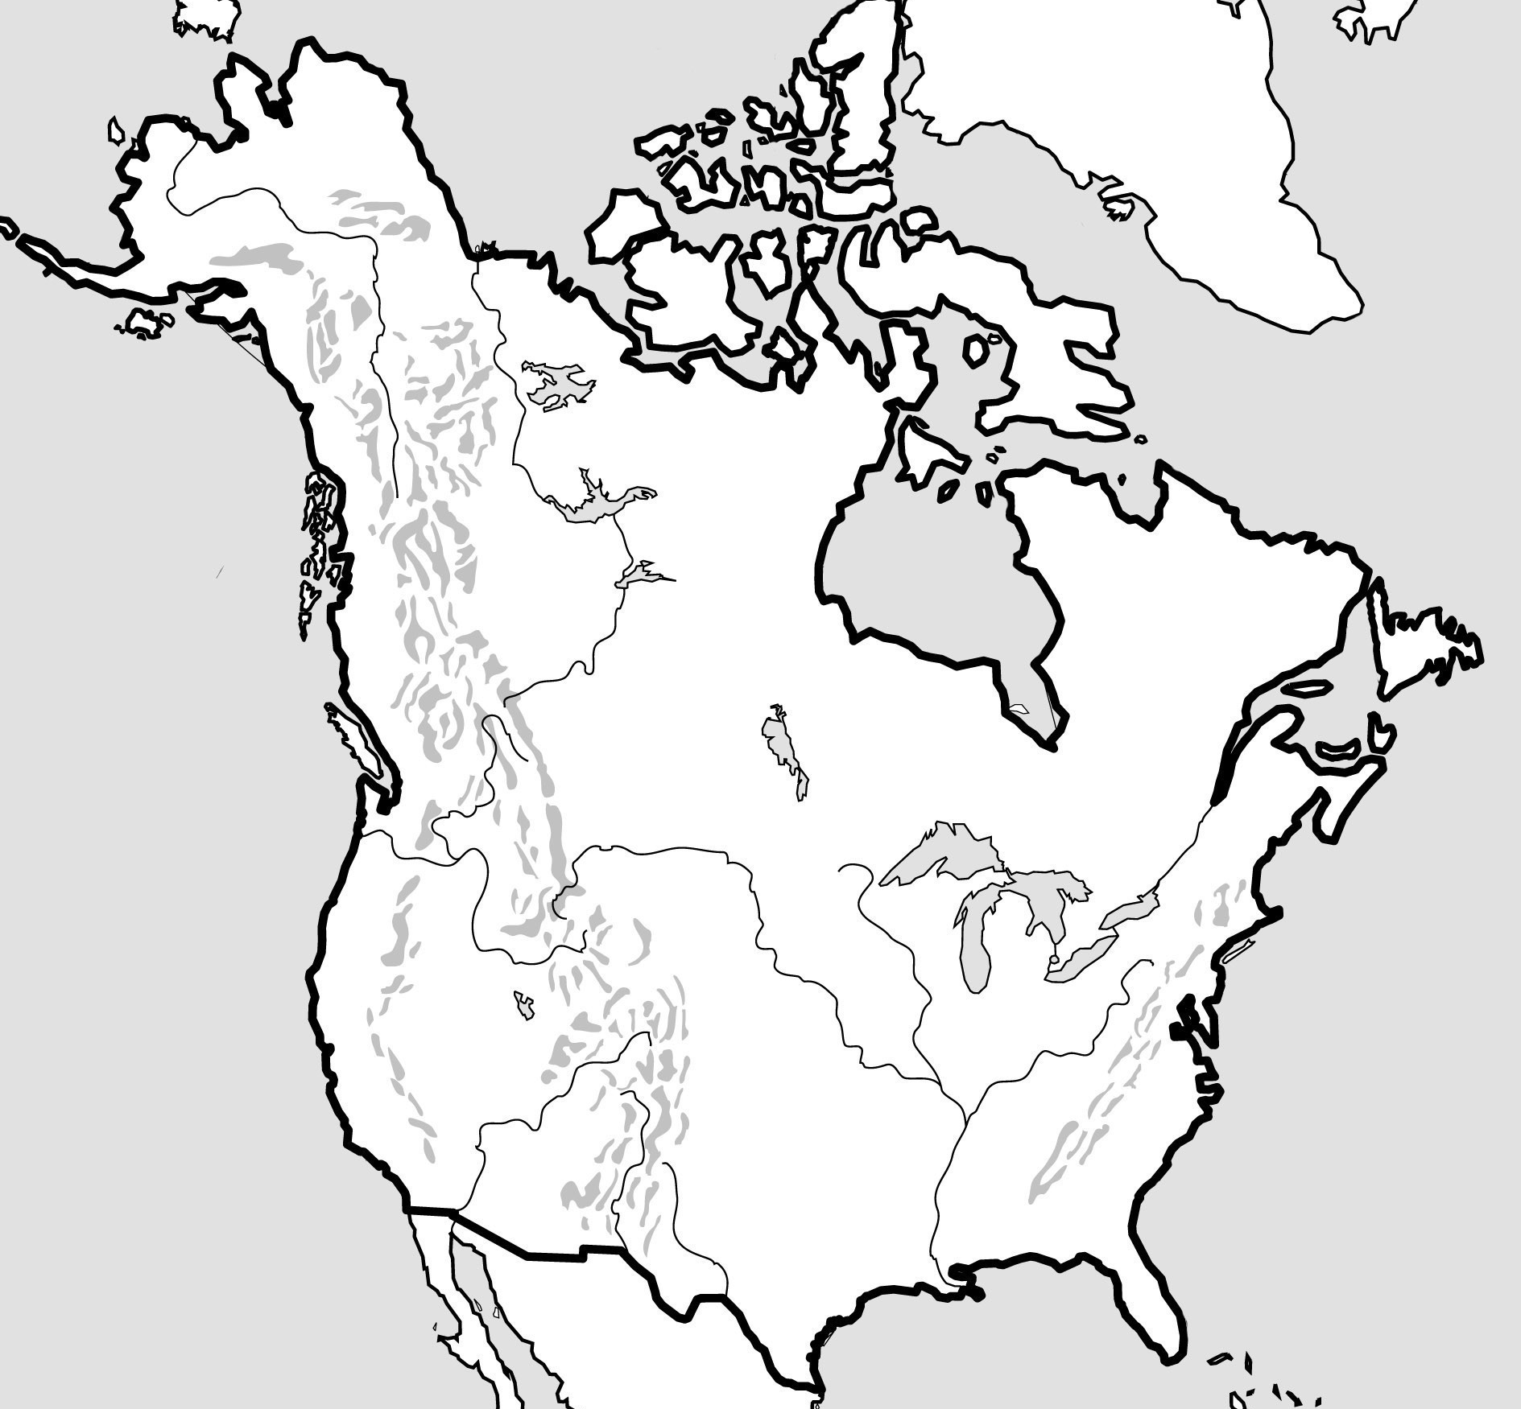
Title:_______________________________________________________________________________

Mapping Lab Questions Pre-AP

1. When looking at the political map of North America, what type of regions are created between the United States, Canada, and Mexico? _________________________________________________________________
2. What commonality can you see from some of North America’s largest cities in respect to location? __________________________________________________________________________________________

3. When looking at the formal regions of the united states, why do you think the Western side has more straight lines than natural borders? Answer in regards to settlement. ___________________________________________ _____________________________________________________________________________________________

4. How do you think the Erie Canal could have helped settlement and transportation of goods in the early 1900s? _____________________________________________________________________________________________

5. Which mountain range would have been the first natural block for early American Colonists? Why this range?
_____________________________________________________________________________________________

6. Using perceptual region terminology, which area of US and Canada is ideal for farming and agriculture?
____________________________________________________________________________________________

7. Explain why controlling/owning the Mississippi River System was so important to Early America and Westward Expansion. ____________________________________________________________________________________

8. According to the Physical Map, most rivers start near what type pf physical features?______________________

9. thinking about question 8, what causes all rivers to empty into the ocean? Use specific geographic terminology correctly. _____________________________________________________________________________________

10. Using MELCO- Which city would have larger temperature swings: (Circle One) Los Angeles or Denver

11. Explain why you chose the answer above.________________________________________________________ _____________________________________________________________________________________________

12. Why are there few, if any large cities in the northern section of Canada? ______________________________

13. What major lines of Latitude divide the areas of North America?_____________________________________ _____________________________________________________________________________________________

Short Answer: 14. The Settlement of North America happened in shifts. Explain how specific physical features (like the Appalachian Mountains, Great Lakes, Mississippi River, and Rocky Mountains) of North American could have aided or hindered North American Settlement.
______________________________________________________________________________________________________________________________________________________________________________________________________________________________________________________________________________________________________________________________________________________________________________________________________________________________________________________________________________________________________________________________________________________________________________

