Name____________________________________________________________________________________Date___________________Period_______________________ISN#
Directions: Write in all of the missing labels for the map and then color according to the instructions.

1. Label your Map “The Middle East and North Africa”

2. Label the following Continents: Asia, Africa, Europe.

3. Label all identified countries

4. Color each country so that it is not touching another country of the same color.

5. Label all major bodies of water.

6. Color in with Blue all major bodies of water (areas with dots)

Map Title:__________________________________________________________________________________

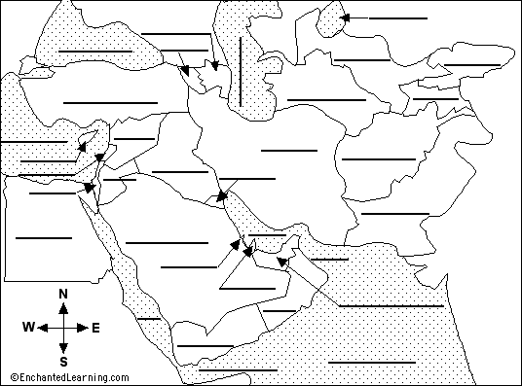

Directions: Fill in the following items according to the key. Some areas of the map will not be colored in.
Bodies of Water (Blue) | Landforms | Other Features:
- Persian Gulf  - Mediterranean Sea  - Red Sea  - Arabian Sea  - Black Sea  - Nile River  - Euphrates River  - Tigris River  - Indian Ocean | Mountains (purple)  - Hindu Kush Mountains  - Caucasus Mountains  - Atlas Mountains  Peninsulas (orange)  - Sinai Peninsula  - Arabian Peninsula | Deserts (brown)  - Sahara  - An Nafud  Canal (red)  - Suez Canal  Continental Divisions (black line)  - Trace the dividing line that separates the Middle East and North African.
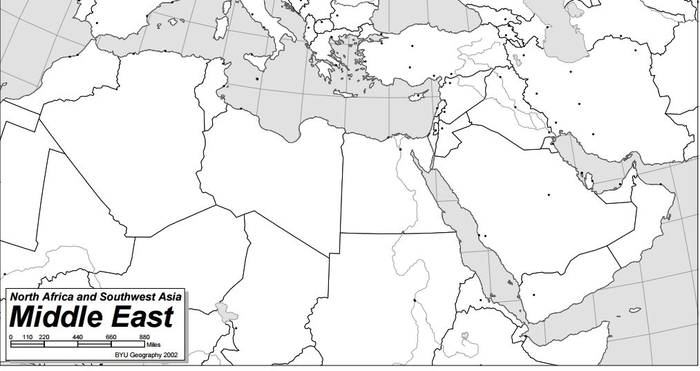
Map Title:_________________________________________________________________________________________________

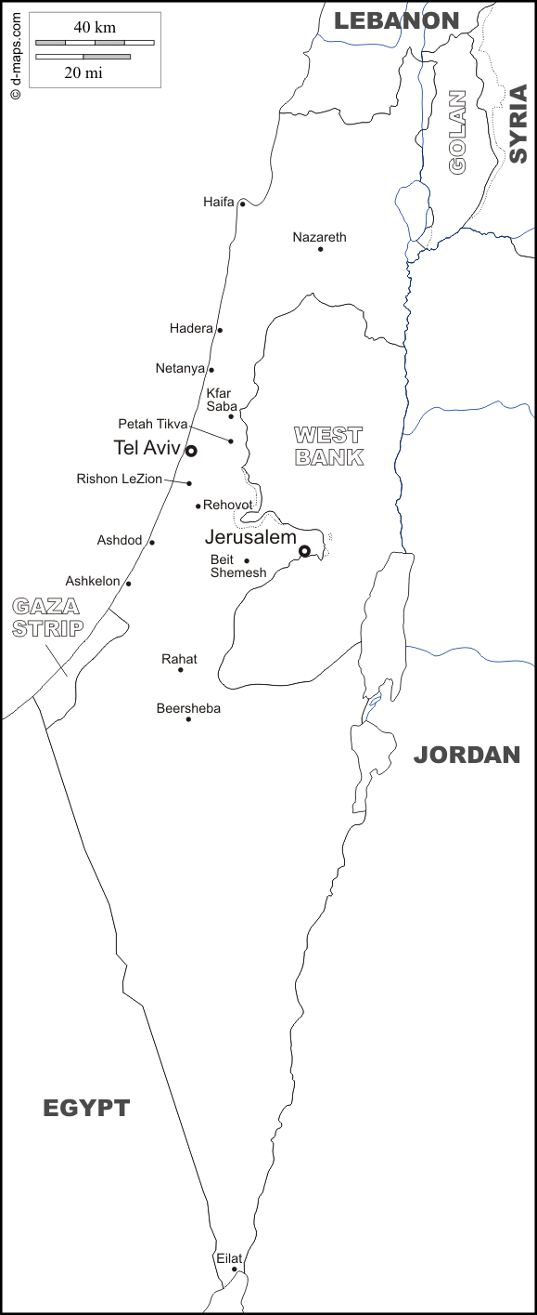
Map Title:_______________________________________________________________________

The map to the left is of Israel, Jordan, Syria, and parts of Lebanon and Egypt. This area is also home to the Gaza Strip and the West Bank, both are areas that have been in contention (conflict) for many years.

Map Directions:
1. Color and label the following water features blue.
Mediterranean Sea Jordan River Dead Sea Sea of Galilee
2. Color and the Gaza Strip Red.
3. Color and the West Bank Orange.
4. Use a Black Star for Jerusalem.
5. Color Israel (and label) and the Golan Heights Yellow.
6. Shade in with green strips the areas within Israel that are Palestinian Controlled. Use the map inserts for this information.

Questions:
1. Why do you think both Israel and the Golan Heights are colored the same color on your map?

2. Why do you think there is a current conflict between Israelis and Palestinians?

3. Into which body of water does the Jordan River empty into?

4. What does the West Bank get its name from?

5. How would you describe the size of modern day Israel? Why is that important?

6. About how far, in miles, is Eilat Israel from Jerusalem?

