Name__________________________________________Date_________Period_______ISN# 5.2

European Mapping Lab
Directions: Today you will be rotating around the room to collect information on Europe by analyzing and completing a Political Map of Europe. Each station will ask you to label specific countries, discuss with your group, and complete critical thinking questions. All stations will be timed, so please stay focused with academic conversations.

Warm-Up: Look at the image below to answer some critical thinking questions.

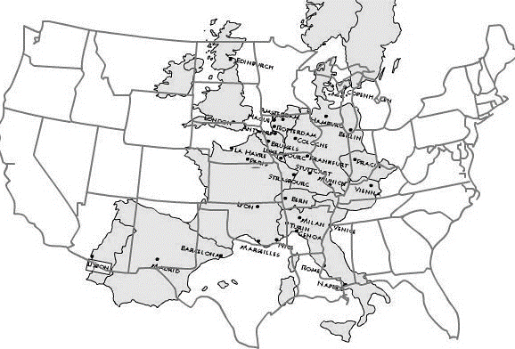
1. What nation is the largest?

2. What continent is overlaid on the United States?

3. Is Europe made up of 1 or many nations?

4. In general, what do you noticed about Europe?

5. Why do you think Europe has to have a higher amount of cooperation than some other continents?

Station 1
1. Label and Color: Portugal, Spain, Italy, Norway, Sweden and Denmark on your map.
2. Discuss: What do these countries have in common?
3. Define Peninsula: ________________________________________________________________________ ________________________________________________________________________________________ ________________________________________________________________________________________
4. Why do you think Spain and Portugal would have higher overall populations than Norway and Sweden?
_________________________________________________________________________________________ _________________________________________________________________________________________
5. Do you think nations are at an advantage or disadvantage if they are peninsulas? Why or why not?
___________________________________________________________________________________________________________________________________________________________________________________________________________________________________________________________________________

Station 2
1. Label and Color: Germany, France, And the United Kingdom
2. Discuss: What do you think these countries have in common?
3: Define Economic Power: __________________________________________________________________ ________________________________________________________________________________________ ________________________________________________________________________________________
4. Why do you think these countries became economic powers? (Hint: look at climate/vegetation map) _________________________________________________________________________________________ _________________________________________________________________________________________
5. What effect could a disagreement between these countries have on the entirety of Europe? ______________ _________________________________________________________________________________________ _________________________________________________________________________________________
6. Do you think being an Economic Power is an advantage or disadvantage for these countries? ____________ __________________________________________________________________________________________________________________________________________________________________________________

Station 3
1. Label and Color: Belgium, Netherlands, Switzerland, Austria, Iceland, Ireland
2. Discuss: What do you think these countries have in common?
3. Define Mid-Range Nation:__________________________________________________________________ __________________________________________________________________________________________________________________________________________________________________________________
4. How are Iceland and Ireland different from the other nations? ______________________________________ __________________________________________________________________________________________________________________________________________________________________________________

5. What economic potentials could Iceland and Ireland have over the other nations?
__________________________________________________________________________________________________________________________________________________________________________________
6. Do you think being a mid-range nation is an advantage or disadvantage? Why? _______________________ __________________________________________________________________________________________________________________________________________________________________________________

Station 4
1. Label and Color: Andorra, Liechtenstein, Monaco, Vatican City, San Marino, Malta
2. Discuss: What do these countries have in common?
3. Define Micro-nation: _____________________________________________________________________ _________________________________________________________________________________________
4. How would a micro-nation compete with other larger nations of Europe? _____________________________ __________________________________________________________________________________________________________________________________________________________________________________
5. Do you think it is an advantage or disadvantage to be a micro-nation? Why? __________________________ __________________________________________________________________________________________________________________________________________________________________________________

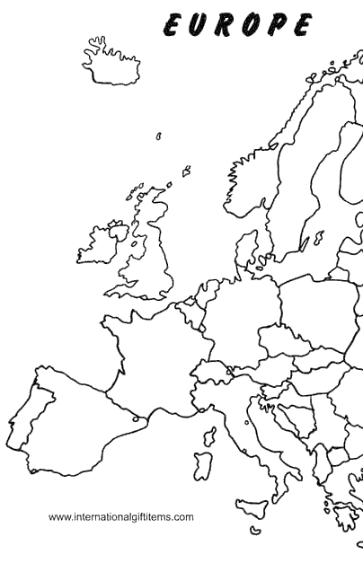
Remember: 1. Color all nations from the same station the same color.

2. Orient your map. This is only showing Western Europe.

3. Some countries are REALLY tiny. Take a close look!

