Name: Date: Period:
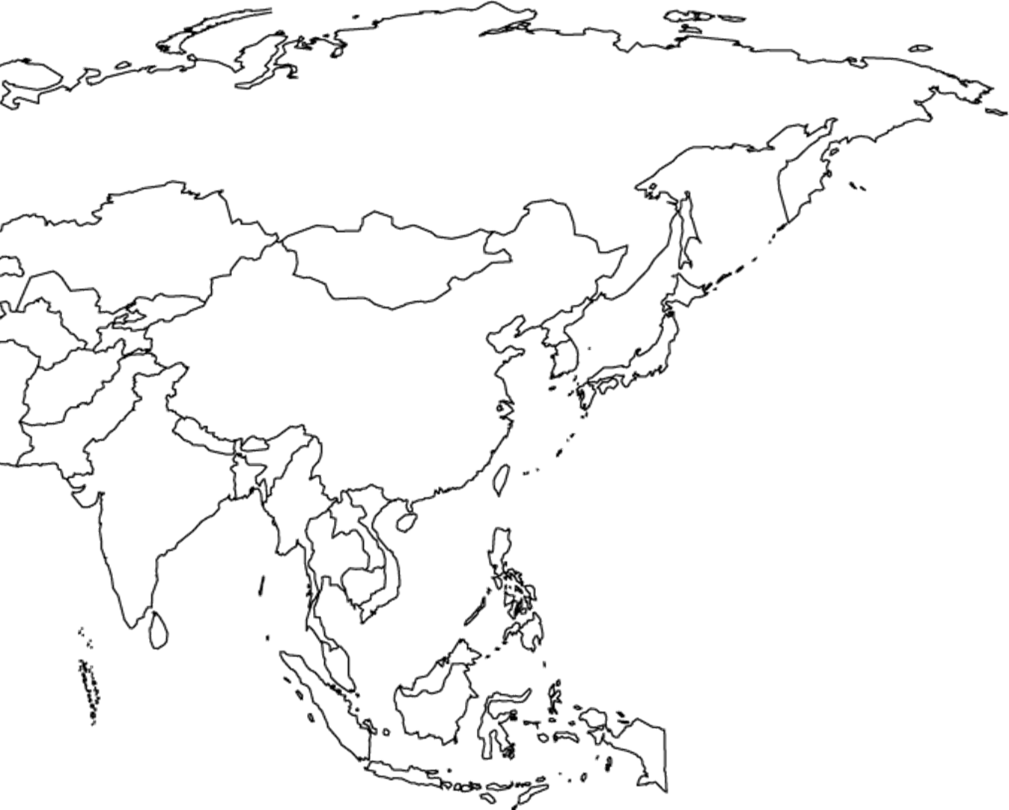
Title:________________________________________________________________________________

1. Label the following countries by placing their number on the map.

1. Malaysia 2. Mongolia 3. North Korea 4. Sri Lanka 5. China
6. India 7. Japan 8. South Korea 9. Philippines 10. Indonesia
11. Nepal 12. Vietnam 13. Thailand 14. Russia 15. Pakistan
16. Bhutan 17. Bangladesh 18. Myanmar 19. New Guinea 20. Laos
21. Cambodia 22. Taiwan

2. Color all the countries on your map (neighbors shouldn’t be the same color)

3. Locate and Label the following Capital Cities on your map using a Black Star
A. 35°N 139°E B. 39°N 116°E C. 28°N 77°E D. 37°N 126°E
4. Add a compass to your map.

5. Title your map.

Title:
Map Key
Water Features
Mountains
Plateau
Plain
Deserts
Peninsula

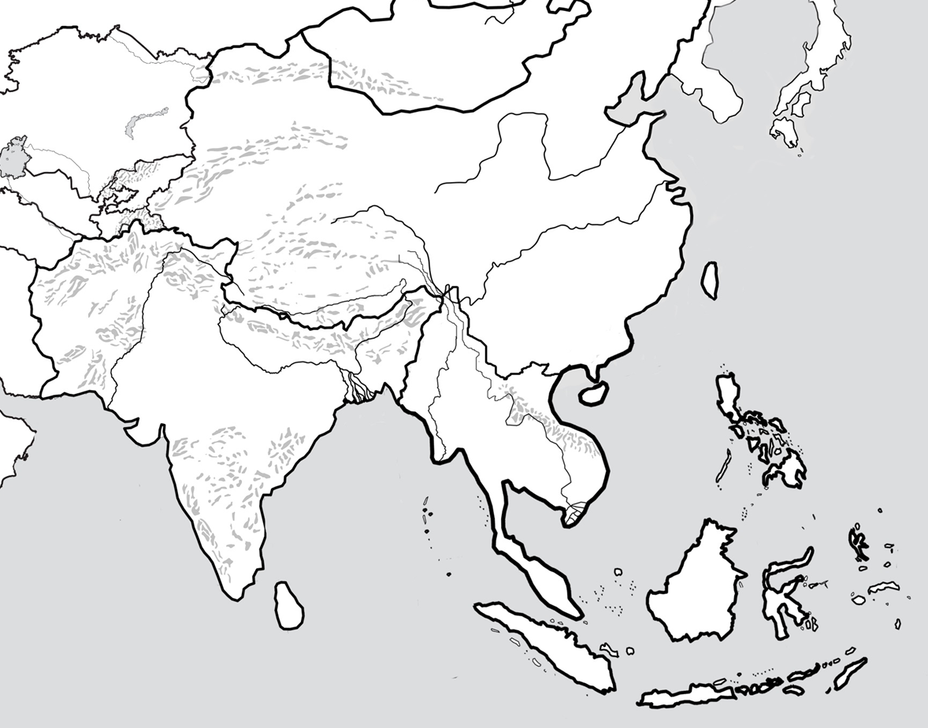

Physical Map Directions
Following directions below to label your physical map. Use pages RA20 and RA21 in your textbook.
1. Label and Color/Outline the following Major Bodies of Water in Light Blue.
- Pacific Ocean
- Indian Ocean
- Bay of Bengal
- Sea of Japan
- South China Sea
- Philippine Sea
- Gulf of Thailand
2. Label and Color the following Major Rivers in Dark Blue,
- Ganges River
- Chiang Jiang (Yangtze River)
- Huang He (Yellow River)
- Mekong River
- Irrawaddy River
- Indus River
- Brahmaputra River
3. Label and Color the following Major Landforms on your Map.
- Mount Everest (Single Red Triangle)
- Himalaya Mountains (Purple Triangles)
- Korean Peninsula (Orange)
- Plateau of Tibet (Brown Dots)
- Gobi Desert (Yellow Dots)
- Altai Mountains (Purple Triangles)
- Great Indian Desert (Yellow Dots)
- Deccan Plateau (Brown Dots)
- Taklimakan Desert (Yellow Dots)
- Ganges Plain (Green Dots)—Below the Himalayas
4. Draw in and label the Tropic of Cancer using a Dotted Black Line.
5. Draw in a label the Equator using a Solid Black Line.
6. Draw a compass on your map.
7. Fill in your Map Key.
8. Title your map “Physical Map of Asia.”

Atlas Questions
Directions: Answer the following questions using pages 84-91 in your atlas and with critical thinking.
1. Name the highest mountain peak in the world:_________________________________________________________________
2. What mountain range serves as a natural barrier for China?__________________________________________________
3. What natural event controls the climate of southern Asia?____________________________________________________
4. How much of Japan’s wheat consumption comes from imports?______________________________________________
5. China and India account for how much of the world’s population? China:______________ India: ______________
6. What percent of India’s population lives away from urban areas?____________________________________________
7. Which Asian city has the largest urban area in the world?_____________________________________________________
8. What areas of Asia contain the highest population density?___________________________________________________
9. Which Asian country is the largest exporter of manufactured goods?________________________________________
10. Why is China forced to import food from other countries?___________________________________________________
11. Which country receives the most exports from China?_______________________________________________________
12. Which country in Asia has the highest people per car ratio?_________________________________________________
13. What does India’s People Per Car Ratio tell you about their standards of living? __________________________ _________________________________________________________________________________________________________________________
14. What makes the country of Japan unique when comparing it to the rest of Asia? _________________________ _________________________________________________________________________________________________________________________
15. What is the main land use in Japan?____________________________________________________________________________
16. What is the main land use in India?_____________________________________________________________________________
17. Which countries are found at the following locations?
20°N 80°E: ________________________ 0° 110°E: __________________________ 40°N 140°E: _______________________
18. In miles, how far away is Pyongyang, North Korea from Seoul, South Korea? _____________________________
19. What correlation can be proved by the maps about population density and the Yangtze, Huang He, and Ganges Rivers? _________________________________________________________________________________________________
20. What physical feature causes most Chinese Rivers to empty towards the East?__________________________

