Name__________________________________________Date________________Period_______

Map 1 Title:____________________________________

Latin America is considered to be all of the countries south of the United States.
- Mexico
- Central America
- Caribbean Islands
- South America
We call all of these areas ‘Latin America’ because they share similar cultural traits, languages, government styles, and heritages. Use the key below to color in and label the different regions of Latin America.

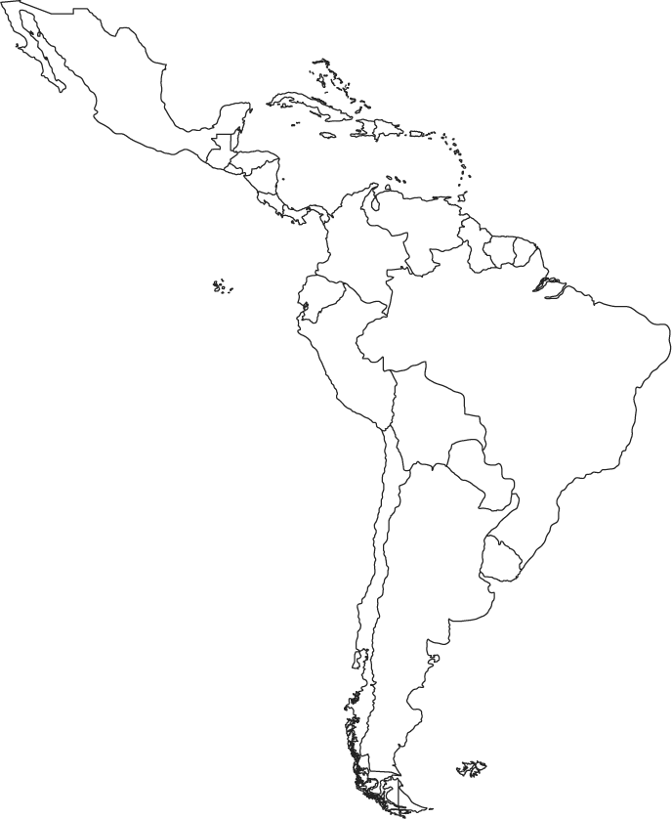

Key
Mexico- Green
Central America- Yellow
Caribbean- Purple
South America- Orange

Title:____________________________________________________________

The continent of South America is made up of 13 different countries and territories, and all but two have access to coastlines. Coastlines provide a way for a country to import and export goods, increasing their economy. Locate and label the following countries based on their access to coastlines.
Northern Coastline
Northern Coast (Green)
1.
2.
3.
4.
5.
Landlocked (Red)
1.
2.

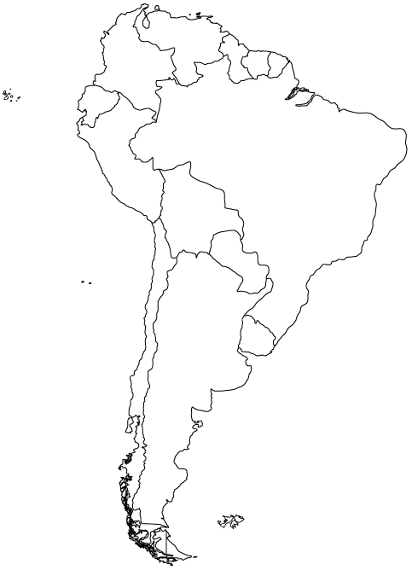

Atlantic Coast (Yellow)
1.
2.
3.

Pacific Coast (Orange)
1.
2.
3.

Title:_______________________________________________ (Day 1 and 2)
Directions: Label the following countries for each map. Then, color it like a political map.
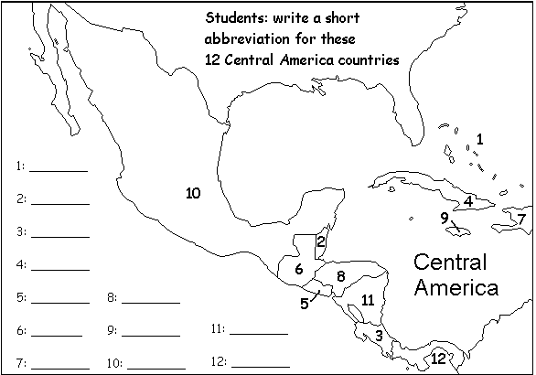

1. 7.
2. 8.
3. 9.
4. 10.
5. 11.
6. 12.

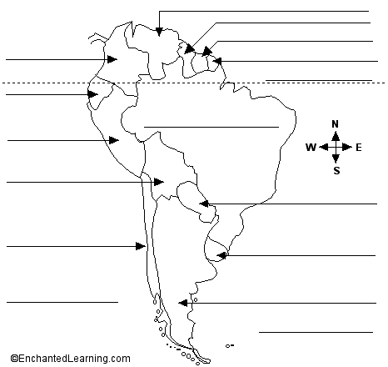

Title:_______________________________________________ (Day 2)

Directions: Label and color/trace the following Features. Outline all water in Blue. Do not use Blue for Land. Only color the features that are listed on the map. **Denotes features of North America.

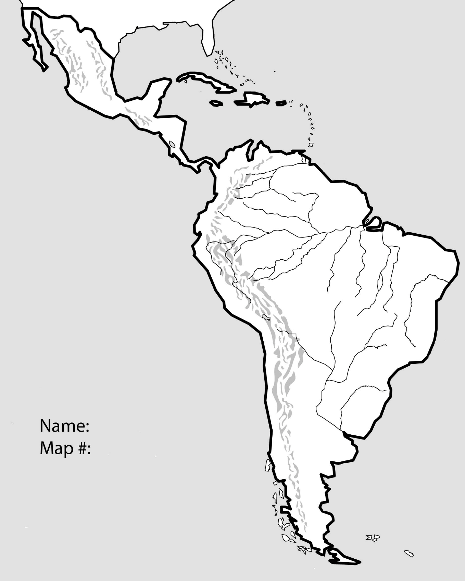
Water Features:
1. Atlantic Ocean-Blue
2. Pacific Ocean-Blue
3. Amazon River-Blue
4. Gulf of Mexico-Blue
5. Caribbean Sea-Blue
6. Panama Canal-Blue
7. Angel Falls-Blue

Land Features:
8. Amazon Rainforest-Dark Green
9. Guiana Highlands-Yellow
10. Brazilian Highlands-Brown
11. Andes Mountains-Purple
12. Pampas Region-Light Green
13. Patagonia Region-Pink
14*. Yucatan Peninsula-Orange
15*. Sierra Madre Occidental Mountains-Purple
16*. Sierra Madre Oriental Mountains -Purple

Mapping Lab Questions- Pre-AP
1. Although Mexico is part of North America, why do we group it as ‘Latin America’?________________ _____________________________________________________________________________________

2. Which region of Latin America has the most diverse landscapes and climates? How can you tell this from the map?__________________________________________________________________________
______________________________________________________________________________________

3. Historically, which nations may have had a lower HDI due to their lack of trading partnerships? ______
______________________________________________________________________________________

4. What causes the southern portion of Latin America to see very little trade and shipping? ____________ ______________________________________________________________________________________

5. Looking at the Scale of Central America, how does it compare to South America? __________________ ______________________________________________________________________________________

6. What potential problems could Brazil face when trying to negotiate policy decisions (Think about its borders)_______________________________________________________________________________ ______________________________________________________________________________________

7. What common culture would you expect to find in Miami, Florida? _____________________________

8. Relatively, where are most mountains found in Latin America? _________________________________

9. What is the largest river system in Latin America? ___________________________________________

10. The Panama Canal connects which major bodies of water?___________________________________

11. Explain why people have not heavily settled interior Brazil. ___________________________________
______________________________________________________________________________________
12. Most rivers in Latin American start in what type of feature?___________________________________

13. The Yucatan and Baja regions of Mexico are similar in that they are both what type of physical feature? _______________________________________________________________________________

14. Why causes the Atacama Desert to be so dry (think LAMECOW)?_____________________________

15. Why would I expect Ecuador to have direct sunlight all year long? _____________________________

16. Although Columbia is near the Equator, why would places like Bogota have cold climates? __________ ______________________________________________________________________________________

17. Historically why have the Caribbean and Central America have been known to have much weaker economies than South America and Mexico?__________________________________________________
1. Although Mexico is part of North America, why do we group it as ‘Latin America’?
A. Location B. Historical Connection C. Similar Culture D. All of the Above

2. Which region of Latin America has the most diverse landscapes and climates?
A. Central America B. Caribbean C. South America D. Mexico

3. Historically, which nations may have had a lower HDI due to their lack of trading partnerships?
A. Mexico B. Argentina C. Paraguay D. Venezuela

4. What causes the southern portion of Latin America to see very little trade and shipping?
A. Distance B. Climate C. Population D. Lack of Resources

5. Looking at the Scale of Central America, how does it compare to South America?
A. Much Smaller B. About the Same Size C. Much Bigger

6. What potential problems could Brazil face when trying to negotiate policy decisions (Think about its borders)? A. Not enough trade partners B. Language Barriers because they speak Portuguese
C. Not enough resources for trade D. Too many shared Borders

7. What common culture would you expect to find in Miami, Florida?
A. Peruvian B. Cuban C. Panamanian D. Chilean

8. Relatively, where are most mountains found in Latin America?
A. Atlantic Coast B. Caribbean Coast C. Pacific Coast D. Southern tip

9. Which region has the most river systems?
A. South America B. Central America C. Mexico D. Caribbean

10. The Panama Canal connects which major bodies of water?
A. Caribbean and Atlantic B. Pacific to Atlantic C. Atlantic to Amazon D. Gulf to the Pacific

11. Why is there a low population density on the interior or Brazil?
A. No Resources B. Too Expensive C. The Desert is too dry D. Rainforest is too thick

12. Most rivers in Latin American start in what type of feature?
A. High Lands B. Dry Lands C. Low Lands D. Wet Lands

13. The Yucatan and Baja regions of Mexico are similar in that they are both what type of physical feature? A. Major Rivers B. Mountain Ranges C. Peninsulas D. Low Elevations

14. What causes the Atacama Desert to be so dry (think LAMECOW)?
A. Mountain Barriers B. Elevation C. Continentality D. Ocean Currents

15. Why would I expect Ecuador to have direct sunlight all year long?
A. Distance from the Sun B. Proximity to the Equator C. Increased Moonlight

