Name______________________________________________Date___________Period__________Due______________
Map Projection and Distortions
Converting a sphere, like earth, to a flat surface results in distortion. This is the most profound single fact about map projections—they distort the world. Imagine if map projection is an attempt to reconstruct your face in two dimensions (on flat paper). Some maps will get the shapes of all your features just right, but not the sizes—your forehead and chin, for instance, may come out huge. Other maps will get the sizes right, but the shapes will be stretched—maybe your full, round mouth will appear wide, thin, and rather mean.

Some maps preserve distances. Measurements from the tip of your nose to your chin, ears, and eyes will be right, even though the size and shape of your features is wrong. Other maps preserve direction. Your features may look weird, and they may be scrunched up or set too far apart, but their relative positions will be correct.
Finally, some maps are compromises—they get nothing exactly right but nothing too far wrong. In particular, compromise projections try to balance shape and area distortion.

The three spatial properties subject to distortion in a projection are:
• Shape
• Area
• Distance/Direction

Shape
If a map preserves shape, then feature outlines (like country boundaries) look the same on the map as they do on the earth. A map that preserves shape is conformal. Even on a conformal map, shapes are a bit distorted for very large areas, like continents. The amount of distortion, however, is regular along some lines in the map. For example, it may be constant along any given parallel. This would mean that features lying on the 20th parallel are equally distorted, features on the 40th parallel are equally distorted (but differently from those on the 20th parallel), and so on.
Area
If a map preserves area, then the size of a feature on a map is the same relative to its size on the earth. For example, on an equal-area world map, Norway takes up the same percentage of map space that actual Norway takes up on the earth.
To look at it another way, a coin moved to different spots on the map represents the same amount of actual ground no matter where you put it.
In an equal-area map, the shapes of most features are distorted. No map can preserve both shape and area for the whole world, although some come close over sizeable regions.

Distance
The images below demonstrates how distance and direction can be distorted when representing a round object on to a flat image. You can see how the curved line (globe) would have to be distorted in some way to fit on the flat line (map). Look at the image with the human head, based on the type of map projection used, the image would be distorted.
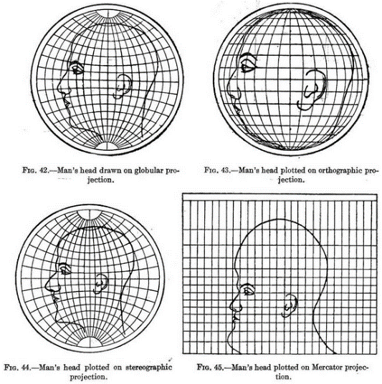

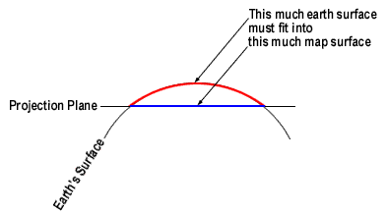

Understanding and Application: Using the images below, create a distorted picture based on the Mercator Map Projection. Color your image on both the Globe and Mercator representations.
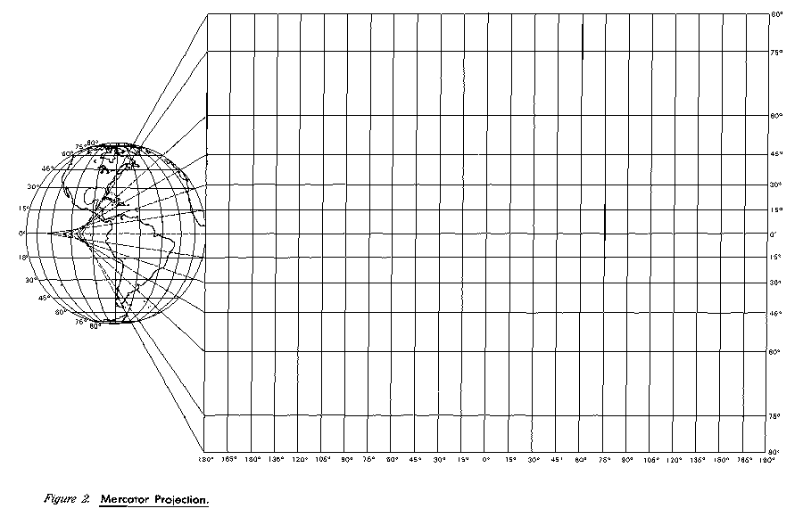
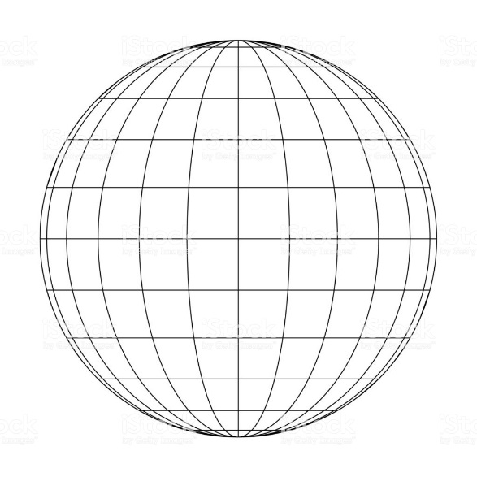
4. Look at the Mercator Projection on the left. Each ‘square’ here, corresponds to the same ‘square’ on the globe.
5. Using the same drawing on your globe above, recreate it for the Mercator Projection, but take into account the distorted new squares.
6. Your new image should have areas of distortion due to the new projection.
1. On the globe to the left, we will call each section a ‘square’, although many are not true squares.
2. Pick a simple image that you can draw (like a football, music note, flower…) and draw it on the globe.
3. Your image must be at least a 6x6, but does not have to fill each square, but simply reach into the squares.

1. Critical Thinking: What is the purpose of displaying distortion on a map?

2. Expository: What misconceptions or problems could you potentially face if you did not understand that projection or distortion existed on maps? Provide a real world example.

3. Comparisons: What are the pros and cons of map projection/distortion? List 2 for each side.
Projection Pros | Projection Cons
1.  2. | 1.  2.

4. Application: Now that you understand projection and distortion, think about the continent of Antarctica on a Mercator projection (normal map view). What does Antarctica look like on the Mercator projection? Is this a true representation of the continent? Why or why not?

