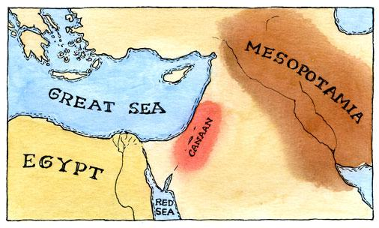 **Judaism:**

Followers of Judaism are called Jews. These people believe in on God- the God of Abraham- called ***Adonai***in Hebrew. Abraham lived in the Middle East about 4,000 years ago at a time when most people believed in many gods. Abraham believed that only one, all powerful God had created the world. Jews believe that God made an agreement, or ***covenant****,* with Abraham. This agreement said that Abraham and the future generations of his family-his ***descendants***- would be God’s chosen people in return for their faith and obedience. These people, called Hebrews, would live in a promise land called Canaan.

Jews base their religion on their holy book, called the **TeNeKh**. This holy book is written in Hebrew, the sacred language of Judaism. The word *TeNaKh* is taken from the holy books three parts. The ***T****orah* contains stories of the ancient Hebrews and the Hebrew law. The ***N****evi’ium* contains the history of the Hebrew messengers of God’s word, or prophets. The ***K****etuvim* contains writings, including *psalms*, prayers written in song or poem form.

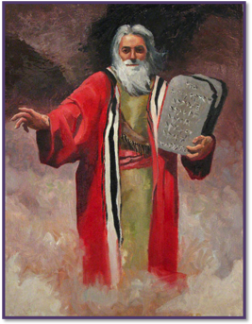The Torah is the most important part of the TeNeKh because it is law of God. Jews believe that about 3,000 years ago, God gave the Torah to Moses, Judaism’s most important prophet. In addition to the history of the early Hebrews, it includes 613 laws, called ***commandments***. These commandments tell the followers of Judaism how to worship and how to live a moral (good) life.

The goal of Judaism is to live a good life according to the laws of the Torah. In addition, followers of Judaism are supposed to pass on Jewish Traditions to their families. An example of this combination is the Torah law that requires Jews to keep the **Sabbath** day, or *Shabbat,* holy. From Friday evening until Saturday evening, Jews must rest and pray.

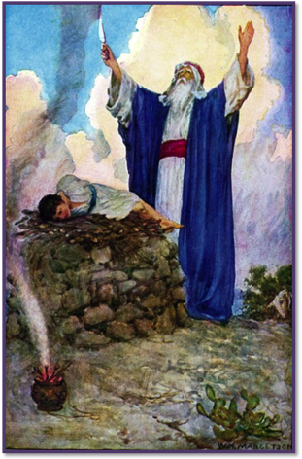Shabbat begins with a traditional family meal. This includes such practices as breaking the Shabbat bread, the ***challah***, and sharing wine. On Friday evening and Saturday morning, Jews gather to pray at a holy building called a ***synagogue***. During the worship service, a teacher, or ***rabbi*** leads the congregation (worshippers) from the TeNeKh. During Saturday’s service the rabbi also gives a religious speech or sermon.

Traditionally, rabbis were Torah scholars who also kept everyday jobs. They acted as rabbis only when working at the synagogue. About 2,000 years ago rabbis began to speak about the Jewish oral law, or ***Talmud***. Jews believe that the Talmud continues to unfold in every generation. This means that God’s teachings continue to be revealed. Rabbis work to understand the continual unfolding of God’s laws and adapt them to the modern world.

The Torah’s laws direct many aspects of Jewish religious and social life. For instance, the Torah commands all Jews to ***fast*** by not eating or drinking during the holiday of ***Yom Kippur***. This holiday is a day Jews set aside for being sorry for bad acts or a day of ***atonement***. The Torah also calls upon Jews to give to the needy to create justice in the world. The Torah outlines what a Jew can eat, called the rules of ***kashrut***. Jews only eat ***kosher*** foods, because they alone meet the Torah’s requirements about the clean preparation of food. Food that is not kosher is called ***tref***. These foods include pork, Shellfish, and meat prepared with dairy products. Today Jews from various sects follow Kashrut to varying degrees.

The three main ***sects*** of Judaism are ***Orthodox, Conservative***, and ***Reform***. All three sects have a special reverence for Jerusalem because it is the sacred city of the prophets.

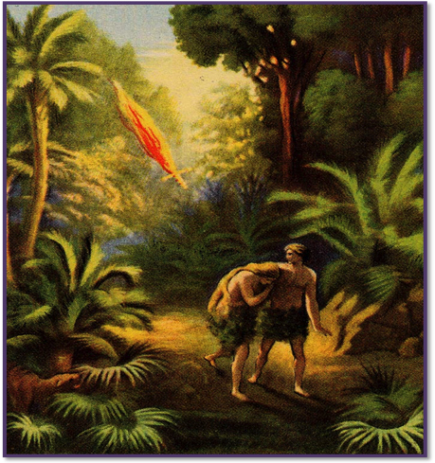**Christianity:**

Followers of Christianity are called ***Christians***. They believe in one God- the *God of Abraham*, often called ***Yaweh*** in English. Abraham lived in the Middle East about 4,000 years ago at a time when most people believed in many gods. However, Abraham believed that only one, all-powerful God created the world.

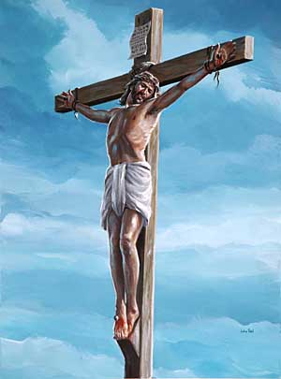Christians believe that God made an agreement, or ***covenant*** with Abraham. This agreement said that Abraham and the future generations of his family, his ***descendants***, would be God’s chosen people in return for their faith and obedience. These people became the ***Hebrews***. Today they are called Jews.

Christians base their religion on the life and teachings of ***Jesus of Nazareth***, known as ***Jesus Christ***. Jesus was a Jew, is said to have been born in ***Bethlehem***, near the city of ***Jerusalem***, around the year 4 B.C. During his life he traveled around northern ***Palestine*** teaching about a new covenant between God and the Jews. Those who followed Jesus’ teachings broke away from other Jews. These followers became Christians, worshipping God in a new way that focused on Jesus’ teachings.

The Christian idea of God is called the ***Trinity*** because Christians believe God has three parts: ***God the Father, God the Son*** (Jesus Christ) and the ***Holy Spirit*** (God’s presence on earth). Therefore, all Christians believe Jesus was both human and God, and most Christians believe Jesus was both human and ***divine*** (God-like). Christians believe that Jesus died on the cross, was buried, and rose from the dead three days later. They believe that Jesus ***ascended*** to heaven to be with God the Father. The story of Jesus’ life is recorded in the Christian holy book, called the ***Bible***.

The Christian Bible has two parts- ***The Old Testament*** and the ***New Testament***. The Old Testament is the history of the law and the stories of the ***prophets***- the ancient Hebrew messengers of God’s word. The Old Testament also contains ***psalms***, or prayers written in song or poem form. The New Testament includes the four ***Gospels***, which are stories of Jesus’ life. The bible has no sacred language, and it has been translated into thousands of languages.

[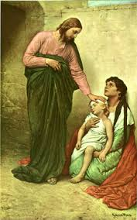](http://www.google.com/imgres?q=jesus+healing+the+sick&um=1&hl=en&sa=X&biw=1280&bih=715&tbm=isch&tbnid=HfBtmVtvVZt_nM:&imgrefurl=http://www.thomaspringle.com/2011/01/ciay-day-218/&docid=__q5ib72e1uC3M&imgurl=http://www.thomaspringle.com/wp-content/uploads/2011/01/JesusHealing.jpg&w=300&h=480&ei=4QOfTvCRCOrb0QHf9JyaCQ&zoom=1)The goal of Christianity is to achieve ***salvation***. The state of salvation is the eternal (never ending) life of ones soul with God in heaven. The opposite of salvation is ***damnation***, or eternal suffering in hell. Christianity holds that those who sin, (turn away from Jesus’ teachings) will suffer damnation.

Christians believe that a person achieves salvation in two ways. The first way is to follow Jesus’s teachings about living a moral life. The second way is to participate in the ***sacraments***- sacred ceremonies in which Christians experience the Holy Spirit. Some Christian groups practice as many as seven sacraments. ***Baptism*** is the ceremony of introduction into Christianity. The ceremony re-creates Jesus’ own baptism in the River Jordan. Communion recreates Jesus’ breaking of bread and sharing wine at his last supper.

Christianity requires specially trained people, like ***ministers***, ***priest***, and ***pastors*** to lead the celebrations and teachings in ***church***. Christianity has three main ***sects***: ***Roman Catholic, Protestant***, and ***Orthodox***. All sects consider Jerusalem the holiest city because that is where Jesus died and rose from the dead.

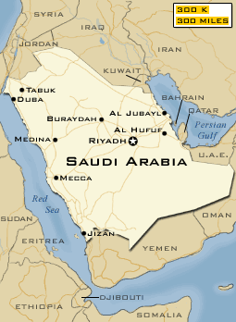**Islam:**

Followers of Islam are called Muslims. Abraham lived in the Middle East about 4,000 years ago at a time when most people believed in many gods. However, Abraham believed that only one, all-powerful God, (Allah in Arabic) created the world. Muslims believe that God made an agreement or covenant with Abraham. This agreement said that Abraham and the future generations of his family, his ***descendants***, would be God’s chosen people in return for their faith and obedience. Abraham had two sons, ***Isaac*** and ***Ishmael***. Muslims believe that the ***Hebrews*** descended from Isaac and the ***Arabs*** descended from Ishmael.

Islam is based on God’s teaching and the example of the life of ***Muhammad***. Muhammad was born in ***Mecca***, located on the Arabian Peninsula, around A.D. 570. Muslims believe that when Muhammad was 40 years old, he had a vision. In this vision, the angel Gabriel appeared and told him to repeat a message from God.

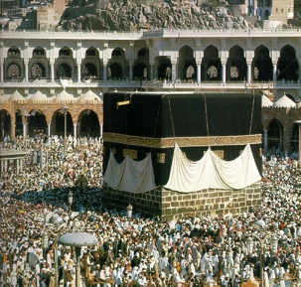God’s message was revealed over the next 23 years. During this time, Muslims learned to accept all the Hebrew messengers of God’s word, or ***prophets***, including Moses and Jesus. However, Muslims did not believe that Jesus was divine and they felt that God’s chosen people had not properly followed the prophets. Muslims consider Muhammad to be God’s final prophet. They believe that through Muhammad, God made Mecca the center of Islam, and its holiest city. After Muhammad’s death, God’s teachings as revealed to Muhammad, were written down in ***Koran*** (Quran)- the holy book of Islam.

Arabic is the sacred language of Islam. Though the Koran has been translated into many languages, it is used for religious purposes only in its Arabic form. The Koran contains the revelations God made to Muhammad.

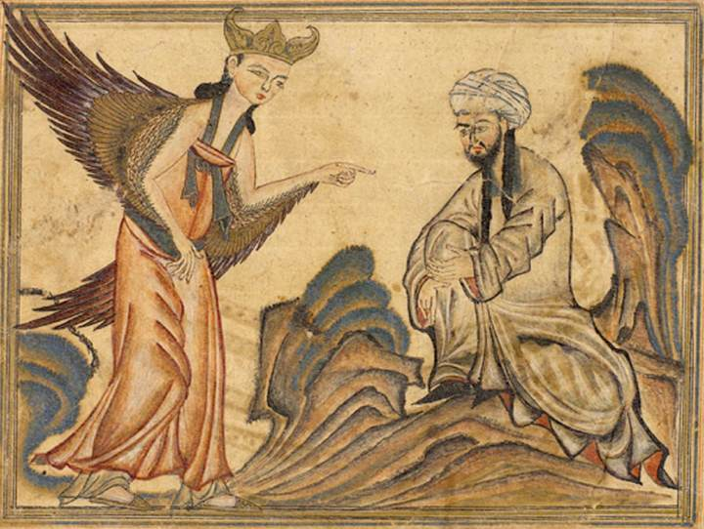These revelations include many of the ideas from the history and laws of ancient Hebrews and their prophets, as well as the story of Jesus’ life. The Koran outlines the goal of Islam: Living according to God’s guidance, is rewarded with **salvation**, paradise with God. The opposite of salvation is ***damnation***.

To achieve salvation, Muslims must participate in five basic practices. These practices are known as the “**five pillars**” and they are found in Koran. The first is, ***shahada***, a public declaration of faith, which is the recitation of the Islamic basic belief, or ***creed***. The second is ***salat***, or prayer Muslims pray five times a day at specific times but always facing Mecca. The third is ***zakat***, or giving to the needy. Islam requires a Muslim to give approximately 2.5% of their income to charity. ***Siyam***, or fasting, is the fourth pillar. For 30 days during the month of Ramadan, Muslims cannot eat or drink from dawn to sunset. The final pillar requires each Muslim who is able to make a ***hajj***, or journey, to Mecca once in his or her life. The Koran also describes a way of life that contains ***halal***, acts that are allowed, and ***haram***, acts that are forbidden.

Muslims worship in a holy building called a ***mosque***. Prayers held on Friday at noon are the most important. During the Friday worship service, an ***imam***, or prayer leader reads from the Koran and gives a religious sermon. Muslims select a person of good character and religious knowledge as their imam. Muslims also hold ***Jerusalem*** sacred as the city of prophets. They believe it is the place where Muhammad met the other prophets and ascended into heaven. The two major Muslim sects are ***Sunni*** and ***Shi’i***, where they often differ over beliefs in leadership within the Muslim community.