Name__________________________________________________________________Date_____________Period_____________

Levels of Development
Directions: Read the following definitions about levels of development.

More Developed Country- countries with a combined long life expectancy, higher education, higher income, and advanced technology/medicines available for all citizens. Ex: United States, England

Newly Industrialized Country- Countries that have recently become industrialized, a climbing life expectancy, and increasing education and technology/medicines for most citizens. Ex: Mexico, Philippines

Less Developed- Countries that have the lowest life expectancies, highest birth rates, and almost no widespread education or technology/medicine for their citizens. Ex: Honduras, Chad, Bhutan

Directions: Use the UpFront Magazine website to fill in the chart. https://upfront.scholastic.com/pages/world-affairs-almanac.html.
- Click North America
- Click Well Being
- Color and label the country, and then decide if it is a More Developed, Newly Industrialized, or a Less Developed country.
1. Canada
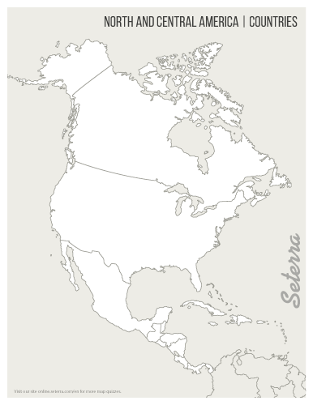 | Area (Square Miles)  Total Population:  Population Increase %________ | Population-Pie Chart  Urban_______%  Rural _______% | Literacy Rate  Life Expectancy: | Per Capita GDP:  $  Human Development Index  0-----------------1
More Developed Newly Industrialized Less Developed

2. Panama
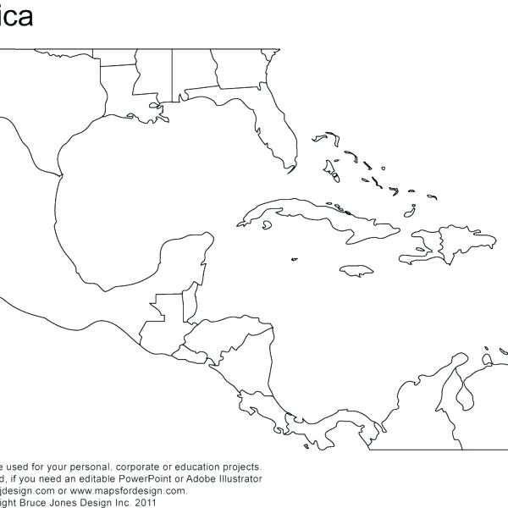 | Area (Square Miles)  Total Population:  Population Increase %________ | Population-Pie Chart  Urban_______%  Rural _______% | Literacy Rate  Life Expectancy: | Per Capita GDP:  $  Human Development Index  0-----------------1
More Developed Newly Industrialized Less Developed

3. Guatemala
 | Area (Square Miles)  Total Population:  Population Increase %________ | Population-Pie Chart  Urban_______%  Rural _______% | Literacy Rate  Life Expectancy: | Per Capita GDP:  $  Human Development Index  0-----------------1
More Developed Newly Industrialized Less Developed

4. United States
 | Area (Square Miles)  Total Population:  Population Increase %________ | Population-Pie Chart  Urban_______%  Rural _______% | Literacy Rate  Life Expectancy: | Per Capita GDP:  $  Human Development Index  0-----------------1
More Developed Newly Industrialized Less Developed

5. Haiti
 | Area (Square Miles)  Total Population:  Population Increase %________ | Population-Pie Chart  Urban_______%  Rural _______% | Literacy Rate  Life Expectancy: | Per Capita GDP:  $  Human Development Index  0------------------1
More Developed Newly Industrialized Less Developed

6. Mexico
 | Area (Square Miles)  Total Population:  Population Increase %________ | Population-Pie Chart  Urban_______%  Rural _______% | Literacy Rate  Life Expectancy: | Per Capita GDP:  $  Human Development Index  0------------------1
More Developed Newly Industrialized Less Developed

Name__________________________________________________________________Date_____________Period_____________

Levels of Development Questions

Directions: Using the notes and information you have just gathered, answer the following questions.

- Place the above countries in the correct place in the table based on their development.
More Developed | Newly Industrialized | Less Developed
1.  2. | 1.  2. | 1.  2.

- Which three countries had the lowest life expectancy?
A. B. C.

- What do you think could affect life expectancy more: Medical Facilities or Income? Explain your answers.

- What makes Haiti unique when you compare it on the map to all of the other countries?

- If a country has a declining literacy rate, is it improving or declining in the standard of living? Why?

- By reviewing your pie charts, what correlation does an urban population have with being more developed?

- If a country is less developed, what major improvements will they need to undergo to move up a level to developing (use your brain power)?

- If a countries population is increasing, what is happening to both birth and death rates?

- How does a level of development affect spatial reorganization?

