Layers of the Earth Foldable Instructions

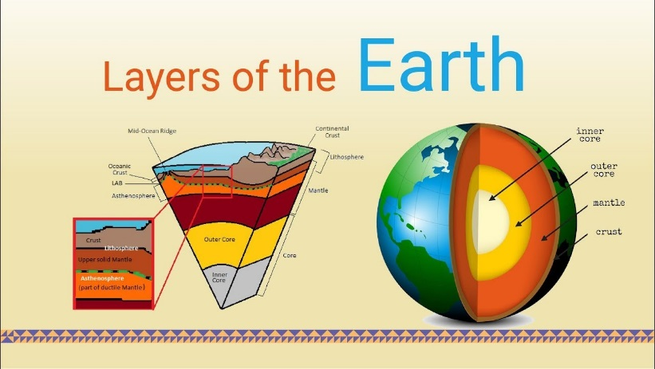
Supplies:
- 1 page of printed layers
- 2 blank pages of paper
- Textbook (page 44-45)
- Colored Pencils/Markers
- Glue/Scissors
Steps:
- Cut out each of Earth’s layers
- Fold your blank paper to make 4 flaps
- Glue on your layers in order (top to bottom)
- Title your Assignment “Layers of the Earth”
- Label each individual layer
  - Inner Core
  - Outer Core
  - Lower Mantle
  - Middle Mantle
  - Upper Mantle
  - Continental Crust
  - Oceanic Crust
  - Convection Currents
- Inside of each flap, write about the following in complete sentences-
  - Size of Layer
  - Makeup of Materials
  - 3-4 Unique facts about specific layer
- Name, Date, Period on the BACK of your foldable

