Name_____________________________________________Date________________Period_______Teacher_________________

Title:____________________________________ (Day 1)

Latin America is considered to be all of the countries south of the United States.
- Mexico
- Central America
- Caribbean Islands
- South America
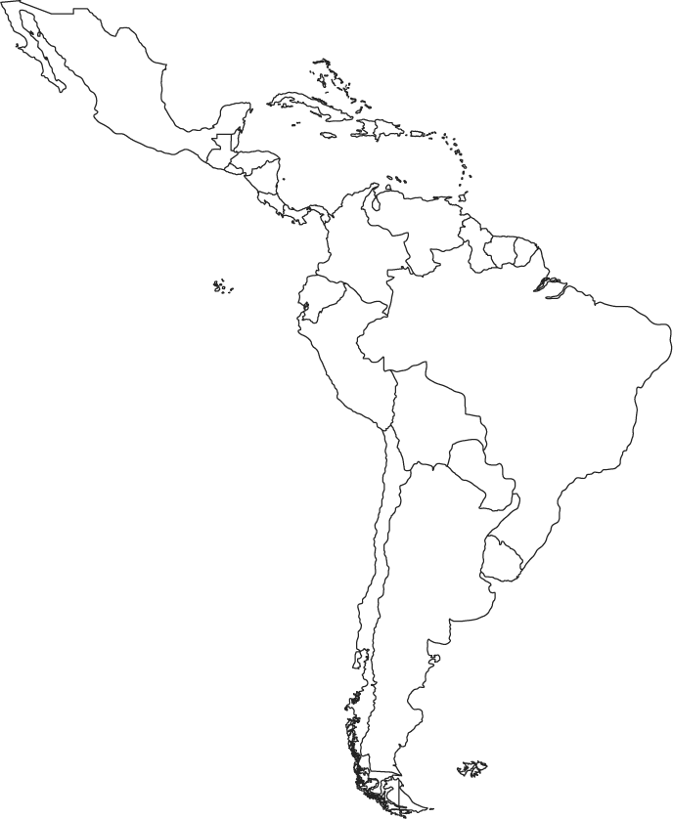
We call all of these areas ‘Latin America’ because they share similar cultural traits, languages, government styles, and heritages. Use the key below to color in and label the different regions of Latin America.

Mexico- Green
Central America- Yellow
Caribbean- Purple
South America- Orange

1. Regions of Latin America

_________ All Items Labeled Correctly

_________All Items Colored Correctly

________ Neat and Easy to Read

Title:____________________________________________________________ (Day 1)

The continent of South America is made up of 13 different countries and territories, and all but two have access to coastlines. Coastlines provide a way for a country to import and export goods, increasing their economy. Locate and label the following countries based on their access to coastlines.
Northern Coastline
Northern Coast (Green)
1.
2.
3.
4.
5.

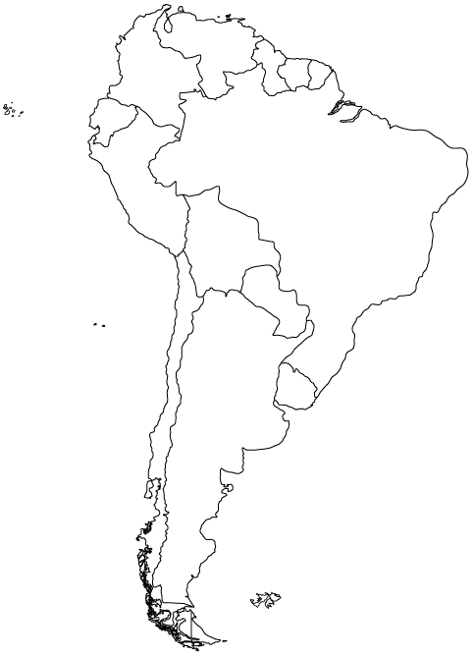

Atlantic Coast (Yellow)
1.
2.
3.
Landlocked (Red)
1.
2.

Pacific Coast (Orange)
1.
2.
3.

2. Land Locked Countries of South America

_________All items labeled correctly

_________All items colored correctly

_________Neat and easy to read

Title:_____________________________________________________ (Day 1 and 2)
Directions: Label the following countries for each map. Then, color it like a political map.
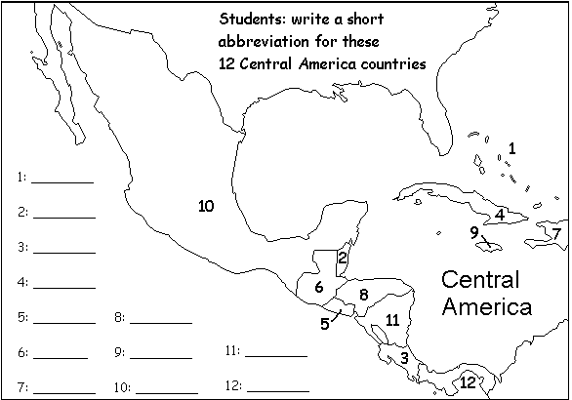

1._______________________ 2.______________________
3._______________________4._______________________
5._______________________6._______________________
7._______________________8._______________________
9._______________________10._____________________
11._____________________12.______________________

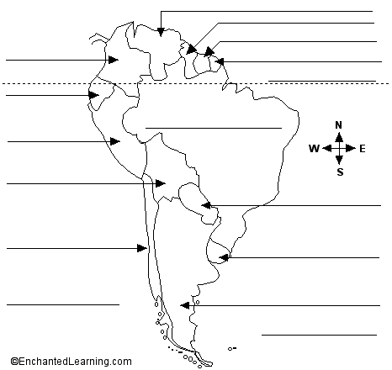

Countries of South America

_________ All Items Labeled Correctly

_________All Items Colored Correctly

________Neat and Easy to Read

Title:_______________________________________________ (Day 2)

Directions: Label and color/trace the following Features. Outline all water in Blue. Do not use Blue for Land. Only color the features that are listed on the map. **Denotes features of North America.

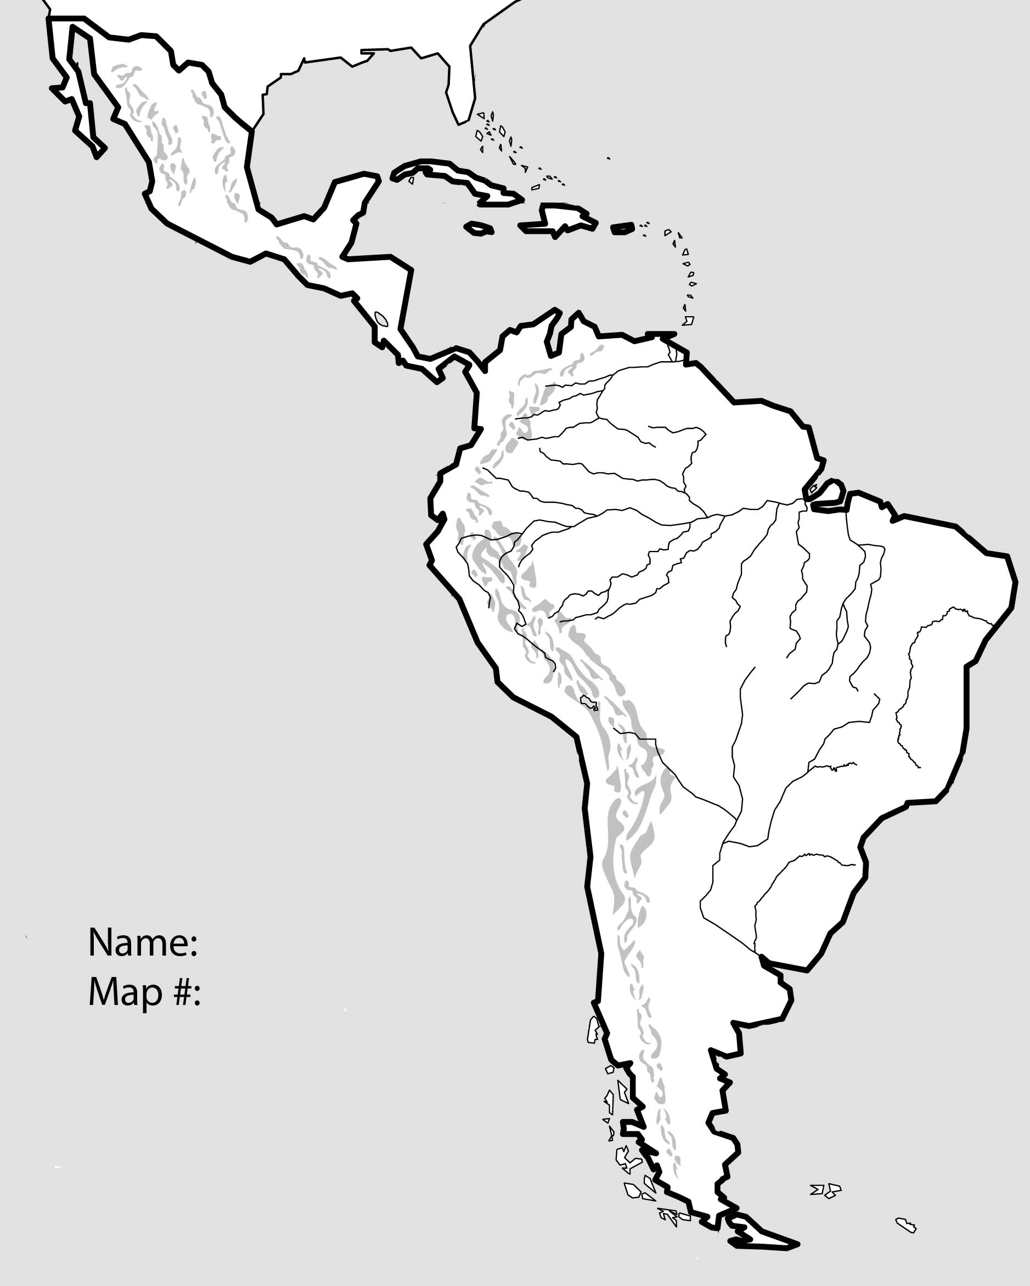
Physical Features of Latin America

___________ Landforms Labeled

___________Landforms Colored

___________Neatness and Accuracy

Water Features:
1. Atlantic Ocean-Blue
2. Pacific Ocean-Blue
3. Amazon River-Blue
4. Gulf of Mexico-Blue
5. Caribbean Sea-Blue
6. Panama Canal-Blue
7. Angel Falls-Blue

Land Features:
8. Amazon Rainforest-Dark Green
9. Guiana Highlands-Yellow
10. Brazilian Highlands-Brown
11. Andes Mountains-Purple
12. Pampas Region-Light Green
13. Patagonia Region-Pink
14*. Yucatan Peninsula-Orange
15*. Sierra Madre Occidental Mountains-Purple
16*. Sierra Madre Oriental Mountains -Purple

Title:____________________________________________________ (Day 2 and 3)
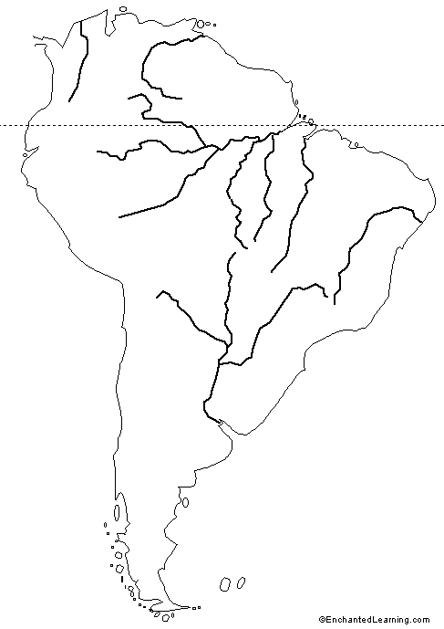
Directions: Use the Atlas, page 61 to complete the population density map. Population Density represents the number of people in an area. Areas with a higher density are due to their location and availability of resources, or an area with extreme poverty where many people must live together to survive.

1. Label and Color the Amazon River.

2. Label the Equator, Atlantic Ocean, and Pacific Ocean.

3. Color all Populations of 100 to over 250 People purple.

4. Color all populations with less than 100 people yellow.

5. Answer the questions below in complete sentences.
1. Near what types of features will you find the highest population densities in South America?

2. Why is there such a low population density in the north/central part of South America?

3. Why does the southern tip of South American have the lowest population density on the continent, even though it has a large amount of coastlines?

Population Density of Latin America

_________Mapping

_________Questions

__________Neatness and Accuracy

Name_________________________________________________Period______________Date___________Late: Yes or No

Latin America Mapping Lab Rubric

Regions | Land Locked | Political | Physical | Population
______Labeled (4)  ______Colored (4)  ______Neat (2) | ______Labeled (6)  ______Colored (6)  ______Neat (2) | ______Labeled (10)  ______Colored (10)  ______Neat (5) | ______Labeled (10)  ______Colored (10)  ______Neat (5) | ____Mapping (10)  ____Questions (10)  ______Neat (5)
_______Total | _______Total | _______Total | _______Total | _______Total

Overall Total Grade:

Name_________________________________________________Period______________Date___________Late: Yes or No

Latin America Mapping Lab Rubric

Regions | Land Locked | Political | Physical | Population
______Labeled (4)  ______Colored (4)  ______Neat (2) | ______Labeled (6)  ______Colored (6)  ______Neat (2) | ______Labeled (10)  ______Colored (10)  ______Neat (5) | ______Labeled (10)  ______Colored (10)  ______Neat (5) | ____Mapping (10)  ____Questions (10)  ______Neat (5)
_______Total | _______Total | _______Total | _______Total | _______Total

Overall Total Grade:

