Early Civilizations of the Middle East and North Africa

Human Migration from East Africa (1.1-1A) | Excerpt over Plant and Animal Domestication (1.2-1A) | Map of How Agriculture Spread (1.2-4A)
1. Read the excerpt and Highlight Plus the paragraph and Map.  2. Examine the arrows on the map. Where does the map indicate is the starting point of human migration?  3. Why do you think that the dates and years are estimates?  4. From the reading, what scientific evidence supports Gugliotta’s theory?  5. Using the Routes of Migration, which habitable continent was most likely the last to see experience human migration?  6. When looking at the map, what physical feature would potentially be the biggest barrier to human migration? | 1. Read the excerpt and Highlight Plus the paragraph and Map.  2. In which two areas of the map do both original centers of production and modern production areas overlap?  3. In your own words, what is plant and animal domestication?  4. Give an example of both a plant and animal that have been domesticated.  5. How do scientists know that domestication occurred in only a few areas?  6. How does domestication lead to lasting civilizations in the future? | 1. Read the excerpt and Highlight Plus the paragraph and Map.  2. In which areas did most agriculture originate from?  3. Looking at the map, provide a theory as to why agriculture did not spread to Australia?  4. Looking at the map, provide a theory as to why agriculture did not spread to modern day Russia and Canada?  5. What made the spread of agriculture possible over the Pacific Ocean and not the Atlantic Ocean?  6. How does the spread of agriculture correlate to the patterns of human migration?

Name____________________________________________________________________Date___________Period_______
Mapping Similarities

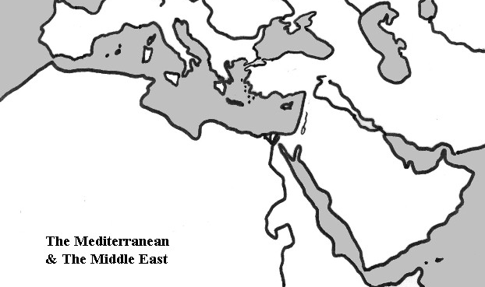
Key

1. Use Green and color all areas of MENA that had Anatomically Modern Humans (1.1-1A)

2. Use Orange and color all areas of MENA that were centers of origin of food productions (1.2-1A)

3. Use Red and color all areas of MENA where agriculture originated (1.2-4A)

Written Response
In the space below, write a FULL paragraph that explains or covers the following information. Make sure to write in complete sentences that answer the questions fully. All grammar rules will apply.

Prompt: Explain the early geographic correlation between human migration and early agriculture of the MENA. Support your answer with evidence from the text or maps.

_________________________________________________________________________________________________________________________________________________________________________________________________________________________________________________________________________________________________________________________________________________________________________________________________________________________________________________________________________________________________________________________________________________________________________________________________________________________________________________________________________________________________________________________________________________________________

