Name___________________________________________________Date___________Period______________
Human Environment Interaction Notes
Warm-Up: Answer in Complete Sentences
Image 1:___________________________________________________________________________________________ ____________________________________________________________________________________________________________________________________________________________________________________________________
Image 2: __________________________________________________________________________________________ ____________________________________________________________________________________________________________________________________________________________________________________________________
Image 3: __________________________________________________________________________________________ ____________________________________________________________________________________________________________________________________________________________________________________________________
How are all three of these images part of Human Geography (finding the interconnectedness)?
______________________________________________________________________________________________________________________________________________________________________________________________________________________________________________________________________________________________________
A. Human Environment Interaction
- ____________or Human Environment Interaction is a ____________________which describes how human beings _____________with the environment to ___________________from it, and how the__________________, in turn, _________________to this interaction.
- It indicates how humans themselves have to _________________________________________________the environment to____________________________________________.
- The acronym DAM (______________________________) is used in HEI.
B. Humans Depend on their Environment
- Humans depend on the environment to _____________________for their __________________ as well as development of their ____________________________.
~______________, clean drinking_______________, _____________for construction, fiber for______________, coal and natural gas for industries and energy are all depended upon for survival.
C. Humans Adapt to Their Environment
- Humans have to _______________to those conditions in the environment which_________________________, to ensure______________________.
- Examples of _________through ____________________________________are: building houses on higher ground in_____________________, using the ______________________of the land to transport water for irrigation, wearing ______________________________________________-…
D. Humans Modify Their Environment
- Humans can _______________the environment to make it ___________________________________________, so that their needs are____________________________________.
- ________________________________allow people to not only survive, but________________.
- Such modifications can include ________________________in the ground for oil extraction, __________________________for water storage and flood control, __________________________________to increase crop production for a large population…

E. Types of Interactions
- Human environment interactions mostly produce positive effects for ____________ (______________), but they also have far-reaching consequences on the environment, that are all too often__________________.
- A few of these interactions may be _________________or have _____________________________________on the environment. Examples of such consequences are the recreational use of mountainous regions for skiing or_____________________, or______________________________________.
- In most cases though, the _____________________ends up being___________________. Human activities have ended up _______________the_______, __________, and______________.
- This has led to increasing surface temperatures of the Earth (______________________), which has placed coastal towns around the world at risk of being submerged.
- The ____________________of forests for cultivation and timber production has __________________many _____________of ____________and_______________, putting entire ecosystems under__________________.

Positive (or Nuetral) | Negative
1.  2.  3.  4.  5. | 1.  2.  3.  4.  5.

In complete sentences describe how HEI is a part of Human Geography? _________________________________________________________________________________________________ ______________________________________________________________________________________________________________________________________________________________________________________________________________________________________________________________________________________________________

Name___________________________________________________Date___________Period______________
Human Environment Interaction Examples
Directions:
- Read each scenario and circle if it is a positive or negative HEI.\
- Then use the code to identify if it is D-A-M (depending, Adapting, Modifying). Some may have multiple correct choices, but use the BEST answer. Don’t forget the images at the bottom!
Depending: Blue
Adapting: Green
Modifying: Red

The Amazon Rainforest is being cut down and used for Timber.  Positive or Negative | Farmers are able to live off of the crops that grow in natural habitats.  Positive or Negative | Communities have a “Cut one Plant Three” program. For each tree cut down, three are replanted.  Positive or Negative
Dams have flooded over lands once used as farmland.  Positive or Negative | Streams and rivers are the main way to transport items.  Positive or Negative | Hydro electricity is produced from Dams across the world.  Positive or Negative
Canal Systems have been around for thousands of years.  Positive or Negative | Nile River provides fish for many people of northern Africa.  Positive or Negative | Houses are built on stilts near flood zones.  Positive or Negative
The Pacific Ocean has a plastic vortez, almost the size of Texas due to pollution.  Positive or Negative | Terrace farming enables more crops to be grown in an area.  Positive or Negative | Slash and burn farming kills all plant life, reducing natural habitats.  Positive or Negative
France made recycling a law. You must recycle all possible materials.  Positive or Negative | Eskimo people of northern Canada use Ice blocks to build homes.  Positive or Negative | Amazonians build lifted houses to avoid ants and bugs.  Positive or Negative
Aqudeucts were made to transport water from the Nile to the dry areas of the Sahara Desert.  Positive or Negative | More areas are turning into deserts as water is being used.  Positive or Negative | Hiking trails and animal reserves are created throughout the United States and Texas to preserve ecosystems.  Positive or Negative
The Aswan High Dam controls seasonal flooding.  Positive or Negative | Gases and pollutants cover Mexico City due to overcrowding.  Positive or Negative | African tribes build homes out of clay to keep cool in the hot summer months.  Positive or Negative
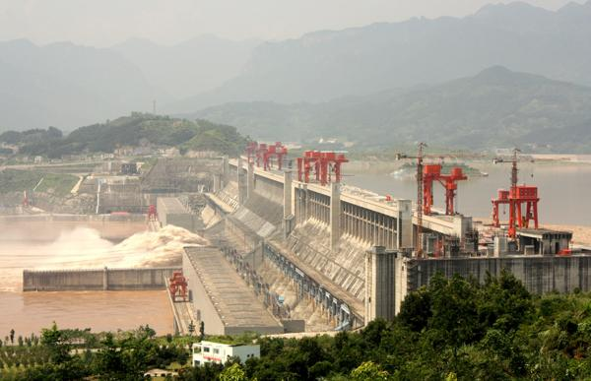  Dam with Water  Positive or Negative | 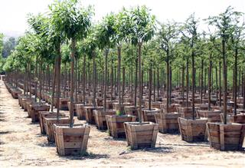  Trees in a Nursery  Positive or Negative | 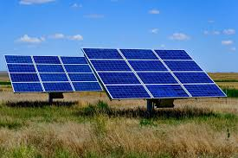  Solar Panels  Positive or Negative

