Name_________________________________________________Date__________________Period_________________
Outbreaks, Epidemics, and Pandemics OH MY!
Explanation
The terms outbreak, epidemic, and pandemic are all used to describe contagious diseases. Although similar in nature, these terms are used to explain the differences in occurrence and contagion region. An outbreak is the sudden occurrence of a disease in a community, which has never experienced the disease before or when cases of that disease occur in numbers greater than expected in a defined area. An epidemic is an occurrence of a group of illnesses derived from a common source, in excess of what would be normally expected in a community or region. A pandemic on the other hand refers to a worldwide epidemic, which could have started off as outbreak, escalated to the level of an epidemic and eventually spread to a number of countries across continents.

BACKGROUND
HIV/AIDs  Human Immunodeficiency Virus/Acquired Immune Deficiency Syndrome | Ebola  Virus
- Autoimmune diseases that attacks the body and immune system  - Can be ‘silent’ or dormant for years (often people do not realize they are infected)  - Transmitted through bodily fluids (most commonly through sexual contact)  - Africa, and in particular the Southern region of Africa has an infection rate of almost 20% of the adult population  - HIV/AIDs has been a large problem since the 1970’s to all, but affects homosexuals more  - South Africa has the highest infection rate, and some medical professionals link this to the culture, religion, and governmental styles  - HIV began as a primate disease and passed on to Humans through hunting and eating of ‘bush meat’ or monkey meat.  - Low income, lack of education, and deficient medical care are all reasons for infection | - Virus that creates high fevers and internal bleeding until death occurs.  - From symptoms to death- can be as little as 5 days.  - Transmitted through bodily fluids (even after a host has died)  - Although not exactly known as to where the first beginnings are, Central and Western Africa have the highest rates (50% fatal)  - Ebola’s largest outbreak was in 2014, starting in Ghana and spreading all the way to Dallas, Asia, and Europe as well as throughout Africa.  - Native groups have a higher infection rate, as it is customary to ‘drain’ bodies of loved ones before burial  - Areas with less government restrictions, education, and low medical treatments see more fatalities due to Ebola  - Latest outbreak April 1, 2019 (YES-5 days ago)

WHY GEOGRAPHERS MATTER
From the beginning when these outbreaks, epidemics, and pandemics started, the WHO (World Health Organization) has looked to Geographers for help. Medical doctors are wonderful at finding treatments for people who are infected, but it has been up to geographers to find out where and why the next outbreak will occur. For both HIV and Ebola, culture, religion, and natural features all had to be studied. For example, Northern Africa has a very low rate of HIV mainly in part to the separation of from Sub-Sahara Africa. Also, some indigenous tribes cleanse the body after death, effectively draining out all bodily fluids by hand (and without gloves or protection). Due to practices like this, geographers needed to know cultural connections so they could predict and stop future outbreaks.

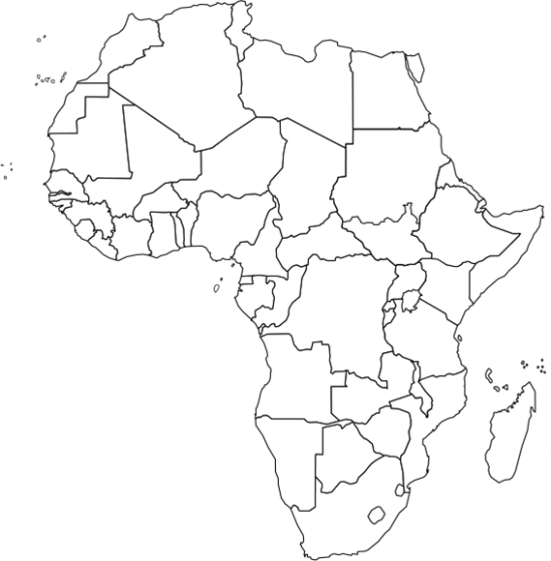
STEP ONE: MAPPING
Using the map on page 580 of the textbook, color in the continent of Africa and create a key for HIV. Then using the printed image, add in a proportional dot map of the Ebola outbreaks and add to your key. These maps will overlap, so color carefully.

Key

HIV Ebola

STEP TWO: THINKING LIKE A GEOGRAPHER
1. What religion is most commonly found in Northern Africa? ____________________________
2. Thinking about your answer for #1 (and what you know from the Middle East), why would this region have a lower rate of infection of HIV than the rest of the continent? Be very specific.

3. What cultural ties have concentrated the Ebola outbreaks to central Africa?

4. What contributes to a higher rate of infection of HIV over Ebola?

5. Which indicator, education or health care, do you think is the probable cause for higher rates of infection of HIV and/or Ebola? Defend your answer.

6. From the bulleted information, what proof do you have that Ebola was a pandemic?

7. Why were geographers so important to the WHO when studying Ebola?

8. What modern cultural shifts could potentially lead to higher HIV rates than before?

9. Considering your map, what physical features help contain outbreaks?

