Name_______________________________________________Date_____________________Period_________________Teacher____________________

Human Environment Interactions of Europe

**Directions:** Using the website, or the readings, fill in the graphic organizer below.

**Geothermal Power in Iceland**

**Where:**

**What is it:**

**How do Humans use it:**

**Positive or Negative** (circle one)

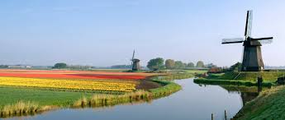

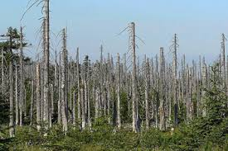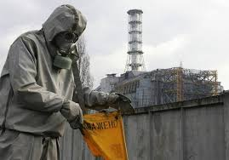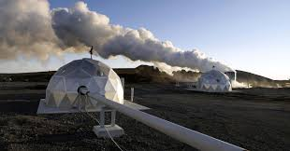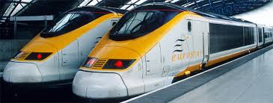

**Polders**

**Where:**

**Why are they built:**

**Why does the Netherlands need Polders:**

**Positive or Negative** (circle one)

**Chernobyl**

**Where:**

**When was the accident:**

**What type of plant was it:**

**Outcome and lasting effects:**

**Positive or Negative** (circle one)

**Acid Rain**

**Where:**

**How does it form:**

**What problems does it cause:**

**Outcome and lasting effects:**

**Positive or Negative** (circle one)

**Chunnel**

**Where:**

**When Was it Built (completed):**

**What is it used for:**

**Cost:**

**Positive or Negative** (circle one)