Chunnel
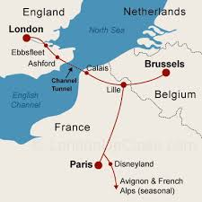
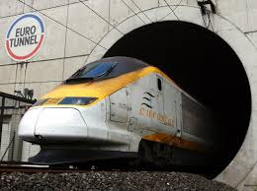

Channel Tunnel = Chunnel
- Construction: June 1988 – May 1994
- Connects Folkstone, England, with Sangatte, France, (31 miles away).
- The Chunnel cuts travel time between England and France to 35 minutes and between London and Paris to two-and-a-half hours.
- Underwater Tunnel connecting the Island nation of the United Kingdom to mainland Europe

As the world’s longest undersea tunnel, the Chunnel runs under water for 23 miles, with an average depth of 150 feet below the seabed. Each day, about 30,000 people, 6,000 cars and 3,500 trucks journey through the Chunnel on passenger, shuttle and freight trains.

Millions of tons of earth were moved to build the two rail tunnels–one for northbound and one for southbound traffic–and one service tunnel. Fifteen thousand people were employed at the peak of construction. Ten people were killed during construction.

The Chunnel’s $16 billion cost was roughly twice the original estimate, and completion was a year behind schedule. But it showed its first net profit in 1999, helping the economy, and commuters of Europe.

In 1996, the American Society of Civil Engineers identified the tunnel as one of the Seven Wonders of the Modern World.

Geothermal Power in Iceland
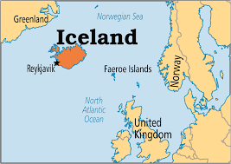
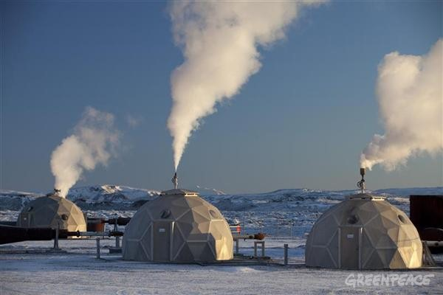

Geothermal Power
- 99 percent of Iceland's electricity is produced from renewable sources, 30 percent of which is geothermal
- Due to many underground magma pits and volcanoes, heat can be extracted and used for heating and power

Iceland is located at the crack in Earth's crust where the North American and Eurasian plates are pulling apart. It possesses two of the traits dearest to geologists in search of exploitable geothermal power; enormous underground reservoirs of water that are continually renewed by levels of annual precipitation that range as high as 177 inches over Iceland's glaciers, and shallow plumes of magma that heat the deepest reaches of these reservoirs to temperatures in excess of 750 degrees Fahrenheit.

By financing thermal and electric power plants throughout the country, as well as the infrastructure required to deliver hot water to homes, the Icelandic government not only eliminated the country's dependence on fossil fuels for heating and electricity, but also jump-started an entire industry.

But geothermal is not entirely risk-free. A recent effort to build such a geothermal power plant in Basel, Switzerland, came to an abrupt halt when it triggered an earthquake measuring 3.4 on the Richter scale, too small to cause damage but large enough to be felt by humans.

Polders in the Netherlands
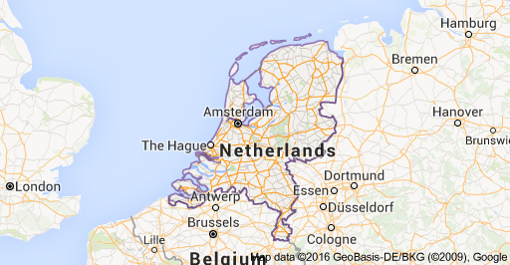
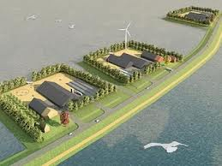

Polders
- Land reclamation (or removing water to expose fertile land) along the margins of the shallow sea began more than 2,000 years ago.
- By the 13th century, windmills were used to pump water out of the areas below sea level, creating the Netherlands’ famous polders.

A polder is a large tract of low-lying wetland or former sea floor partially or wholly encircled by dikes and drained mostly with pumps. Poldering is so important the Netherlands would barely exist without it. The problem with poldering is that, because the polders lie below the surrounding water levels, water invariably seeps back under the dikes (. As a result, the water must be pumped by windmill or electricity more or less continuously into canals, which are found throughout poldered areas. The canals collect the water, which then flows or is pumped away to the sea.

The land of the Netherlands, however, is affected by other variables unrelated to global warming. The sea walls, drainage canals, levees and dikes themselves have impacted the country. River deltas in general tend to subside, or sink, naturally, increasing the impact of a rise in sea level. The Netherlands’ engineering projects also have limited the ability of streams to naturally add new sediments to the deltas.

One example is the Biesbosch, a small inland delta and national park, where the Dutch government has breached some dikes originally built to protect farmland and dug additional drainage channels. No longer will the water be held captive by tightly constricted river and canal channels. Instead, big floods are allowed to spread across the Biesbosch delta to serve as a temporary reservoir. This tends to reduce the threat of water spilling over the top of levees that guard densely populated cities downstream. Other ideas are to place newly built homes on stilts or design them to float. In the future entire villages might be built to float in place, linked by buoyant sidewalks and roads.
Chernobyl
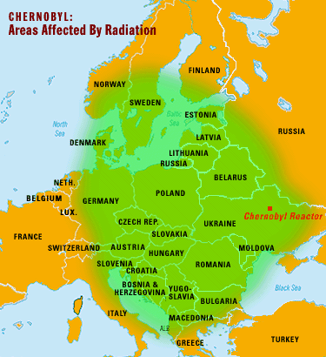
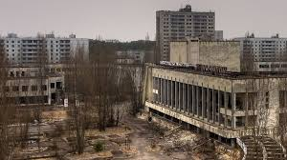

- April 26, 1986, the world’s worst nuclear accident to date occurs at the Chernobyl nuclear plant near Kiev in Ukraine.
- 200 people were directly exposed and 31 had died immediately
- As many as 70,000 suffered severe poisoning. In addition, a large area of land may not be livable for as much as 150 years.

The Soviet Union built the Chernobyl plant, which had four 1,000-megawatt reactors, in the town of Pripyat. At the time of the explosion, it was one of the largest and oldest nuclear power plants in the world. The explosion and subsequent meltdown of one reactor was a catastrophic event that directly affected hundreds of thousands of people. Still, the Soviet government kept its own people and the rest of the world in the dark about the accident until days later.

It soon became apparent that the Soviets were covering up a major accident and had ignored their responsibility to warn both their own people and surrounding nations. Two days after the explosion, Swedish authorities began measuring dangerously high levels of radioactivity in their atmosphere.

Years later, the full story was finally released. Workers at the plant were performing tests on the system. They shut off the emergency safety systems and the cooling system, against established regulations, in preparation for the tests. Even when warning signs of dangerous overheating began to appear, the workers failed to stop the test. Xenon gases built up and at 1:23 a.m. the first explosion rocked the reactor. A total of three explosions eventually blew the 1,000-ton steel top right off of the reactor. Flames shot 1,000 feet into the air for two days, as the entire reactor began to melt down. Although firefighting was futile, Pripyat’s 40,000 people were not evacuated until 36 hours after the explosion. Potentially lethal rain fell as the fires continued for eight days. Dikes were built at the Pripyat River to contain damage from contaminated water run-off and the people of Kiev were warned to stay indoors as a radioactive cloud headed their way.
Acid Rain
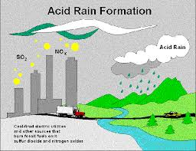

- Acid rain is rain consisting of water droplets that are unusually acidic because of atmospheric pollution
- The gases responsible for acid deposition are normally a byproduct of electric power generation and the burning of coal.

Acid deposition can occur via natural sources like volcanoes but it is mainly caused by the release of sulfur dioxide and nitrogen oxide during fossil fuel combustion. When these gases are discharged into the atmosphere they react with the water, oxygen, and other gases already present there to form sulfuric acid, ammonium nitrate, and nitric acid. These acids then disperse over large areas because of wind patterns and fall back to the ground as acid rain or other forms of precipitation.

As acid rain falls on trees, it can make them lose their leaves, damage their bark, and stunt their growth. By damaging these parts of the tree, it makes them vulnerable to disease, extreme weather, and insects. Acid falling on a forest’s soil is also harmful because it disrupts soil nutrients, kills microorganisms in the soil, and can sometimes cause a calcium deficiency. Trees at high altitudes are also susceptible to problems induced by acidic cloud cover as the moisture in the clouds blankets them. Damage to forests by acid rain is seen all over the world, but the most advanced cases are in Eastern Europe. It’s estimated that in Germany and Poland, half of the forests are damaged, while 30% in Switzerland have been affected.

Finally, acid deposition also has an impact on architecture and art because of its ability to corrode certain materials. As acid lands on buildings (especially those constructed with limestone) it reacts with minerals in the stones sometimes causing it to disintegrate and wash away. Acid deposition can also corrode modern buildings, cars, railroad tracks, airplanes, steel bridges, and pipes above and below ground.

Water Pollution
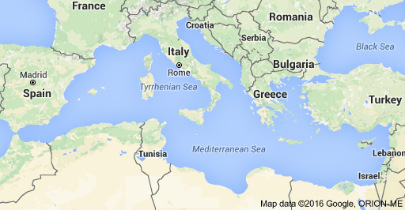
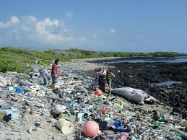

- A survey found around one thousand tons of plastic floating on the surface, mainly fragments of bottles, bags and wrappings.
- The Mediterranean Sea's biological richness and economic importance means plastic pollution is particularly hazardous, say Spanish researchers.
- Plastic has been found in the stomachs of fish, birds, turtles and whales.

Given the biological wealth and concentration of economic activities in the Mediterranean Sea, the effects of plastic pollution on marine and human life could be particularly relevant in this plastic accumulation zone.
"We identify the Mediterranean Sea as a great accumulation zone of plastic debris," said Andres Cozar of the University of Cadiz in Puerto Real, Spain, and colleagues.
"Marine plastic pollution has spread to become a problem of planetary scale after only half a century of widespread use of plastic materials, calling for urgent management strategies to address this problem."
Plastic is accumulating in the Mediterranean Sea at a similar scale to that in oceanic gyres, the rotating ocean currents in the Indian Ocean, North Atlantic, North Pacific, South Atlantic and South Pacific, the study found. A high abundance of plastic has also been found in other seas, including the Bay of Bengal, South China Sea and Barents Sea in the Arctic Ocean.

"These very small plastic fragments lend themselves to being swallowed by marine species, potentially releasing chemicals into the gut from the plastics," Dr. Morritt, of the School of Biological Sciences, told BBC News,"Plastic doesn't degrade in the environment - we need to think much more carefully about how we dispose of it, recycle it, and reduce our use of it."

The Mediterranean Sea represents less than 1% of the global ocean area, but is important in economic and ecological terms. It contains between 4% and 18% of all marine species, and provides tourism and fishing income for Mediterranean countries

