Panama Canal  1. Connects the _____________and ____________Oceans  2. Cuts through the country of ________________  3. Creates a ____________and ___________shipping routes.  4. Boosted Panama’s ________________  5. ____________________much of the natural landscapes and _________________many natural waterways. | Atacama Desert  1. _______________________due to the ___________________ ________________ from the Andes.  2. One of the _______________________(dryer than the polar deserts)  3. Over ____________________________call the Atacama home and use it for __________________________ (__________, tomatoes, cucumbers)  4. ______________________is also very common, since this is their normal terrain.  5. Mining _______________is also very common in the Atacama Desert.
Amazon Rainforest  1. Amazon is home to over _______________Square miles of forests.  2. Roughly ____________________of forests are lost _________________(20% total has been lost)  3. Loss of ______________________for ________________________________species  4. ________________is ________________________and isn’t suitable for long term farming, causing more deforestation  5. _____________________help the GDP of South America | Terrace Farming  1. Used in areas with high ____________________  2. Creates ____________________area for farming  3. Prevents ____________and ___________runoff.  4. Enables _________________of people throughout the _______________to farm and survive with various ___________ ________________________
Slash and Burn  1. ____________ technique used to ________________________by burning it  2. Removes _________________life  3. Often causes ____________________ fires(over ___________ in 2019 alone)  4. Leaves behind ______________________  5. Creates a _______________________for ______________ ______________________for thousands of South Americans | El Nino  1. _________________currents from the ______________ _____________________sea temperatures.  2. ____________and __________are ________due to the ____________________________  3. ___________________ of the regions are hurt.  4. Areas on land also see a ___________________, causing __________________

Name________________________Date_____________ISN# 4.13  HEI of Latin America  - HEI is how __________________________the ____________________________ both ____________________and __________________ways to make life ___________________/better (for people).  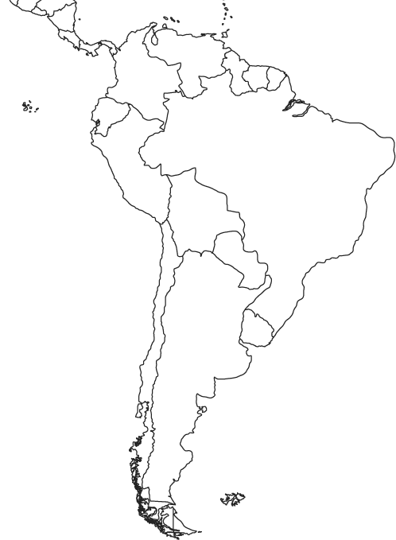 | Name________________________Date_____________ISN# 4.13  HEI of Latin America  - HEI is how __________________________the ____________________________ both ____________________and __________________ways to make life ___________________/better (for people).

