Name___________________________________________________________________________Date________________Period____________________
Human Environment Interaction
Warm-Up: What do you think Human Environment Interaction is? How would you explain it to a peer? ____________________________________ ________________________________________________________________________________________________________________________________________________________________________________________________________________________________________________

Human Environment Interaction | Description and Use | Positive or Negative | Location | Illustration
Wind Turbines

Dust Bowl

Natural Lakes

St. Lawrence Seaway

Oil Spill

Case Study: Earthquakes triggered by fracking or waste water disposal?

Directions: Read the information over Fracking. Then decide if you believe earthquakes are caused by fracking or by waste water disposal.
Answer your question using the ABE Model.
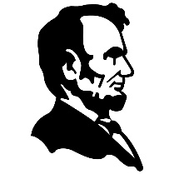 | A- Answer the question | State if you think earthquakes are caused by fracking or not.
 | B-Back it up | Tell me why you think they are or not.
 | E- Explain your reasoning | Provide evidence (from the reading) that proves what you said above.

________________________________________________________________________________________________________________________________________________________________________________________________________________________________________________________________________________________________________________________________________________________________________________________________________________________________________________________________________________________________________________________________________________________________________________________________________________________________________________________________________________________________________________________________________________________________________________________________________________________________________________________________________________________________________________________________________________________________________________________________________________________________________________________________________________________________________________________________________________________________________________________________________________________________________________

