Name________________________________________________Date_______________Period__________ISN#______
Levels of Development: Sub Sahara Africa
Directions: Using the CultureGrams on the various countries of Africa, record the countries current indicators. Then, rank the following countries based on their level of development.
Country | GDP | Age | Education | Life Expectancy | Kids | Rural or Urban
Algeria

Botswana

DR of Congo

Ivory Coast

Kenya

Rwanda

Nigeria

Somalia

South Africa

1. From the information collected above, which three nations would be considered More Developed?
A. B. C.
2. From the information collected above, which three nations would be considered Newly Industrialized?
A. B. C.
3. From the information collected above, which three nations would be considered Less Developed?
A. B. C.

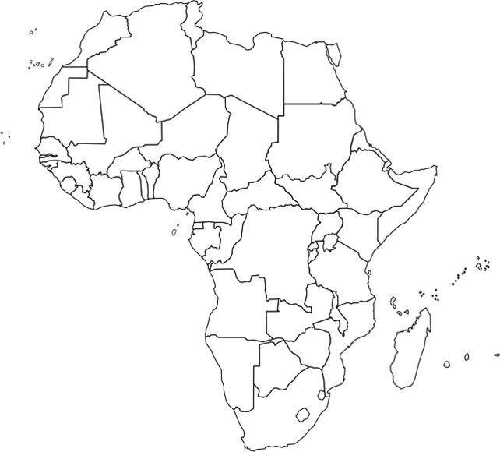
4. Label and color the map by the key based on your rankings above.
More Developed Nations- Green
Newly Industrialized Nations- Yellow
Less Developed Nations- Red

5. What trends can you find with countries that are considered More developed and their location within the African continent?

6. What trends do you notice about the nations that are considered Newly Industrialized or Less Developed and their location within the African continent?

7. Using the Population pyramids below, match them to the correct country and EXPLAIN how the population trends match the chosen country.
Country Choices: Somalia Kenya South Africa
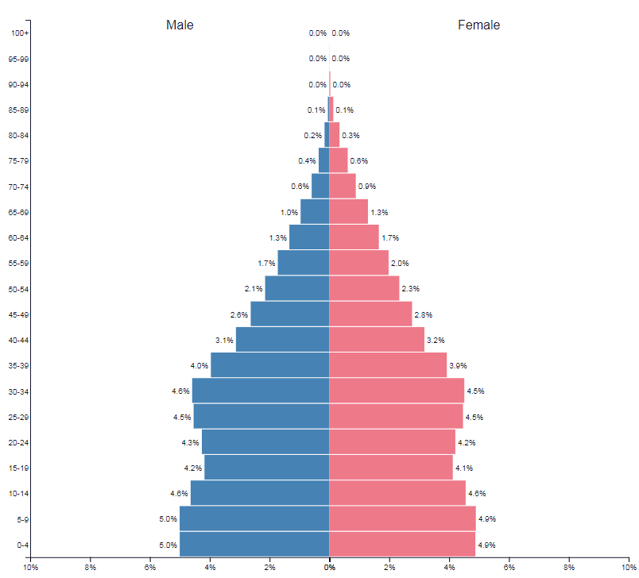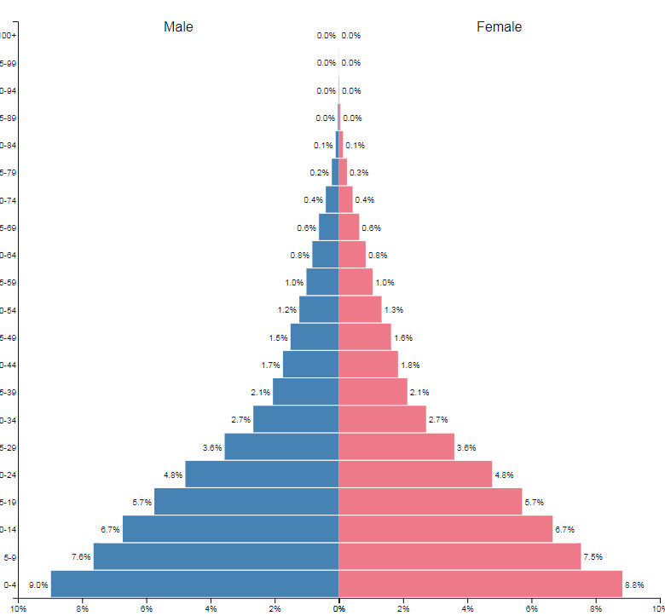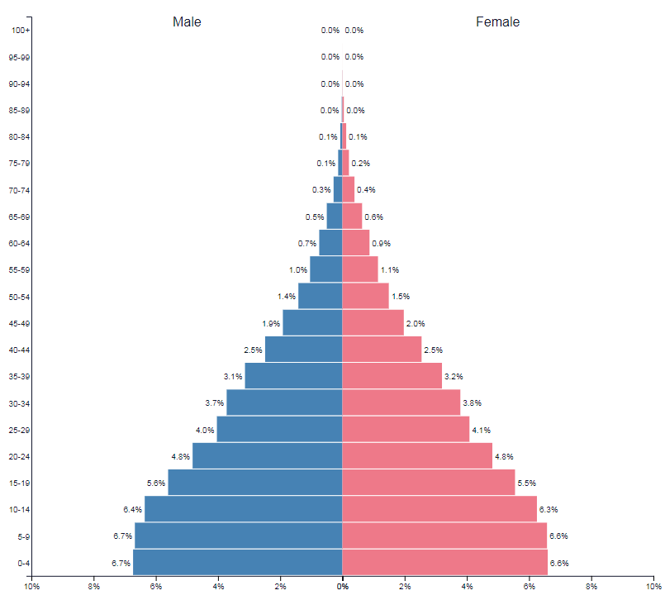
Country Of: | Country Of: | Country Of:
Because- | Because- | Because-
8. Quick illustrations: Draw a representation of what life would look like in the following nations based on their level of development.

