Name_________________________________________________________Date____________Period__________

Government Systems of Europe

**Monarchy**

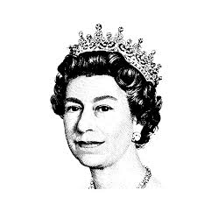



**Dictatorship**

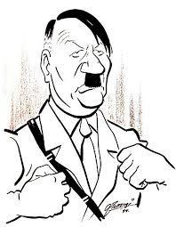

**Democracy**



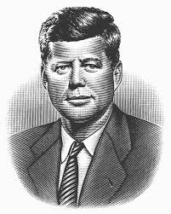

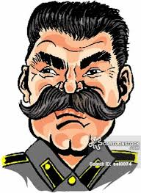

**Communist**

**Theocracy**



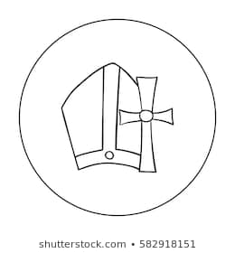



**Totalitarian**

