Genocides in Africa

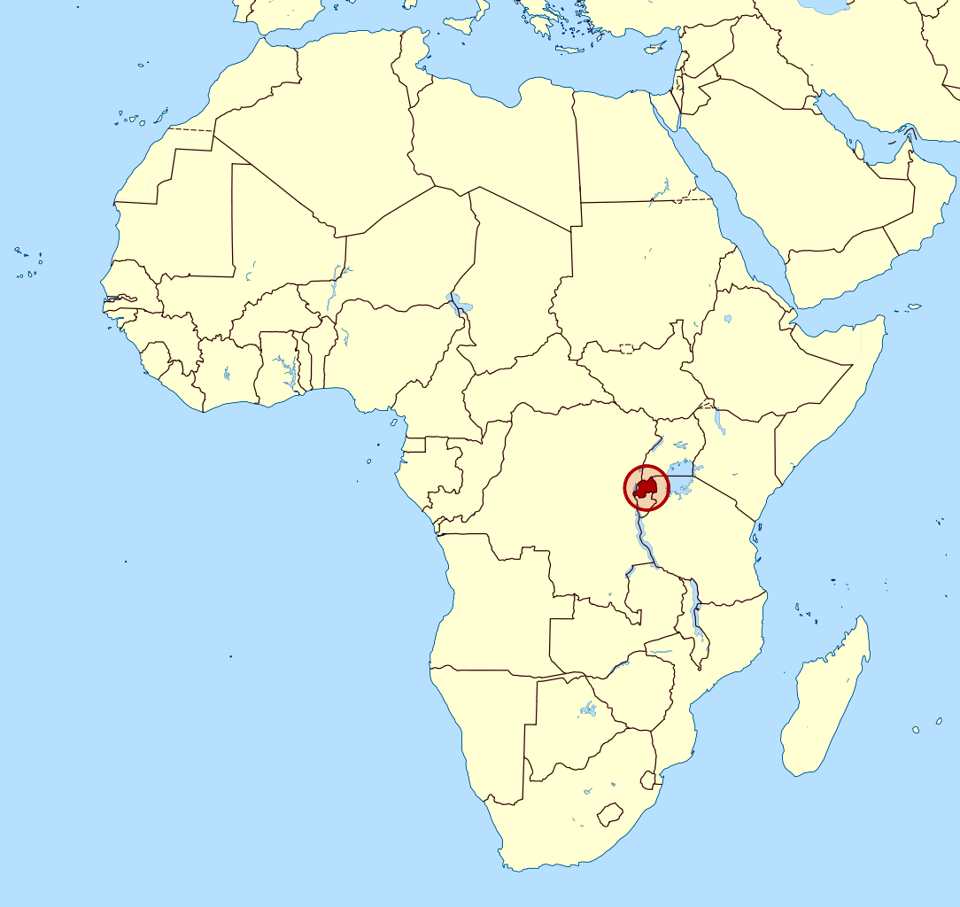
War continues to be a major cause of hunger and malnutrition in Africa. Since 1990, conflicts in countries such as Rwanda have halted economic development, cause widespread starvation, and cost the lives of countless Africans. Huge refugee populations fleeing war-torn areas and crossing borders into neighboring countries strain already limited food resources.

Rwanda
Conflict between indigenous peoples resulted in extraordinary dislocations. In Rwanda and Burundi, the colonial powers had favored the Tutsi people and given them positions of power over the majority Hutu. In 1959, the resentment among the Hutus sparked a violent rebellion. Conflict between the two peoples continued for decades. The country erupted in violence over the discrimination against Hutus in 1994. In this violent outbreak, called the Rwanda genocide, the Hutus killed hundreds of thousands of Tutsi people.
The civil war in Rwanda in 1990s between the Hutu and the Tutsi resulted in the genocide of over 800,000 people, most of whom were Tutsi. Over 2 million people became refugees. Since then, Rwanda has intervened in neighboring countries to limit the ethnic extremism that led to genocide within its own border. This involvement, however, had taken a toll on the country by preventing attention from managing resources and getting its economy back up since Rwanda is a heavily agricultural society.

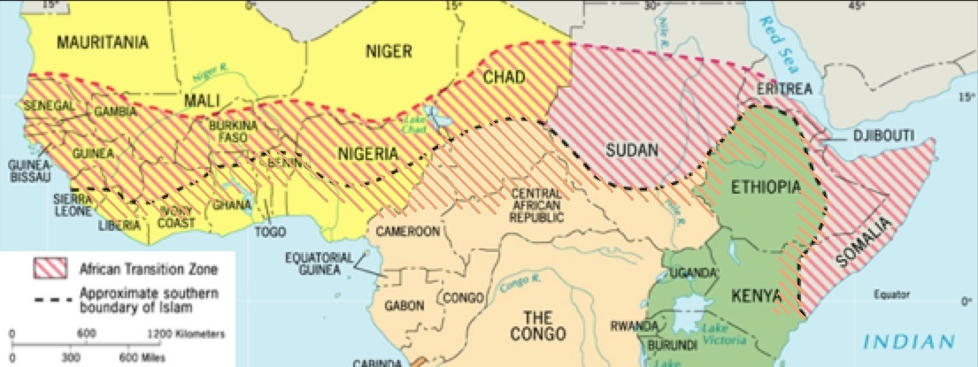
Sudan
A transition zone is a physical area in which the land undergoes a radical change such as from desert to tropical. The countries in the Transition Zone are packed with cultural differences. At times, these differences have led to conflicts, like those between north and south Sudan. Arabic-speaking Muslims live mostly in the northern cities and favor Islamic-oriented governments. People in the south live mostly in rural areas, are focused on a subsistence economy, and prefer native governments. These differences led to a conflict in which nearly 300,000 people died and an estimated 2.7 million people were displaced between 1983 and 2005.
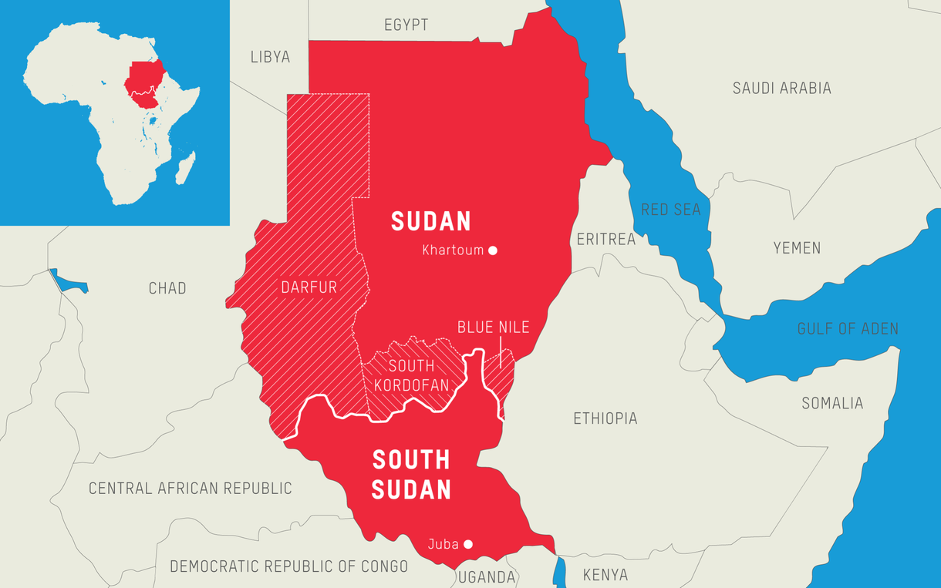
A peace agreement was finally signed in 2005, which provided considerable independence for Sudan’s southern provinces. Although the agreement ended the conflict between the north and south, it did not address the conflict in the western Darfur region of the country. The civil war in Darfur occurred because non-Arab Sudanese accused the government of favoring Sudanese Arabs. Finally in 2011, the southern provinces of Sudan held a referendum and voted for independence. South Sudan is now an independent country, with Juba as its capital.
Most recently, in January of 2011, South Sudan shut down all of its oil fields after a disagreement about fees Sudan demanded to transport oil. In May 2011, Sudan seized control of Abyei, a disputed oil-rich border region, after three days of clashes with South Sudanese forces. On September 27, 2011, the presidents of Sudan and South Sudan signed agreements of cooperation. The status of Abyei, however, was not addressed. The future of the region is still uncertain.

